HealthConnect Experience Lab
Week 8: Data Analytics Track, Final Analytics & Decision Support Package
AnalystLab Africa Internship Programme

Executive Summary
Over the past several weeks I analysed HealthConnect's appointment data to understand why nearly half of all scheduled appointments end in a no-show. My analysis found that booking lead time and prior no-show history are the two strongest, statistically significant predictors of missed appointments, and that these two factors compound when combined. Patients booking more than a month ahead with a history of missing appointments no-show at a rate of 73.2%, compared to just 17.1% for patients booking within a few days with no prior no-shows. Distance to the clinic and reminder channel also play a smaller role. These findings are backed by chi-square testing, not just visual patterns, and I've translated them into specific, actionable recommendations for HealthConnect below.

1. Week 7 to Week 8 Transition
- My main Week 7 output: the Testing and Refinement Report, where I checked my KPI calculations and dashboard against the raw dataset and statistically tested my headline findings.
- The most important testing result: confirming, through chi-square testing, that booking lead time and prior no-show history are genuinely, significantly associated with no-shows, not just a coincidental pattern.
- The major issue I found: a small inconsistency in how I'd documented the distance band boundary at exactly 5km, which I traced back and corrected.
- What was refined: my documentation now matches my actual Power BI formula exactly, and my recommendations now carry statistical weight rather than just descriptive comparison.
- What's now ready: my dashboard, KPIs, and core findings are all validated and ready to stand as the final analytical output for this project.
- What still needs integrating: a genuine two-way exchange with a Data Science collaborator, which hasn't been possible since none was assigned to this project.
- Tracks involved in final integration: Data Science, as the intended recipient of my validated findings.
- What I intend to demonstrate in my final presentation: how I moved from an initial exploratory look at the data all the way through to a statistically validated, actionable set of findings, and how that connects to the wider HealthConnect solution.

2. Final Integration Readiness
Requirement | My Response
What is my final component? | My Power BI dashboard and analytics report, tracking KPIs and patterns around patient appointment attendance and no-shows.
What problem does it address? | Understanding which factors most strongly predict missed appointments, so HealthConnect can act on them rather than guessing.
What is its current status? | Complete and validated. All KPIs are confirmed accurate against the raw dataset, and my two strongest findings are statistically significant.
What did I improve during Week 7? | Found and corrected a documentation inconsistency in a distance boundary, and added statistical testing to confirm my headline finding.
Which other track(s) does it depend on? | None directly, my work is built entirely from the raw HealthConnect dataset.
Which track(s) depend on my output? | Data Science, since my validated findings identify which variables are worth prioritising as prediction model features.
What output will I provide? | A statistically validated findings handoff naming booking_lead_days and previous_no_shows as strong candidate features, plus a recommended engineered interaction feature.
What output do I need from another track? | Confirmation from Data Science on which features they used and how they performed, not possible since no collaborator was assigned to this project.
What evidence demonstrates readiness? | My KPI verification table, chi-square test results, and corrected dashboard documentation from Week 7.
What limitations remain? | No live Data Science collaborator, an unresolved data inconsistency in waiting_time_minutes, and smaller sub-segment findings not yet backed by large samples.

3. Final KPIs
KPI | Result | Business Question It Answers
Overall No-Show Rate | 48.5% | How big is the attendance problem overall?
No-Show Rate by Booking Lead Time | 24.8% to 60.5% across bands | Does booking timing affect attendance?
No-Show Rate by Prior No-Show History | 43.5% vs 55.4% | Does past behaviour predict future no-shows?
No-Show Rate by Distance Band | 46.4% to 54.1% across bands | Does distance to the clinic affect attendance?
No-Show Rate by Reminder Channel | 45.8% to 51.4% across channels | Do reminders, and which channel, improve attendance?
Combined Risk, Lead Time and Prior History | 17.1% (lowest) to 73.2% (highest) | Which specific patient segment carries the highest risk?

4. Validated Findings
- Booking lead time is the strongest, statistically significant predictor of no-shows (chi-square = 319.69, p < 0.001), holding consistently across every appointment type and patient history segment tested.
- Prior no-show history is also statistically significant (chi-square = 68.37, p < 0.001), and compounds with lead time rather than acting independently.
- The highest identifiable risk segment (31 or more days lead time, 1 or more prior no-shows, 15km or more from the clinic) reaches a 73.2% no-show rate across 179 appointments.
- The lowest identifiable risk segment (0 to 3 day lead time, no prior no-shows) sits at 17.1% across a much larger sample.
- Distance and reminder channel matter, but modestly compared to lead time and history, and did not change materially under deeper testing.
- Demographic factors like gender and age show little to no effect, confirming the real drivers are behavioural and logistical, not who the patient is.

5. Final Dashboard
The dashboard below brings together all six KPI cards and the core breakdown charts. A further matrix visual, added during Week 6, layers booking lead time against prior no-show history directly, making the compounding risk pattern visible at a glance.
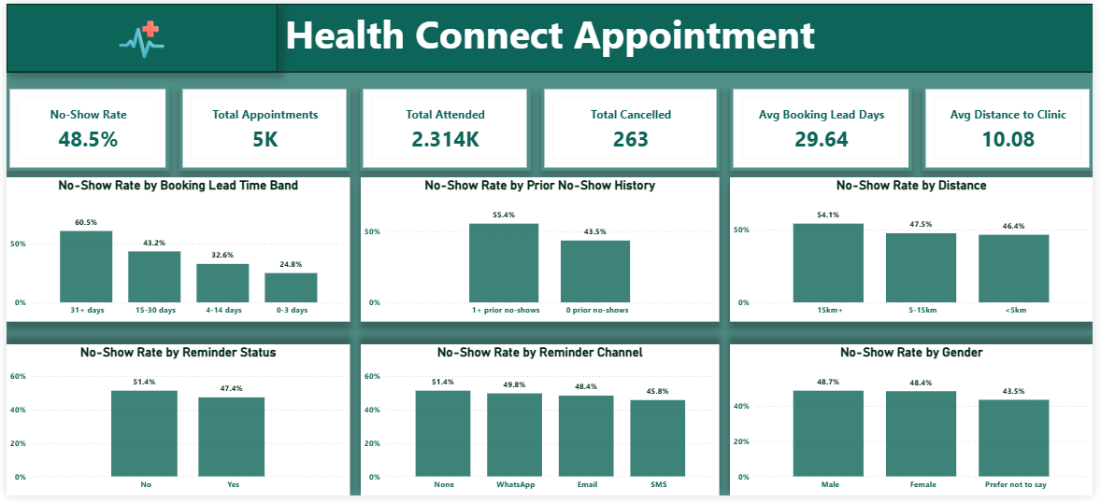
Every figure shown here has been independently verified against the raw dataset as part of Week 7 testing.

6. Key Business Insights
- 1. Booking lead time is the single biggest lever HealthConnect has. Patients booking a month or more ahead miss appointments more than twice as often as those booking within a few days.
- 2. Risk compounds rather than adds. A patient with both a long lead time and a prior no-show is far riskier than either factor suggests alone, a 56 percentage point spread separates the safest and riskiest identifiable groups.
- 3. Distance is a real but secondary factor. Worth addressing, but not where the biggest gains lie.
- 4. SMS reminders outperform other channels, though reminders overall only move the needle modestly.
- 5. Demographics are not the answer. Any intervention should target behaviour and logistics, not who the patient is.

7. Recommendations
- Target the highest-risk segment directly with proactive outreach, such as a confirmation call, for patients booking far ahead who also have a prior no-show.
- Introduce a mid-point reminder for appointments booked more than a month in advance, rather than relying on a single reminder close to the date.
- Make SMS the default reminder channel where a patient's number is on file.
- Explore telehealth or transport support for patients living farther from the clinic, as a secondary, lower-priority intervention.
- Avoid demographic-based targeting, and focus resources on the behavioural and logistical factors validated in this analysis.

8. Analytical Limitations
- Imputed data: small gaps in distance_to_clinic_km and waiting_time_minutes were filled using the column median, a reasonable estimate rather than the true recorded value for those specific appointments.
- Waiting time inconsistency: waiting_time_minutes is recorded even for appointments that were never attended, which does not fully make sense and was never resolved, only documented.
- Correlation, not causation: these findings show strong association, not proof that booking timing or history directly causes no-show behaviour.
- Small sample segments: some of the more detailed, multi-factor segments are based on smaller appointment counts and should be treated as directional rather than conclusive.
- Synthetic dataset: these findings demonstrate a sound end-to-end analytical approach rather than reflect a real clinic's actual patients.

9. HC-POD Final Integration
- Track collaborated with: Data Science. No live collaborator was assigned to this project across the entire Experience Lab, documented honestly here as in every previous week rather than fabricated.
- Dependency: the Data Science track's no-show prediction model depends on knowing which variables are worth prioritising as input features.
- Output received: none, at no point during the project was Data Science output available to receive.
- Output provided: a complete, statistically validated findings handoff across Weeks 6 and 7, naming booking_lead_days and previous_no_shows as strong candidate features, and recommending an engineered interaction feature between the two.
- Final integration activity: consolidating all validated findings into this final package, in a form ready for a Data Science collaborator to use immediately, whenever one is assigned.
- What changed: my analytical output evolved from a set of exploratory percentages in Week 5 into a statistically tested, business-ready recommendation set by Week 8.
- How this improved the solution: a future model built on these findings would rest on validated evidence rather than untested assumptions, improving the credibility of the overall HealthConnect solution.
- Evidence: the KPI validation table, chi-square test results, and this final findings package.
- Contribution to the final presentation: this analysis forms the evidence base explaining why HealthConnect has a no-show problem and which patients to prioritise, the foundation the rest of the HC-POD's work builds on.

10. My Contribution to the End-to-End HealthConnect Walkthrough
- The problem: HealthConnect loses appointment capacity and continuity of care because close to half of all scheduled appointments end in a no-show.
- The data: 5,000 anonymised appointment records covering demographics, booking details, appointment history, reminders, distance, and outcomes.
- The analytics: my work revealed that no-shows are driven primarily by booking lead time and prior no-show history, with distance and reminders playing smaller roles, and demographics playing almost none.
- Business value: HealthConnect can now target its limited administrative resources, extra reminders, confirmation calls, at the specific patient segments proven to carry the highest risk, rather than treating every patient the same way.
- Limitations: these findings identify strong associations, not guaranteed causes, and a live connection to a predictive model has not yet been established due to the missing Data Science collaborator.

