Inter-VLAN Routing Implementation Report
Router-on-a-Stick Configuration using Cisco Packet Tracer

1. Objective
This project demonstrates inter-VLAN routing using the router-on-a-stick method. A single Layer 3 router (Router1) connects to a Layer 2 switch (Switch0) via a trunk link, routing traffic between three VLANs so that hosts in separate broadcast domains can communicate.

2. Network Topology
Router1 connects to Switch0 through a single trunked FastEthernet link. Six PCs (PC0-PC5) are distributed across the switch's access ports, grouped into three VLANs.
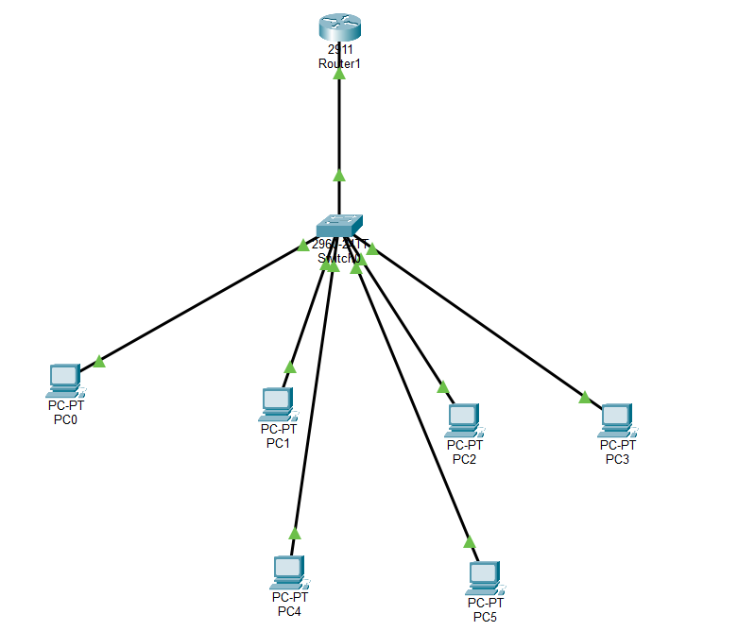
Figure 1: Logical topology — Router1, Switch0, and PC0-PC5.

3. Device Roles
Device | Model | Role
Router1 | Cisco 2911 | Router-on-a-stick / inter-VLAN gateway
Switch0 | Cisco 2960-24TT | Access & trunk switch (802.1Q)
PC0-PC5 | Generic PCs | End-user hosts across VLANs 10/20/30

4. VLAN and IP Addressing Plan
VLAN ID | Name | Network | Gateway (Sub-int) | Switch Ports
10 | Faculty/Data | 192.168.10.0/24 | 192.168.10.1 | Fa0/1 - Fa0/2
20 | Sales | 192.168.20.0/24 | 192.168.20.1 | Fa0/3 - Fa0/4
30 | Management | 192.168.30.0/24 | 192.168.30.1 | Fa0/5 - Fa0/6

5. Switch Configuration
Switch0 was configured with three VLANs and access ports assigned per host group. The uplink to Router1 (Fa0/24) was configured as an 802.1Q trunk carrying all three VLANs.
- VLAN 10, 20, and 30 created on Switch0.
- Access ports Fa0/1-Fa0/6 assigned to their respective VLANs (switchport mode access).
- Fa0/24 set to trunk mode, allowing VLANs 10, 20, and 30 (switchport trunk allowed vlan 10,20,30).
- VLAN 1 (default/management) left with no IP address and administratively shut down for security.
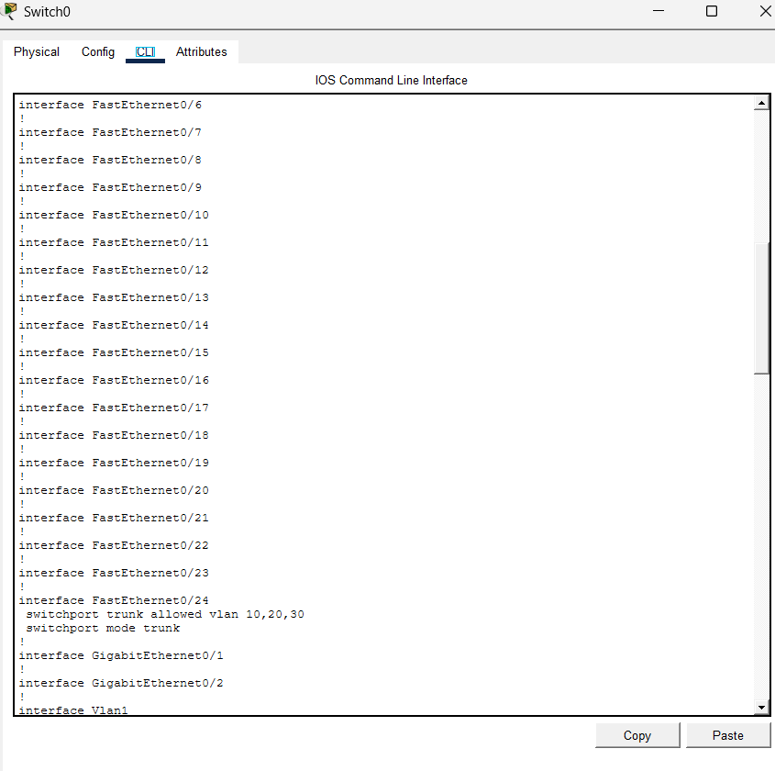
Figure 2: Switch0 running-config showing the Fa0/24 trunk and VLAN allowed list.

6. Router Configuration (Router-on-a-Stick)
On Router1, the physical interface connected to the switch was divided into logical sub-interfaces, one per VLAN. Each sub-interface was configured with 802.1Q encapsulation and an IP address that serves as the default gateway for that VLAN.
- interface Gi0/0.10 — encapsulation dot1Q 10 — ip address 192.168.10.1 255.255.255.0
- interface Gi0/0.20 — encapsulation dot1Q 20 — ip address 192.168.20.1 255.255.255.0
- interface Gi0/0.30 — encapsulation dot1Q 30 — ip address 192.168.30.1 255.255.255.0
- Physical interface Gi0/0 enabled with 'no shutdown' to activate all sub-interfaces.

7. End-Device Configuration
Each PC was assigned a static IP address within its VLAN's subnet, with the corresponding router sub-interface set as the default gateway.
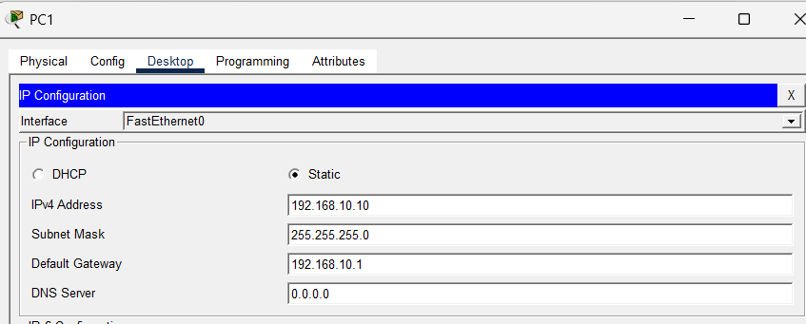
Figure 3: PC1 static IP configuration — 192.168.10.10/24, gateway 192.168.10.1 (VLAN 10).

8. Verification and Testing
Connectivity was verified using extended ping tests between hosts in different VLANs, confirming that traffic was successfully routed by Router1 across VLAN boundaries. The switch trunk carried tagged traffic for all three VLANs without cross-VLAN leakage at Layer 2, and full reachability was achieved only after the router sub-interfaces were brought up.
- PC-to-PC ping within the same VLAN: successful (switched locally).
- PC-to-PC ping across VLANs (e.g., VLAN 10 to VLAN 20): successful via Router1.
- Router interface status confirmed up/up on all three sub-interfaces.

9. Conclusion
The lab successfully implements inter-VLAN routing in a router-on-a-stick topology. Segmenting hosts into VLANs 10, 20, and 30 reduced broadcast domains and improved network organization, while the single trunked router link provided full routed connectivity between all segments without requiring a dedicated physical interface per VLAN.

