**Assignment Description**

**Language: Oracle SQL**

**Number of Questions: 24**

**Duration: 3 hours**

**Programming Assignment**

**Assignment 1 – Database Creation and Querying Exercises**

**Objectives:**

**In this assignment you will create a database along with tables for which you will Write SQL queries for the instructions specified. These will include addition of constraints, modifications, deletions, insertions and updates. You will also be asked to perform Oracle SQL Joins, sub-queries, functions, triggers, views and indexes as well as packages and procedures. This will be used to assess your overall knowledge of Oracle SQL.**

**STRUCTURE REQUIREMENTS:**

* **Ensure proper syntax and naming convention for example: ensuring the table and column names are all lower case.**
* **Set up the primary keys for each table with constraints listed.**
* **Because you will not be asked to create an actual database in your environment, it is important that your answers clearly illustrate that you understand the questions being asked as well as how to properly structure your answers.**

**REPORTING REQUIREMENTS:**

* **Make sure that you list the section number for each question and title/headings as well as question numbers when submitting your answer.**
* **Please enter all of your answers in a Microsoft Word Doc.**

**SUBMISSION REQUIREMENTS:**

**Submissions will be in the Oracle material GitHub repository.**

**Activities:**

**Section 1-**

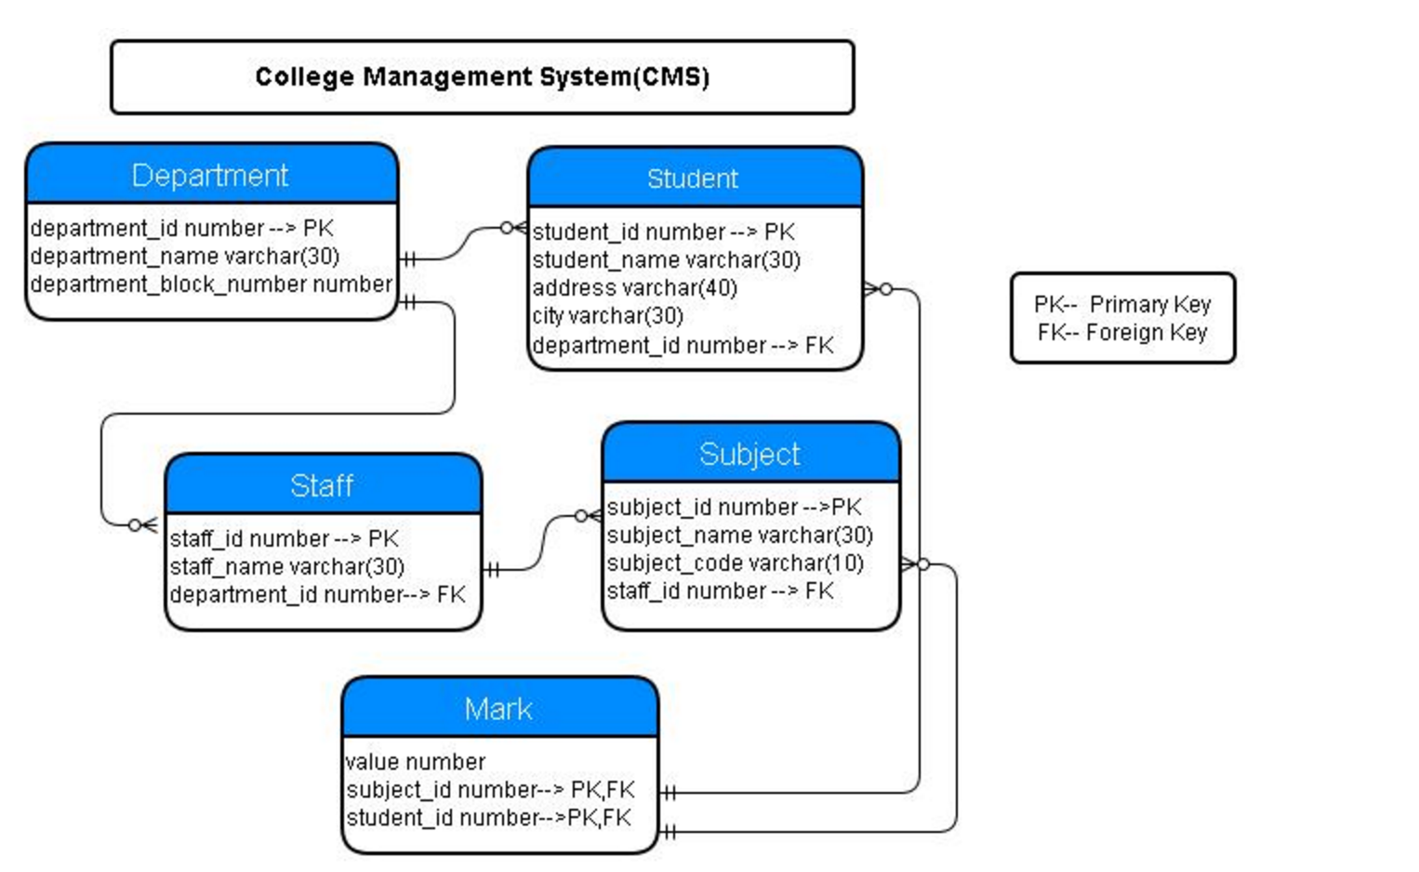

**Creating Tables:**

**Referring to the schema above for reference and using Oracle SQL, create the tables identified below using the following order:**

**TABLES TO CREATE:**

**1-department (department_id number PK, department_name varchar(30), department_block_number number)**

**2-student (student_id number, student_name varchar(30), address varchar (40), city varchar(30), department_id number FK)**

**3-staff (staff_id number, staff_name varchar(30), department_id number FK)**

**4- subject (subject_id number PK, student_name varchar (30), student_code varchar(10), staff_id number FK)**

**5- mark (value number, subject_id number PK FK, student_id number PK FK)**

**6-Add a constraint by writing a query to add a not null constraint to the column staff_name in the staff table.**

**7-Add a column by writing a query named emailid of type varchar (20) to the student table.**

**8-Modify the size of the type of field emailid on the student table by writing a query to change it to varchar(50);**

**9-Remove the emailid column on the student table by writing a query.**

**Section 2-**

**Inserting Into Tables**

**10 - Download the following excel sheet in LMS under Documents -> Week 3 -> Oracle hands on:**

* **DEPARTMENT**
* **STAFF**
* **MARK**
* **SUBJECT**
* **STUDENT**

**11 - Insert those excel sheets to their corresponding tables**

**Section 3-**

**Updating Records**

**12 - Update a record by writing a query to update the subject_name in the subject table from Sales to Computer Science and subject_code from 1842 to 1919.**

**Section 4-**

**Deleting Records**

**13 - Delete the row from the subject table where subject name is Accounting by writing the appropriate query.**

**Section 5-**

**Basic Selection of Records**

**14 -** **Display the names of the department in the college by writing the appropriate query. Please note that these must be displayed in ascending order.**

**15- Display the names of the departments where departments block number is between 3 and 10 by writing the appropriate query.**

**16- Display the names of all the students in the college by writing the appropriate query. Please note these must be displayed in ascending order.**

**Section 6-**

**Selecting Single Rows**

**17- Display the names of the students who are from Chicago, Taylor and San Jose. Please note these must be displayed in ascending order of their respective id.**

**18-** **Writing the correct query, display the address and city of the students table give the alias as Address_Student.**

**19- Display all of the student’s names whose names are of 6 characters in length by writing the correct query.**

**Section 7-**

**Selecting Groups**

**20- Display the blocknumber and number of departments in each block by writing the correct query that is ordered by block id. Make sure it is displayed as count (department_name)**

**21-** **Display the number of students in the college by writing the correct query and give an alias as stud_count.**

**Section 8-**

**SQL Joins**

**22-** **Display the names of the department and the student count in each department by writing the correct query. The student count in each department must be in ascending order based on the department name and an alias of student_count for the student count.**

**23-** **Display the Student_Name from STUDENT and the Subject_name from SUBJECT where the Subject_code from SUBJECT is greater than 1600.**

**24-** **Display the Stundent_Name from STUDENTS and the Subject_name from SUBJECT where the value on MARK table is less 3.**