Data Cleaning & Manipulation :

The data was imported in PowerBI. Using power query, the data was cleaned and manipulated so that the analyses could be run on them. These steps describes the changes. You can find it in the upper ribbon by clicking the tab named Transform Data.

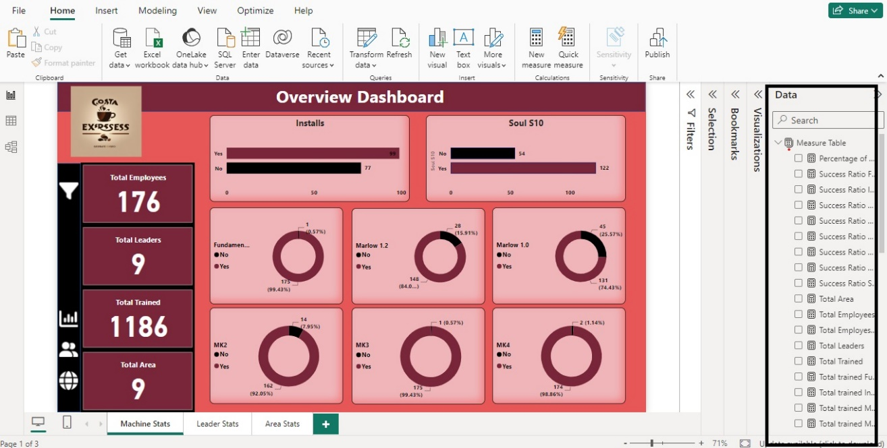

Creating Measures using DAX :

There are approximately 35 measures created using DAX function. There are some unique formulas. Based on these formulas, many more measures were created.

Total Area = DISTINCTCOUNT(datacostaandrew[Area])  
-- Unique values from the area column.

Total Employees = COUNTROWS(datacostaandrew)

--- Total Number of Emplyees.

Total Leaders = DISTINCTCOUNT(datacostaandrew[Team Leader])

--- Total Number of Leaders.

Total Trained Machines = [Total trained Installs] + [Total trained Soul S10] +  [Total trained MK4] +[Total trained MK3] + [Total trained Marlow_1.0] +[Total trained Marlow_1.2]+ [Total trained MK2] + [Total trained Fundamentals]

--- Summation of individual trained machines.

Total Untrained = [Total untrained Fundamentals] + [Total untrained Installs] + [Total untrained Marlow_1.0] + [Total untrained Marlow_1.2] + [Total untrained MK2] + [Total untrained MK3] + [Total untrained MK4] + [Total untrained Soul S10]

--- Summation of individual untrained machines.

Total trained Installs =

CALCULATE(

    COUNTROWS(datacostaandrew),

    datacostaandrew[Installs] = "Yes")

--- Total trained installs machine. It is counting the ‘Yes’ from the column and adding that.

** Similarly, 7 others were created using the same formulae for the 7 features.

Total untrained Installs =

CALCULATE(

    COUNTROWS(datacostaandrew),

    datacostaandrew[Installs] = "No")

--- Total untrained installs machine. It is counting the ‘No’ from the column and adding that.

** Similarly, 7 others were created using the same formulae for the 7 features.

Success Ratio Fundamentals = [Total trained Fundamentals] / ([Total trained Fundamentals] + [Total untrained Fundamentals])

--- It is the success percentage which tells what percentage of machine has been trained for Fundamentals machines.

** Similarly, 7 others were created using the same formulae for the 7 features.

Percentage of Success = [Total Trained Machines] / ([Total Trained Machines] + [Total Untrained])

--- Overall success rate. It determines the best leader.

Charts & Figures :

In this step, 6 donut charts & 2 column charts were created for displaying the percentage of trained and untrained machines. KPI’s were presented in card visual. By clicking the filter icon, you can access to the filters where you will be able to filter the visuals by team leaders & Areas. There are some other buttons which will take you to other pages.

Leader stats page helps you to find the best leader and what are his contribution to the company.

Area Stats will tell you about the least & most trained machines of each area with their success ratio.