Computer Programming
BSCS [1-A]

FINAL TERM PROJECT REPORT



Submitted By [Group No. 2]:
- M Ahmad (046) (Leader)
- Mubeen Asif (041)
- M MUSTAFA ALI (033)

Submitted to: Sir Sauood

PROJECT NAME
Traffic Violation Management System

DEPARTMENT OF COMPUTER SCIENCES
BAHRIA UNIVERSITY, LAHORE CAMPUS

Table of Contents
Marks Distribution 3
Abstract 4
1. Introduction 5
2. Database Design 5
3. Problem Statement 5
4. Objectives 5
5. Results 5
6. Screen Shots of Final Product 5
7. References 5

Marks Distribution
------------------------------ For Instructor Use Only ----------------------------------
Project Grading Sheet
Sr. No. | Task | Max Marks | Obtained Marks | Comments(if any)
1. | Report | 2.5
2. | Implementation | 12.5
3. | Viva  (Oral/Task Based or Both) | 5
Total |  | 20 |  | Signature:
---------------------------------------------------------------------------

Abstract
Traffic Violation Management System is the software solution for streamlining the management and tracking of all type of traffic violations. It will provide an interface for recording traffic violations, which stores all details, including person's ID, type of violation, fine amount, violation date, and location. The project is developed in C++ using file handling for the securing of data. It enables the system to save violation records into a file for loading it into the system at any time in future.
It makes use of basic file operations in C++ to load data from and save data to a file, ensuring violation records are preserved across runs of the program. In addition, it includes error handling to handle cases of no records existing or in case of file operations failing. The project aims at offering a simple yet effective tool for managing traffic violations and providing an easy way through which the traffic police authorities can maintain their records and calculate fines.
This project is particularly suitable for small applications in which the record keeping should be very efficient.
The core functions of the system are:
Adding Violation Records: A person can add the violations of the person(vehicle) with its ID, its Violation type, Its total fine, the location on which violation takes place and with its date as well
Displaying Violations for a Specific Person: The system can display all violations associated with a particular person, offering a detailed report of their offenses.
Sum of Fine The program calculates and displays the total fine for a person based on his violation history with the help of its ID.

Introduction
The Traffic Violation Management System is a software application intended to help traffic authorities record, manage, and track traffic violations efficiently. C++ is the programming language used in the development of this system. Users are allowed to add violation records, view violations associated with a specific individual, and compute the total fines owed. The data is maintained in a text file so that they persist across different sessions.
Motivation
The motivation behind this project lies in the need for a more organized and automated method of managing traffic violations. The traditional manual tracking takes time and is error-prone. This system, therefore, offers a streamlined solution that enhances accuracy and saves valuable time for traffic authorities.
Importance for Industry Practice
This system is a very important tool in the traffic management industry because it allows law enforcement to effectively manage violation records and collect fines. It is a perfect example of how technology can enhance record-keeping, boost efficiency, and contribute to the evolution of traffic management practices. The project also opens the way for further improvements, such as database integration or real-time updates.

Database Design

The database design for the Traffic Violation Management System is structured to store and manage records of traffic violations efficiently. It follows a simple, flat file-based approach, where data is stored persistently in a text file.
The records are stored in a text file named violations.txt. Each record is written sequentially, with attributes stored in the following format:
Field Name | Data Type | Description
PersonID | String | Unique identifier for the individual who committed the violation.
ViolationType | String | Description of the type of traffic violation (e.g., speeding, red-light jump).
FineAmount | Long Long (Int) | Monetary penalty imposed for the violation.
ViolationDate | String | The date on which the violation occurred (format: YYYY-MM-DD).
Location | String | The location where the violation was recorded.

Problem Statement
- Traffic violation records are often manually or through outdated systems which lead to inefficiency, mistakes, and trouble in keeping track of the violations.
- There is a need for an automated and organized system to keep a record and manage traffic violation records, compute fines, and produce reports because the existing process is a time-consuming one for the traffic authorities.
- Moreover, the present systems lack the easy access of historical violation data and do not have an easy and user-friendly way of getting, updating, or analyzing violation records.

Objectives
- The Traffic Violation Management System is designed in a way that makes the recording and management of traffic violations easier to handle in terms of storing and retrieving violation data efficiently.
- Such a system will allow for adding records of violations made effortless, calculate total fines, and allow the presentation of the individual's violation history.
- In particular, it aims at boosting accuracy, reducing manual errors, and allowing for an easy-to-use interface. Furthermore, the project ensures data persistence and integrity through effective file handling, with a possibility of future enhancement in terms of database and other advanced functionalities.

Results:
The Traffic Violation Management System achieves the proposed objectives by implementing core functionalities using C++.
Methods and Logical Steps
- Data Persistence Through File Handling:
  - Violation records are stored in a text file (violations.txt) to ensure data is not lost between program runs.
  - Records are loaded into memory when the program starts, enabling efficient retrieval and analysis.
- Adding a Violation Record:
  - The system prompts the user to input a person's ID, violation type, fine amount, date, and location.
  - The record is appended to the in-memory data structure and saved to the text file.
- Displaying Violations for a Person:
  - The system allows users to input a person's ID.
  - It retrieves and displays all violation records associated with that ID, providing a detailed history.
- Calculating Total Fines:
  - The system computes the total fine for a specific person by summing up the FineAmount for all violations associated with their ID.
- Error Handling:
  - The system gracefully handles scenarios such as missing files, invalid input, and exceeding record storage limits.

Achievements
- Ease of Use:
The system provides a user-friendly menu-driven interface to add, view, and analyze traffic violations.
- Data Accuracy:
By automating record-keeping and calculations, the system reduces the likelihood of manual errors.
- Persistence:
Violation records are reliably preserved across multiple program runs, ensuring data availability.
- Efficient Record Management:
Users can access detailed violation histories and calculate total fines instantly, improving operational efficiency.

Limitations and Future Scope
- Scalability Issues:
The current implementation uses a flat file for storage, which may become inefficient as the data size grows. Transitioning to a database system is recommended for large-scale applications.
- Limited Features:
Additional features, such as updating or deleting violation records and generating detailed reports, can enhance functionality.
- Real-Time Integration:
Future versions could include real-time updates and integration with traffic surveillance systems to automate record creation.

Summary of Results
The project successfully demonstrates how a simple, file-based Traffic Violation Management System can be implemented using C++. It achieves the objectives of efficient record-keeping, accurate fine calculations, and user-friendly data retrieval, providing a valuable tool for traffic authorities in small-scale applications.

Screen Shots of the Final Product

Adding a Violation Record
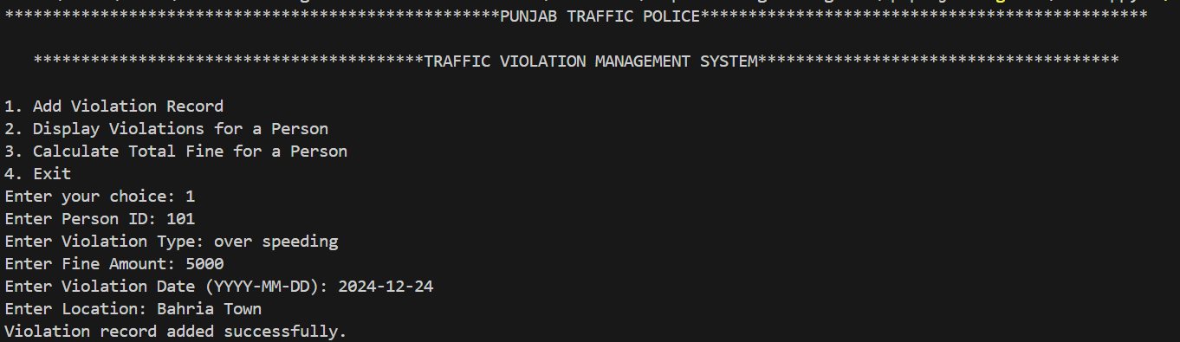
Fig.1

Displaying Violations for a specific person

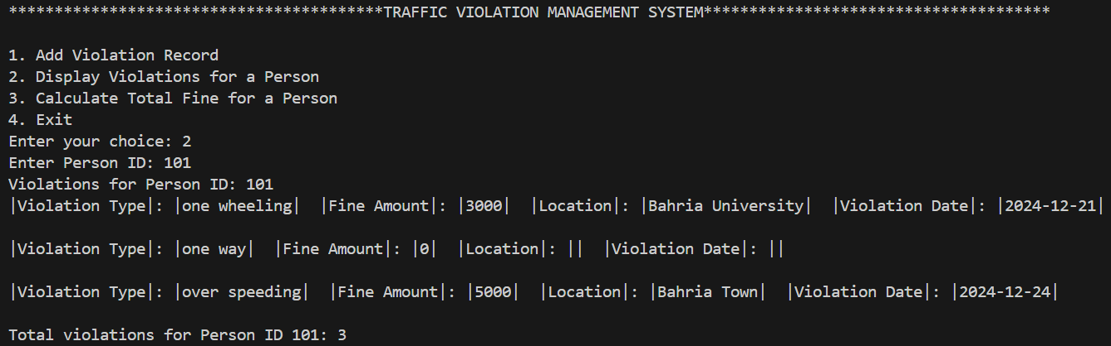
Fig.2

Calculating Total Fines

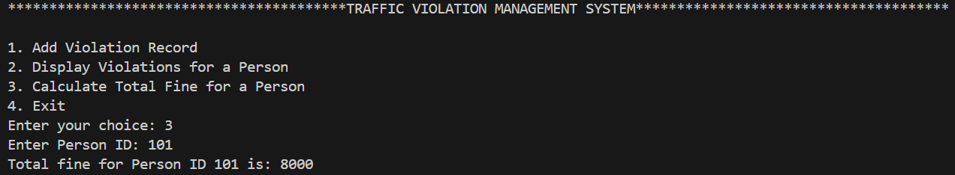
Fig.3

References
https://myprojectideas.com/traffic-management-system-with-c/

https://youtu.be/nDzUSx3bG8Y

https://github.com/jamesjose03/Traffic-Fines-System

