WELLCOME TO
LuxuryStay
USER’S GUIDE:

Aptech North Nazimabad | ADSE I | NOV 14,2025



ADVISOR/TEACHER/MENTOR | SIR OWAIS AHMED
BATCH CODE | 2303G1
SEMESTER | ADSE I
SERIAL NUMBER | ENROLLMENT NUMBER | STUDENT NAME
1 | Student1483150 | MUHAMMAD HASSAN
2 | Student1485457 | MUHAMMAD ALI
3 | Student1429988 | SAMIULLAH
4 | Student1485459 | MUDASSAR AHMED

ADMIN PANEL:

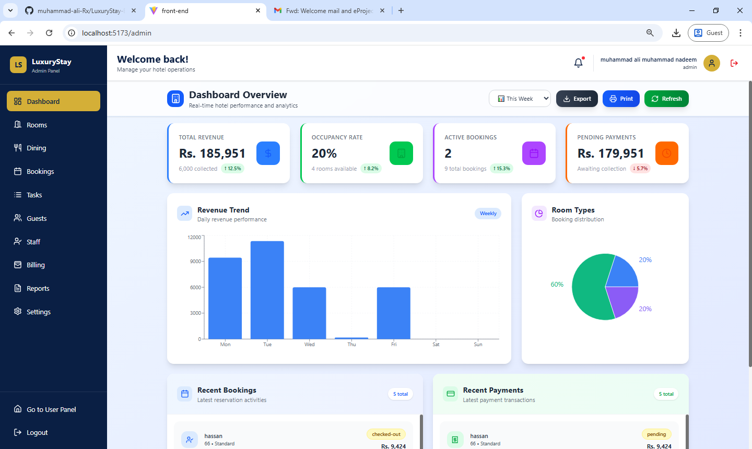

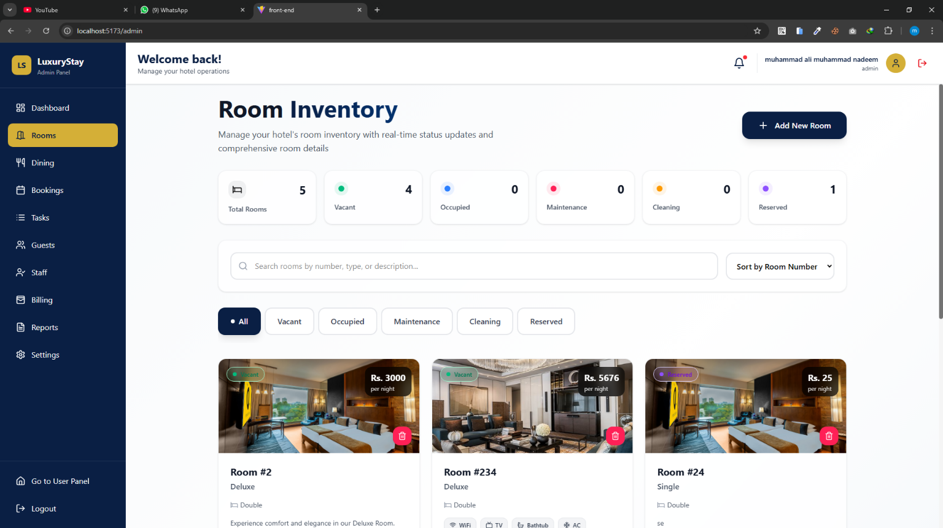

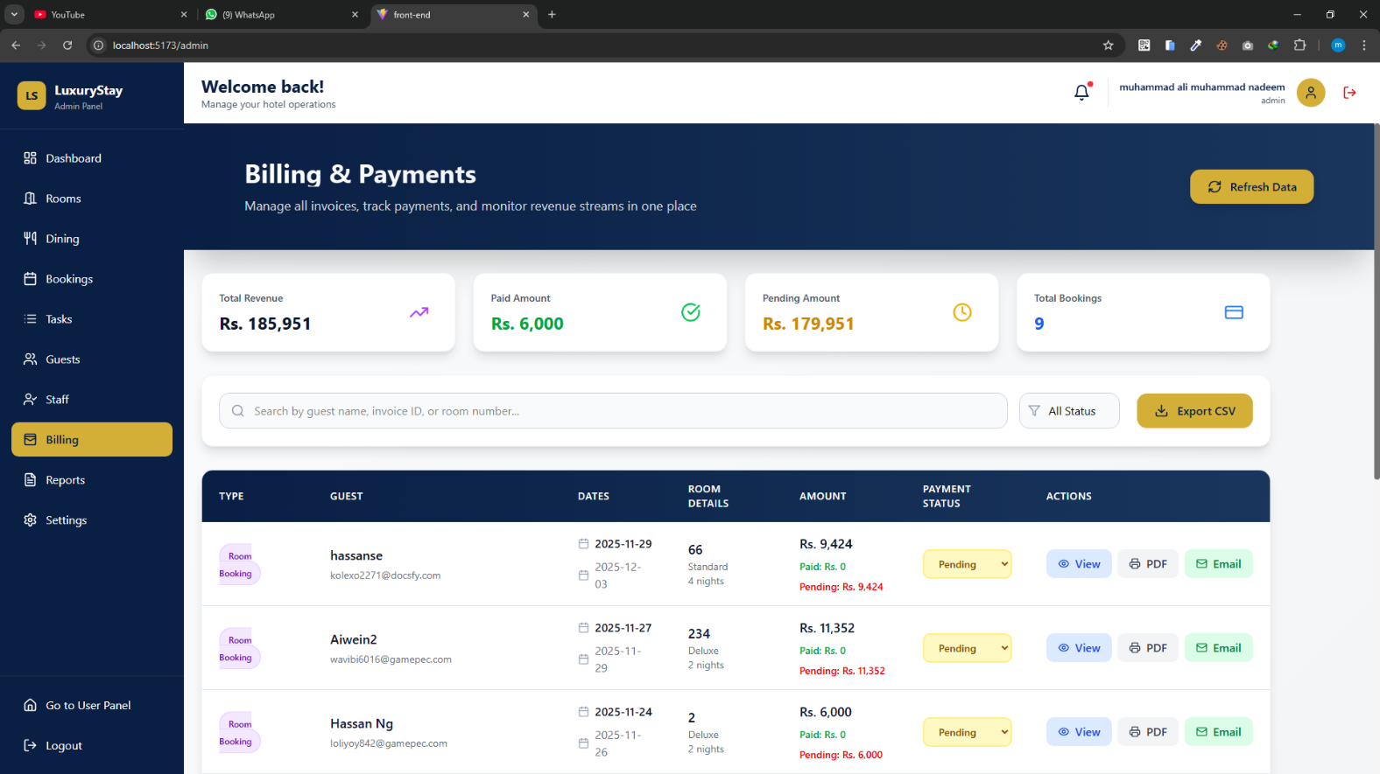

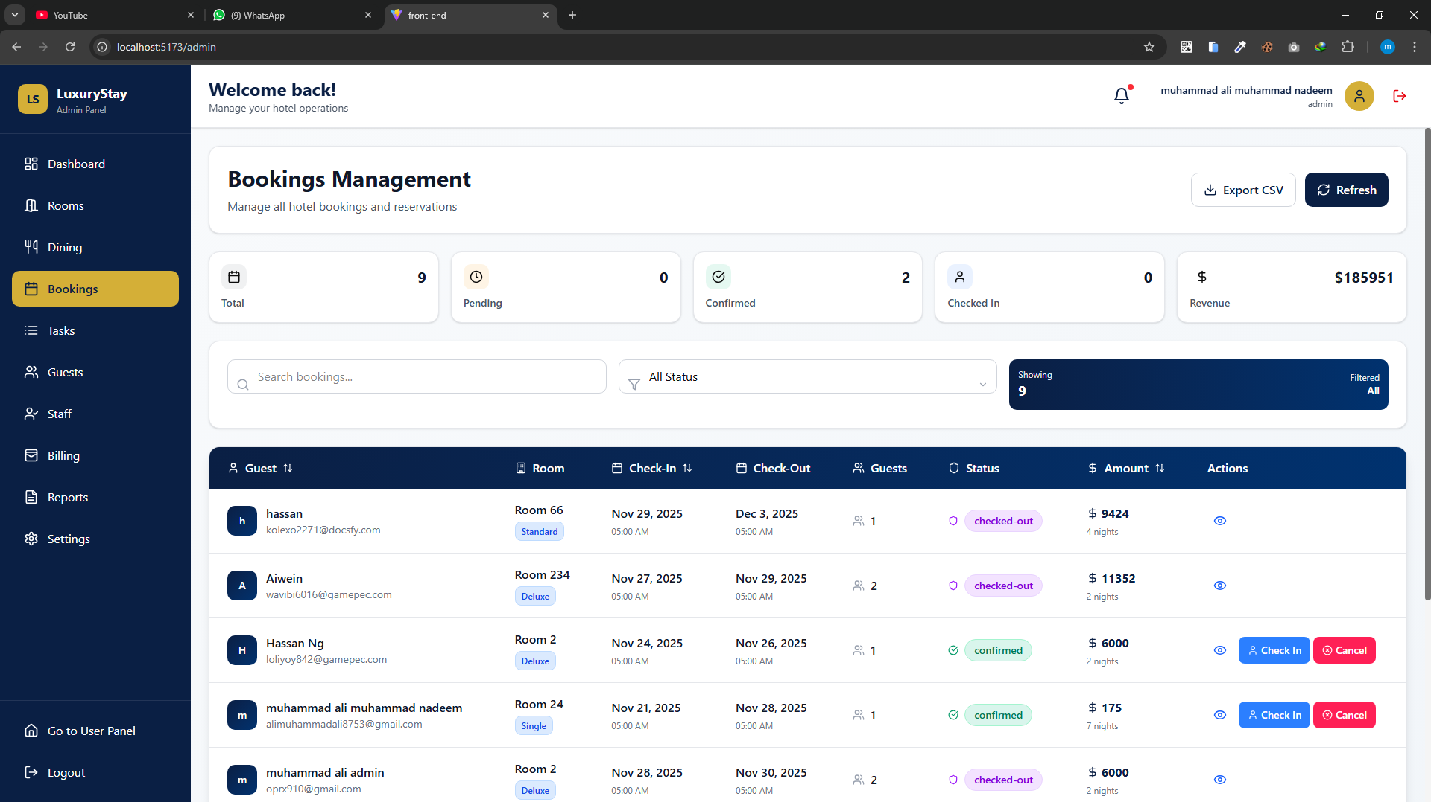

USER PANEL;

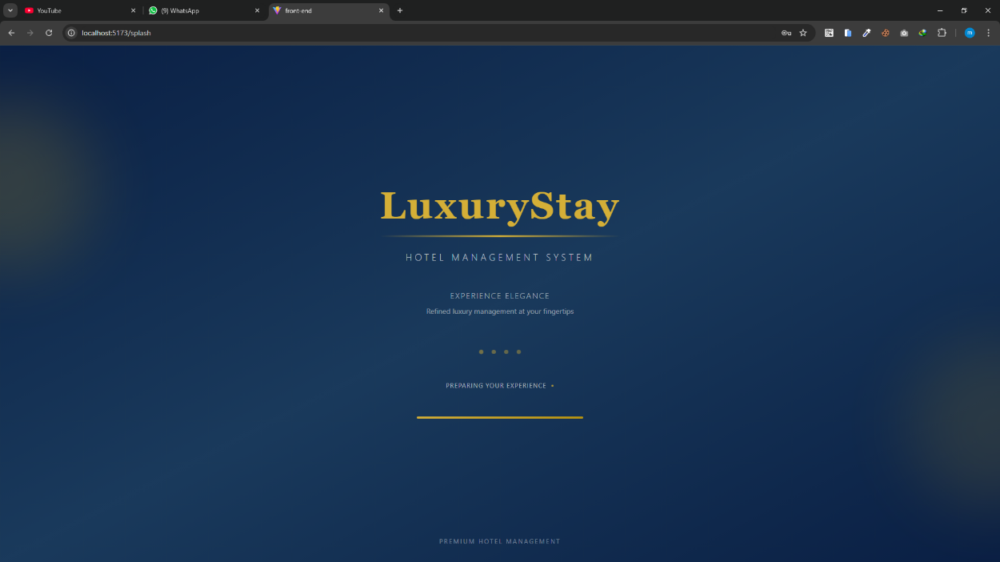

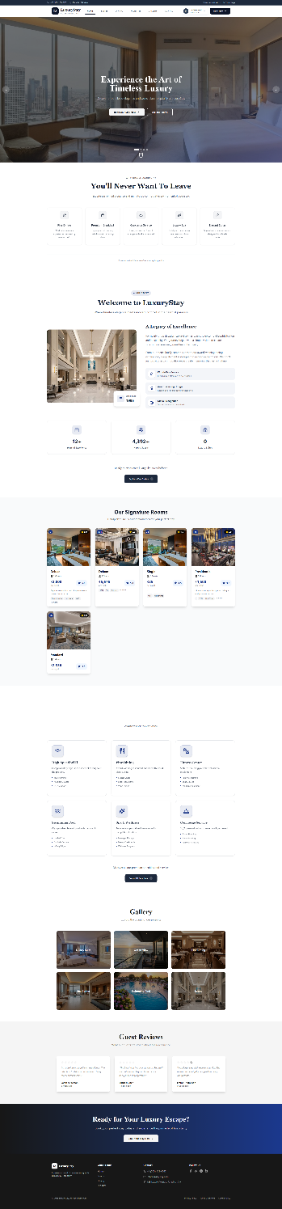

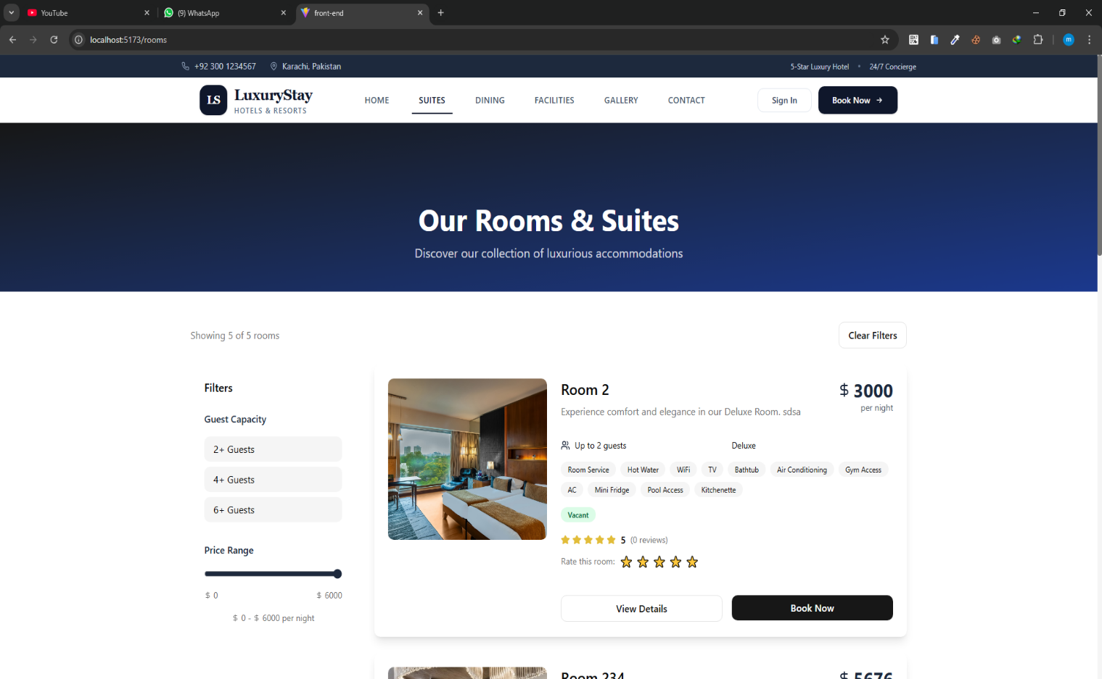

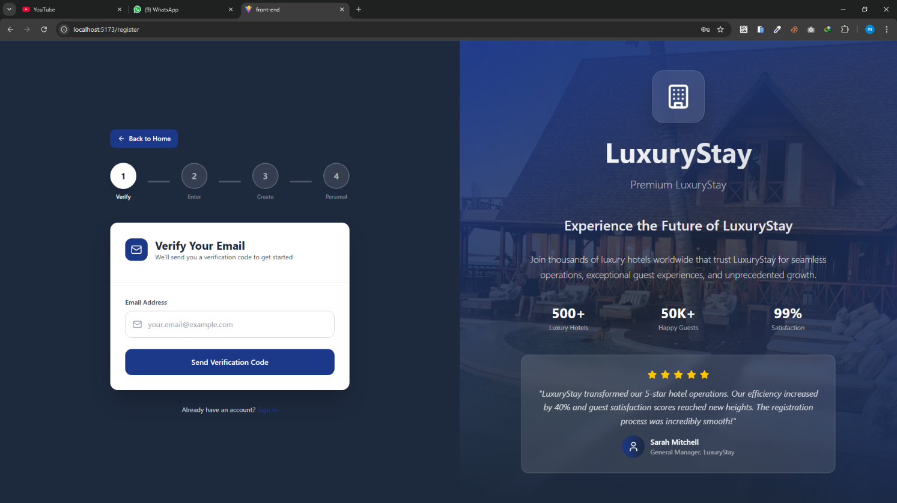

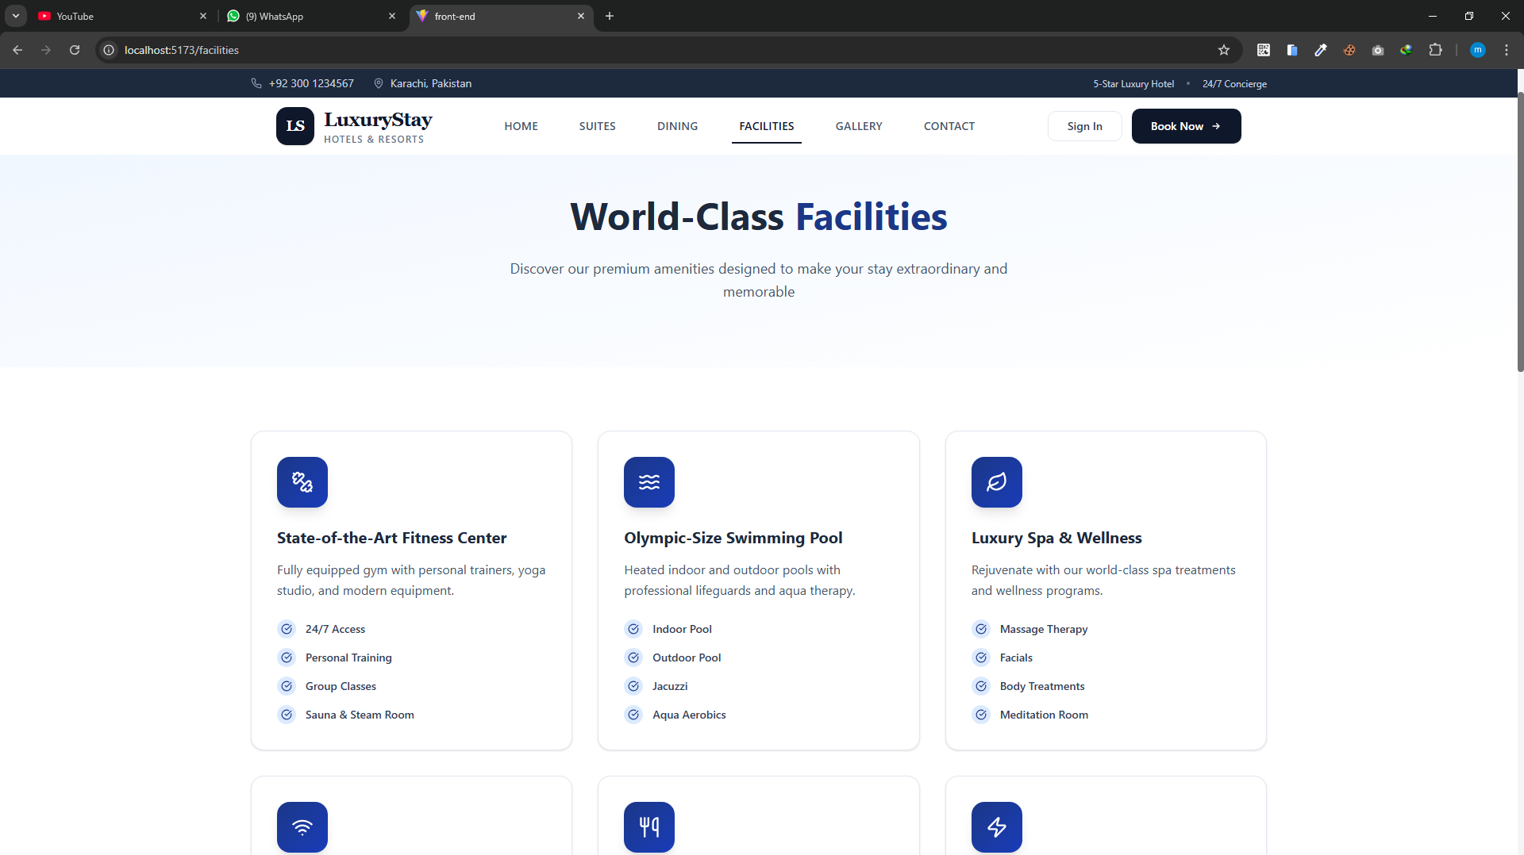

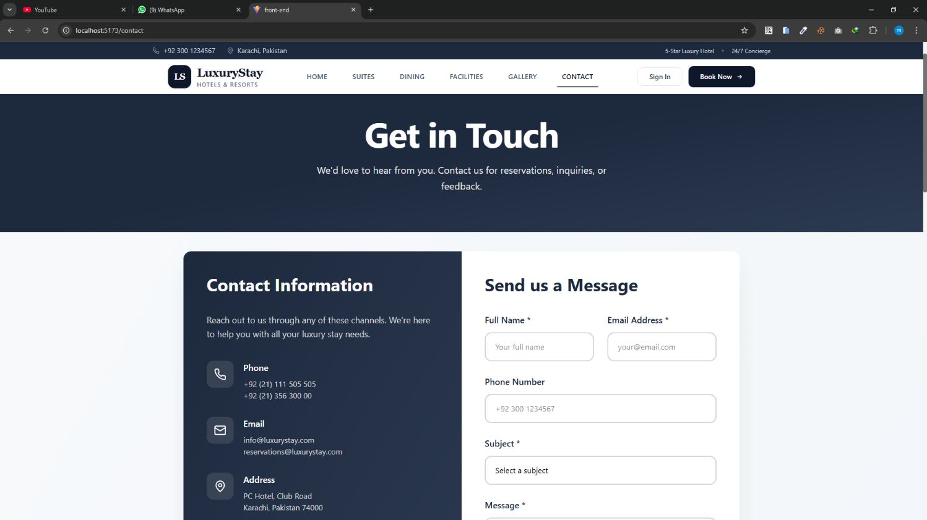


Thank you so much for reading my User Guide Manual of the Website.

