Registration Number | 2025-BSCPE-136
Name | Muhammad Awais

Second Mini Project
Brick Breaker Game

Objectives:
- To implement Object-Oriented Programming concepts (classes, objects, encapsulation) in a real C# game.
- To understand game loop architecture and real-time rendering using Raylib-cs.
- To implement game states (Menu, Playing, LevelComplete, GameOver, YouWin) using enumerations.
- To design and implement a power-up system with multiple active effects.
- To implement particle effects, ball trails, combo multipliers, and screen feedback.
- To handle collision detection between ball, bricks, and paddle accurately.
- To implement a high score system using file I/O.
- To practice multi-class design with separation of concerns.

Introduction / Theory:
Brick Breaker is a classic arcade game where the player controls a paddle to bounce a ball and break bricks. This project implements the game in C# using the Raylib-cs library for real-time 2D rendering.

The game uses Object-Oriented Programming with separate classes for game entities (Ball, Particle, PowerUp), static utility methods, and a main Program class that manages the game loop, state machine, physics, and rendering.

OOP Concepts Applied:
Concept | How Used in Project
Classes & Objects | Ball, Particle, PowerUp are separate classes with properties
Encapsulation | Game state and data hidden inside static fields in Program class
Enumerations | GS enum defines game states: Menu, Playing, LevelComplete, GameOver, YouWin
Collections | List<Ball>, List<Particle>, List<PowerUp> for dynamic game objects
File I/O | High score saved and loaded from highscore.txt
Static Methods | Helper methods for audio, particles, brick reset encapsulated as static

System Architecture:
The project follows a Game Loop Architecture — a continuous loop that updates game logic and renders graphics at 60 frames per second.

Game Loop Flow:
1. INPUT — Keyboard events (Left, Right, Space, P, M)

2. UPDATE — Physics, collisions, power-ups, timers, particles

3. RENDER — Draw bricks, ball, paddle, UI, effects to screen

Game States (GS Enum):
State | Description | Transition
Menu | Main menu screen showing controls | ENTER → Playing
Playing | Active gameplay state | All bricks cleared → LevelComplete / GameOver
LevelComplete | Level cleared screen | ENTER → next level Playing
GameOver | Player lost all lives | R → Playing / M → Menu
YouWin | All 3 levels completed | R → Playing / M → Menu

Class Design:

Ball.cs
using System.Numerics;
class Ball
{
public Vector2 Pos, Vel;
public bool Active;
public float Age;
}

Ball represents extra balls spawned by the Triple power-up. Each ball has its own position, velocity, active flag, and age (removed after 15 seconds).

Particle.cs
using System.Numerics;
using Color = Raylib_cs.Color;
class Particle
{
public Vector2 Pos, Vel;
public Color Col;
public float Life, Size;
}

Particles are spawned when bricks break. Each particle has position, velocity, color, life (fades out), and size. They move outward and disappear after their Life reaches zero.

PowerUp.cs
using System.Numerics;
class PowerUp
{
public Vector2 Pos;
public char Type; // W=Wide, S=Slow, T=Triple, D=Dual, E=ExtraLife
public bool Active;
}

PowerUps fall from broken bricks. Each has a Type character that determines its effect when caught by the paddle.

GS Enum (Game States)
enum GS { Menu, Playing, LevelComplete, GameOver, YouWin }

Game Features:

Brick Types:
Type | Value | Appearance | Behavior
Normal | 1 | Row color | 1 hit to break
Strong | 2 | Grey + '2' | 2 hits — first hit downgrades to Normal
Explosive | 3 | Orange + '!' | Breaks and destroys all neighboring bricks

Power-Up System:
Type | Key | Effect | Duration
Wide Paddle | W | Paddle expands to 165px wide | 9 seconds
Slow Ball | S | Ball speed reduced to 55% | 7 seconds
Triple Balls | T | 3 extra balls spawned at angles | 12 seconds
Dual Break | D | Next 2 bricks destroyed regardless of type | 10 seconds
Extra Life | E | Gain 1 life (max 5) | Instant

Combo & Score Multiplier:
Each consecutive brick hit within 2 seconds increases the combo counter. When combo reaches 3 or more, score multiplier becomes 3x. Displayed as 'COMBO x3' on screen.

Achievement System:
Achievement | Condition
Score Master! | Reach a score of 1000 or more
Brick Basher! | Break 100 or more bricks in one session

Key Code Sections:

1. Brick Initialization (ResetBricks)
static void ResetBricks()
{
for (int r = 0; r < ROWS; r++)
for (int c = 0; c < COLS; c++)
{
int t = 1;
if (r == 0 && rand.NextDouble() < 0.25) t = 3; // explosive
else if (r <= 1 && rand.NextDouble() < 0.3) t = 2; // strong
bricks[r, c] = t;
flashTimer[r, c] = 0f;
}
}

Each level the bricks are randomly assigned types. Row 0 has 25% chance of explosive bricks. Rows 0-1 have 30% chance of strong bricks. Rest are normal.

2. Brick Hit Handler (HandleBrickHit)
static void HandleBrickHit(int r, int c, float bx, float by)
{
int type = bricks[r, c];
int basePoints = rowPoints[r] * level;
int multiplier = comboCount >= 3 ? 3 : 1;
if (type == 1) // Normal brick
{
bricks[r, c] = 0;
score += basePoints * multiplier;
SpawnParticles(bx + BW/2f, by + BH/2f, rowColors[r]);
}
else if (type == 2) // Strong brick — downgrade
{
bricks[r, c] = 1;
score += (basePoints / 2) * multiplier;
}
else if (type == 3) // Explosive brick
{
bricks[r, c] = 0;
// Destroy all neighbors in 3x3 area
for (int rr = Math.Max(0,r-1); rr <= Math.Min(ROWS-1,r+1); rr++)
for (int cc = Math.Max(0,c-1); cc <= Math.Min(COLS-1,c+1); cc++)
if (bricks[rr,cc] != 0) { bricks[rr,cc] = 0; totalBricksBroken++; }
}
comboCount++;
comboTimer = 2.0f;
}

3. Ball-Paddle Physics
// Angle bounce based on hit position on paddle
float spd = ballVel.Length();
float off = (ballPos.X - paddleX) / paddleW - 0.5f; // -0.5 to +0.5
ballVel.X = off * spd * 2.4f;
ballVel.Y = -MathF.Abs(ballVel.Y);
// Cap horizontal speed at 90% of total speed
if (MathF.Abs(ballVel.X) > spd * 0.9f)
ballVel.X = MathF.Sign(ballVel.X) * spd * 0.9f;
ballVel = Vector2.Normalize(ballVel) * spd; // Maintain constant speed

The ball's horizontal direction depends on where it hits the paddle. Hitting the edge creates a steep angle; hitting the center bounces straight. Speed remains constant using Vector2.Normalize.

4. Power-Up Collection
switch (pu.Type)
{
case 'W': // Wide paddle
wideActive = true; wideTimer = 9f; paddleW = 165; break;
case 'S': // Slow ball
slowActive = true; slowTimer = 7f;
ballVel = Vector2.Normalize(ballVel) * (ballVel.Length() * 0.55f); break;
case 'T': // Triple balls
tripleActive = true; tripleTimer = 12f;
multiBalls.Add(new Ball { Pos=ballPos, Vel=new Vector2(spd*0.6f,-spd*0.8f) });
multiBalls.Add(new Ball { Pos=ballPos, Vel=new Vector2(-spd*0.6f,-spd*0.8f) });
multiBalls.Add(new Ball { Pos=ballPos, Vel=new Vector2(0,-spd) }); break;
case 'D': // Dual break
dualBreakActive = true; dualBreakTimer = 10f; dualBreakHits = 0; break;
case 'E': // Extra life
if (lives < 5) lives++; break;
}

5. High Score File I/O
static void SaveHS()
{
if (score > highScore)
{
highScore = score;
File.WriteAllText(HS_FILE, highScore.ToString());
}
}
// At startup:
if (File.Exists(HS_FILE))
int.TryParse(File.ReadAllText(HS_FILE), out highScore);

Game Controls:
Key | Action
← → | Move paddle left / right
SPACE | Launch ball
P | Pause / Resume game
M | Toggle audio on/off
1/2/3 | Switch visual theme (unlocked by score)
ENTER | Start game / Next level
R | Restart after Game Over

Output:

Main Menu Screen:
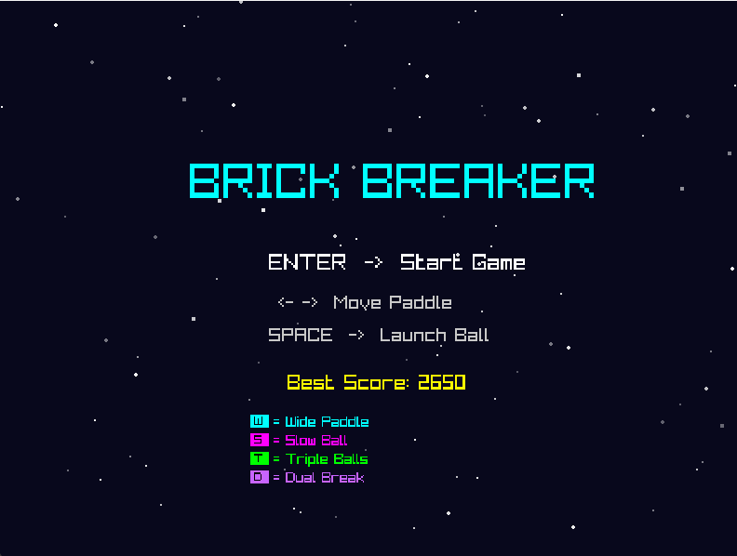

Gameplay — Bricks and Ball:
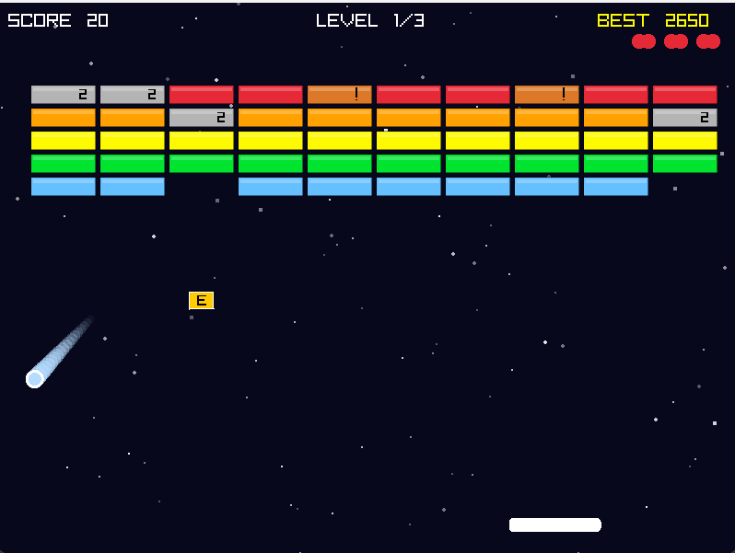

Level Complete Screen:

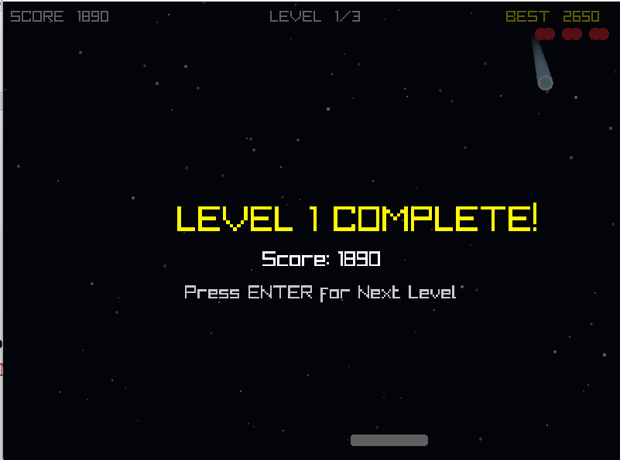

Game Over Screen:
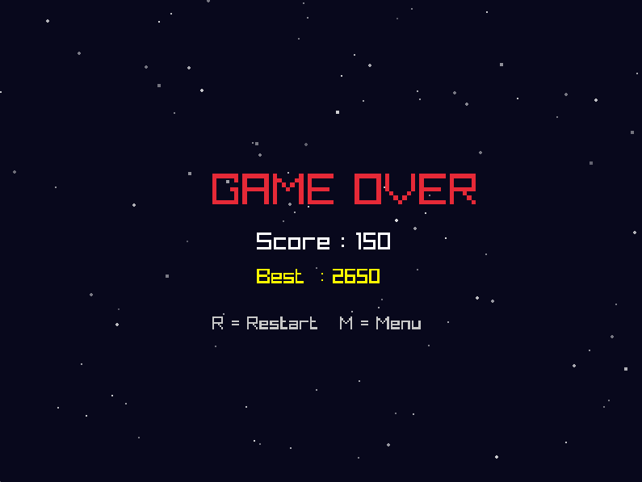

Conclusion:
- I successfully implemented a fully functional Brick Breaker game in C# using Raylib-cs with real-time 2D rendering at 60 FPS.
- I applied Object-Oriented Programming concepts by designing separate classes (Ball, Particle, PowerUp) and organizing game logic into focused static methods.
- I designed a power-up system with 5 different effects including Wide Paddle, Slow Ball, Triple Balls, Dual Break, and Extra Life — each with its own timer and visual feedback.
- I implemented collision detection for ball-brick and ball-paddle interactions with angle-based physics that makes gameplay skill-dependent.
- I added a combo multiplier system, particle effects, ball trail, achievement notifications, and animated star background to enhance the game feel.
- I practiced file I/O by persisting the high score across sessions using a text file.
- This project gave me deep understanding of game loop architecture, real-time state management, and the application of OOP in interactive software.

