Registration number | 2025-BSCPE-136
Name | Muhammad Awais

First Mini Project
University Admission Management System

Objectives:
- To design and implement a 3-Tier Architecture system that clearly separates Presentation, Business Logic, and Data Layer responsibilities.
- To enforce academic rules such as maximum 20 credit hours per program and maximum 9 credit hours per student during subject registration.
- To provide a user-friendly console-based interface that allows administrators to manage programs, students, subjects, and fees efficiently.
- To implement a fee calculation module that generates accurate fee challans based on the number of credit hours registered by each student.
- Presentation Layer (Console Interaction)
- Business Logic Layer (BLL)
- Data Layer (DL)

Introduction/Theory:
The University Admission Management System is a console-based application developed in C# using a 3-Tier Architecture that separates Presentation, Business Logic, and Data layers for clean and maintainable code.
This system allows the university's admission department to manage academic programs, process student applications, generate merit lists, register subjects, and calculate fees in a structured and automated way.
Students can apply for admission by providing their personal details including name, age, FSC marks, and ECAT marks, and can submit preferences for multiple programs offered by the university.
The system calculates merit based on a weighted formula — 40% FSC and 60% ECAT — and allocates programs to students from highest merit to lowest, respecting available seat limits.
After admission, registered students can enroll in subjects offered by their allocated program, with a maximum of 9 credit hours per student, and the fee department can generate fee challans based on enrolled credit hours.

Task: Implement The University Admission Management System:

Question:
- Academic branch offers different programs within different departments. Each program has a
- degree title and duration of degree.
- Students apply for admission in the university and provide their name, age, FSC, and ECAT marks,
- and select any number of preferences among the available programs.
- The admission department prepares a merit list according to the highest merit and available seats
- and registers selected students in the program.
- The academic branch also adds subjects for each program. A subject has a subject code, credit
- hours, and subject type. A program cannot have more than 20 credit hours for subjects. A student
- registers multiple subjects but cannot take more than 9 credit hours.
- The fee department generates fees according to the registered subjects of the students.

Case Study Overview:
The system manages:
- Academic programs (degree title, duration)
- Student applications (name, age, FSC, ECAT, preferences)
- Merit list generation
- Subject registration (max 30 credit hours)
- Fee calculation

Layer-wise Class Design:

1. Presentation Layer (Console Layer)
Handles input/output via console
Classes
- Menu
- StudentView
- ProgramView
- AdmissionView
Responsibilities
- Display menus
- Take user input (student data, preferences)
- Show:
- Merit list
- Program allocation
- Registered subjects
- Fee details
- Call functions from Business Logic Layer
Example Tasks
- Show menu: Add Student / View Merit / Register Subjects
- Print results on screen

2. Business Logic Layer (Core System)
Handles all processing and rules
Classes
- Student
- Program
- Subject
- AdmissionManager
- MeritCalculator
- RegistrationManager
- FeeCalculator
Responsibilities
- Store and process student/program data
- Calculate merit based on FSC & ECAT
- Generate merit lists
- Allocate students to programs
- Enforce constraints:
Max 30 credit hours
- Handle subject registration
- Calculate fees
Example Logic
- Sort students by merit
- Assign program based on preference + merit
- Check credit hour limits

3. Data Layer (Storage Layer)
Handles data storage (in-memory using lists/arrays)
Classes
- StudentDL
- ProgramDL
- SubjectDL
Responsibilities
Store:
- List of students
- List of programs
- List of subjects
Provide methods:
- Add data
- Retrieve data
- Search records

System Flow:
1. User interacts via console (Presentation Layer)
2. Requests sent to Business Logic Layer
3. BLL processes logic
4. Data stored/retrieved from Data Layer
5. Results displayed on console

Functional Requirements:
✔ Student Management
• Add student (name, age, FSC, ECAT)
• Enter program preferences
✔ Program Management
• Add programs (degree, duration, seats)
✔ Merit Calculation
• Generate merit list
• Allocate programs
✔ Subject Registration
• Register subjects per student
• Max 30 credit hours
✔ Fee Calculation
• Calculate fee based on subjects

Data Layer Classes

Subject.cs
using System;
using System.Collections.Generic;
using System.Text;

namespace TASK___1
{
public class Subject
{
public string Code { get; set; }
public string Name { get; set; }
public int CreditHours { get; set; }
}
}

SubjectDL.cs
using System;
using System.Collections.Generic;
using System.Text;

namespace TASK___1
{
using System.Collections.Generic;
using System.Linq;

public class SubjectDL
{
public static List<Subject> subjects = new List<Subject>();

public static void AddSubject(Subject s)
{
subjects.Add(s);
}

public static List<Subject> GetAll() => subjects;
public static Subject GetByCode(string code) => subjects.FirstOrDefault(x => x.Code == code);
}
}

ProgramOffer.cs
using System;
using System.Collections.Generic;
using System.Text;

namespace TASK___1
{
public class ProgramOffer
{
public int Id { get; set; }
public string Name { get; set; }
public int Seats { get; set; }
public int AvailableSeats { get; set; }
}
}

ProgramDL.cs
using System;
using System.Collections.Generic;
using System.Text;

namespace TASK___1
{
using System.Collections.Generic;
using System.Linq;

public class ProgramDL
{
public static List<ProgramOffer> programs = new List<ProgramOffer>();

public static void AddProgram(ProgramOffer p)
{
p.Id = programs.Count + 1;
p.AvailableSeats = p.Seats;
programs.Add(p);
}

public static List<ProgramOffer> GetAll() => programs;

public static ProgramOffer GetById(int id) => programs.FirstOrDefault(x => x.Id == id);
}
}

Student.cs
using System;
using System.Collections.Generic;
using System.Text;

namespace TASK___1
{
using System.Collections.Generic;

public class Student
{
public int Id { get; set; }
public string Name { get; set; }
public double FSC { get; set; }
public double ECAT { get; set; }

public double Merit => ((FSC / 1100.0) * 100 * 0.40) + ((ECAT / 400.0) * 100 * 0.60);

public List<int> Preferences { get; set; } = new List<int>();
public int AllocatedProgramId { get; set; } = -1;
public List<string> RegisteredSubjects { get; set; } = new List<string>();
}
}

StudentDL.cs
using System;
using System.Collections.Generic;
using System.Text;

namespace TASK___1
{
using System.Collections.Generic;
using System.Linq;

public class StudentDL
{
public static List<Student> students = new List<Student>();

public static void AddStudent(Student s)
{
s.Id = students.Count + 1;
students.Add(s);
}

public static List<Student> GetAll() => students;
public static Student GetById(int id) => students.FirstOrDefault(x => x.Id == id);
}
}

Business Logic Layer Classes

AdmissionManager.cs
using System;
using System.Linq;

namespace TASK___1
{
public class AdmissionManager
{
public void AllocateSeats()
{
var meritList = StudentDL.GetAll()
.OrderByDescending(s => s.Merit)
.ToList();

if (meritList.Count == 0)
{
Console.WriteLine("Koi student nahi hai.");
return;
}

Console.WriteLine("\n========== ADMISSION PROCESSING ==========");

foreach (var student in meritList)
{
if (student.AllocatedProgramId != -1) continue;

bool allocated = false;
foreach (var pref in student.Preferences)
{
var prog = ProgramDL.GetById(pref);
if (prog != null && prog.AvailableSeats > 0)
{
student.AllocatedProgramId = pref;
prog.AvailableSeats--;
Console.WriteLine($" {student.Name} → {prog.Name} (Merit: {student.Merit:F1})");
allocated = true;
break;
}
}

if (!allocated)
Console.WriteLine($" {student.Name} → NOT ALLOCATED (no seats available)");
}

Console.WriteLine("==========================================");
}
}
}

RegistrationManager.cs
using System;
using System.Collections.Generic;
using System.Text;

namespace TASK___1
{
public class RegistrationManager
{
public bool Register(int studentId, string subjectCode)
{
var student = StudentDL.GetById(studentId);
if (student == null) return false;

var subject = SubjectDL.GetByCode(subjectCode);
if (subject == null) return false;

int current = GetCurrentCredits(student);
if (current + subject.CreditHours > 9)
{
System.Console.WriteLine("Error: Maximum 9 credit hours allowed!");
return false;
}

student.RegisteredSubjects.Add(subjectCode);
return true;
}

private int GetCurrentCredits(Student student)
{
int total = 0;
foreach (var code in student.RegisteredSubjects)
{
var sub = SubjectDL.GetByCode(code);
if (sub != null) total += sub.CreditHours;
}
return total;
}
}
}

FeeCalculator.cs
using System;
using System.Collections.Generic;
using System.Text;

namespace TASK___1
{
public class FeeCalculator
{
public double Calculate(int studentId)
{
var student = StudentDL.GetById(studentId);
if (student == null) return 0;

int totalCredits = 0;
foreach (var code in student.RegisteredSubjects)
{
var sub = SubjectDL.GetByCode(code);
if (sub != null) totalCredits += sub.CreditHours;
}

return totalCredits * 8000; // 8000 per credit hour
}
}
}

Presentation Layer Classes

ProgramView.cs
using System;
using System.Collections.Generic;
using System.Text;

namespace TASK___1
{
using System;

public class ProgramView
{
public void Add()
{
ProgramOffer p = new ProgramOffer();

Console.Write("Program Name: ");
p.Name = Console.ReadLine();

Console.Write("Total Seats: ");
p.Seats = int.Parse(Console.ReadLine());

ProgramDL.AddProgram(p); // Must call this
Console.WriteLine("Program added successfully!\n");
}

public void ViewAll()
{
var list = ProgramDL.GetAll();

Console.WriteLine("\n--- All Programs ---");

if (list.Count == 0)
{
Console.WriteLine("No programs added yet.");
return;
}

foreach (var p in list)
{
Console.WriteLine($"ID: {p.Id} | Name: {p.Name} | Seats: {p.AvailableSeats}/{p.Seats}");
}
}
}
}

StudentView.cs
using System;
using System.Collections.Generic;
using System.Text;

namespace TASK___1
{
using System;
using System.Collections.Generic;

public class StudentView
{
public void Add()
{
Student s = new Student();

Console.Write("Name: ");
s.Name = Console.ReadLine()!;
Console.Write("FSC Marks: ");
s.FSC = double.Parse(Console.ReadLine()!);
Console.Write("ECAT Marks: ");
s.ECAT = double.Parse(Console.ReadLine()!);

Console.Write("Number of Preferences: ");
int count = int.Parse(Console.ReadLine()!);

for (int i = 0; i < count; i++)
{
Console.Write($"Preference {i + 1} (Program ID): ");
s.Preferences.Add(int.Parse(Console.ReadLine()!));
}

StudentDL.AddStudent(s);
Console.WriteLine("Student added successfully!");
}

public void ViewAll()
{
var list = StudentDL.GetAll();
if (list.Count == 0)
{
Console.WriteLine("No students added yet.");
return;
}

Console.WriteLine("\n--- All Students ---");
foreach (var s in list)
{
Console.WriteLine($"ID: {s.Id} |\n Name: {s.Name} |\n FSC: {s.FSC} |\n ECAT: {s.ECAT} |\n Merit: {s.Merit:F1}");
}
}
}

}

RegistrationView.cs
using System;
using System.Collections.Generic;
using System.Text;

namespace TASK___1
{
using System;

public class RegistrationView
{
public void Register()
{
Console.Write("Enter Student ID: ");
int id = int.Parse(Console.ReadLine());

RegistrationManager rm = new RegistrationManager();

while (true)
{
Console.Write("Enter Subject Code (0 to stop): ");
string code = Console.ReadLine();
if (code == "0") break;

bool done = rm.Register(id, code);
if (done)
Console.WriteLine("Subject registered successfully.");
}
}
}
}

FeeView.cs
using System;
using System.Collections.Generic;
using System.Text;

namespace TASK___1
{
using System;

public class FeeView
{
public void ShowFee()
{
Console.Write("Enter Student ID: ");
int id = int.Parse(Console.ReadLine());

double fee = new FeeCalculator().Calculate(id);
Console.WriteLine($"Total Fee = Rs. {fee}");
}
}
}

Menu.cs
using System;
using System.Linq;

namespace TASK___1
{
public class Menu
{
public void Show()
{
Console.WriteLine("==========================================");
Console.WriteLine(" UNIVERSITY ADMISSION MANAGEMENT SYSTEM");
Console.WriteLine("==========================================");

AddSubjectsFirst();

int choice = -1;
do
{
Console.WriteLine("\n========== MAIN MENU ==========");
Console.WriteLine("1. Add Program");
Console.WriteLine("2. Add Student");
Console.WriteLine("3. Process Admissions (Merit List)");
Console.WriteLine("4. Register Subjects for Student");
Console.WriteLine("5. View Merit List");
Console.WriteLine("6. View Fee");
Console.WriteLine("0. Exit");
Console.WriteLine("================================");
Console.Write("Enter Choice: ");
choice = int.Parse(Console.ReadLine()!);

switch (choice)
{
case 1: new ProgramView().Add(); break;
case 2: new StudentView().Add(); break;
case 3: new AdmissionManager().AllocateSeats(); break;
case 4: new RegistrationView().Register(); break;
case 5: ShowMeritList(); break;
case 6: new FeeView().ShowFee(); break;
case 0: Console.WriteLine("Goodbye!"); break;
default: Console.WriteLine("Invalid choice!"); break;
}

} while (choice != 0);
}

private void ShowMeritList()
{
var list = StudentDL.GetAll()
.OrderByDescending(s => s.Merit)
.ToList();

if (list.Count == 0)
{
Console.WriteLine("Koi student nahi hai.");
return;
}

Console.WriteLine("\n========== MERIT LIST ==========");
Console.WriteLine($"{"Rank",-6}{"Name",-20}{"FSC",-10}{"ECAT",-10}{"Merit",-10}{"Program"}");
Console.WriteLine(new string('-', 65));

int rank = 1;
foreach (var s in list)
{
string prog = s.AllocatedProgramId == -1
? "Not Allocated"
: ProgramDL.GetById(s.AllocatedProgramId)?.Name ?? "Unknown";

Console.WriteLine($"{rank++,-6}{s.Name,-20}{s.FSC,-10}{s.ECAT,-10}{s.Merit,-10:F1}{prog}");
}
Console.WriteLine(new string('=', 65));
}

private void AddSubjectsFirst()
{
Console.WriteLine("\n--- Pehle Subjects Add Karein ---");
Console.Write("Kitne subjects add karne hain? ");
int count = int.Parse(Console.ReadLine()!);

for (int i = 0; i < count; i++)
{
Console.WriteLine($"\nSubject {i + 1}:");
Console.Write(" Subject Code : "); string code = Console.ReadLine()!;
Console.Write(" Subject Name : "); string name = Console.ReadLine()!;
Console.Write(" Credit Hours : "); int credits = int.Parse(Console.ReadLine()!);

SubjectDL.AddSubject(new Subject
{
Code = code,
Name = name,
CreditHours = credits
});

Console.WriteLine(" Subject add ho gaya!");
}

Console.WriteLine("\nSaare subjects add ho gaye!");
}
}
}

Program.cs (Main Entry Point)

using System;
using TASK___1;

class Program
{
static void Main()
{
new Menu().Show();
}
}

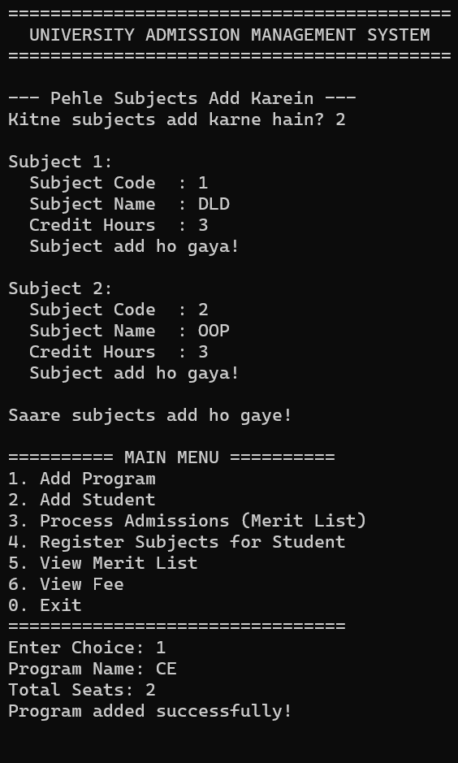
Output:
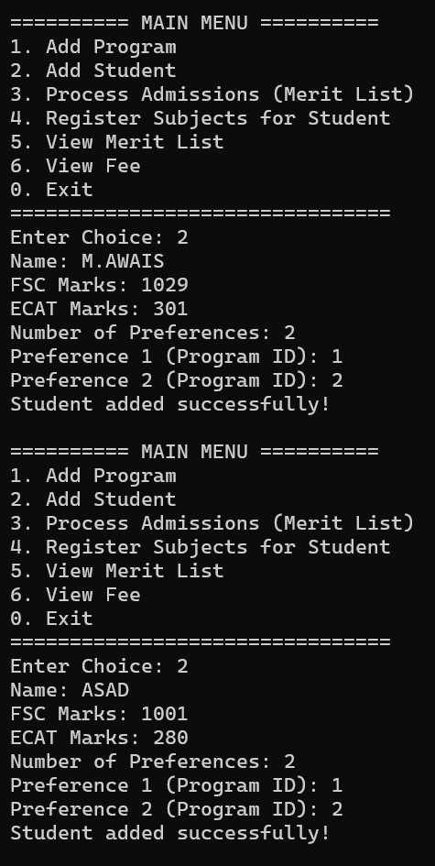

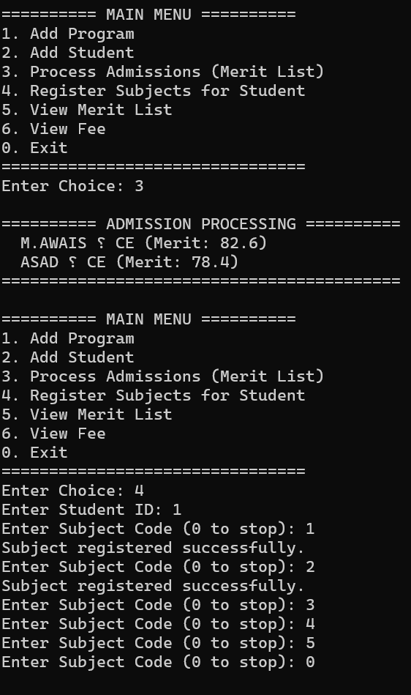
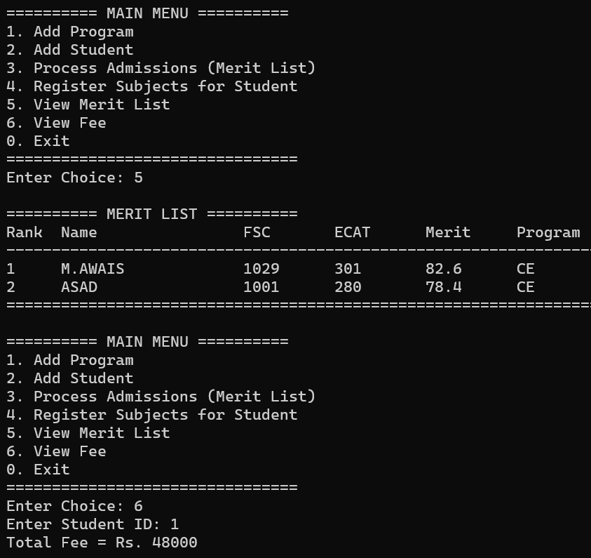
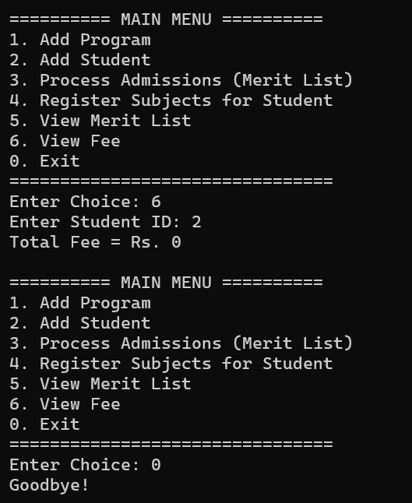
Conclusion:
- I learned how to implement 3-Tier Architecture by separating Presentation, Business Logic, and Data layers in a real C# project.
- I understood how to apply Object-Oriented Programming concepts like classes, objects, and methods to model real-world entities.
- I learned how to implement business rules such as merit calculation and seat allocation based on student preferences.
- I gained experience in managing in-memory data storage using static lists and passing data between different layers.
- This project improved my problem-solving skills and gave me confidence in building structured console-based C# applications.

