Urban Crime Intelligence and Records Management


A project report submitted as part of the coursework for Database Systems during the 2nd Semester, 2026.

Submitted By
Muhammad Awais 2025-BSCPE-136
Alim Anwar 2025-BSCPE-168

Supervised By
Dr. Bilal Ahmad

Spring 2026

B.Sc. Computer Engineering
Department of Electrical, Electronics & Telecom Engineering
University of Engineering and Technology Lahore, Faisalabad Campus
Chronic Kidney Disease Prediction System
Using SQL Database Design and Machine Learning

In this report, I explain the complete journey of building a Chronic Kidney Disease prediction system. I describe how I selected the dataset, designed the database, implemented SQL tables and queries, trained the machine learning model, and developed the frontend workflow.

1. Dataset Search and Selection Process
I started the project by searching for a real-world healthcare dataset that could support both database implementation and machine learning. I wanted a dataset that had a clear target variable, multiple medical attributes, and enough complexity to practice cleaning, normalization, SQL queries, and model training.

1.1 Search Process
- I checked Kaggle because it contains many public machine learning datasets.
- I checked the UCI Machine Learning Repository because it provides research-oriented datasets.
- I reviewed public GitHub repositories to understand how other students structured similar healthcare projects.
After comparing different options, I selected the Chronic Kidney Disease dataset. I selected it because it contains patient medical information and a clear classification label showing whether a patient has CKD or does not have CKD.

1.2 Dataset Overview
Item | Description
Dataset Name | Chronic Kidney Disease Dataset
Records | 400 patient records
Features | 25 medical and diagnostic attributes
Target Variable | classification: ckd / notckd
File Format | kidney_disease.csv

2. Database Design Process
After selecting the dataset, I started designing the database. My goal was not to keep all columns in one large table. I wanted to design a cleaner database structure where patient information, medical tests, medical conditions, and prediction results were separated logically.

2.1 Design Decisions
- I kept demographic and basic patient measurements in the patients table.
- I moved laboratory measurements such as blood glucose, blood urea, serum creatinine, hemoglobin, and cell counts into the medical_tests table.
- I stored condition-related categorical values such as hypertension, diabetes mellitus, appetite, pedal edema, and anemia in the medical_conditions table.
- I stored machine learning output in the predictions table so model results remained separate from original patient data.

2.2 Normalization
I normalized the database to reduce duplicate information and to maintain data integrity. The design follows a clean relational structure where patient_id works as the main link between tables.

3. Tables and Relationships
I designed four main tables for the project. Each table has a clear role, and each child table connects back to the patients table using patient_id as a foreign key.
Table | Purpose | Key Relationship
patients | Stores basic patient data such as age, blood pressure, specific gravity, albumin, and sugar. | Primary table
medical_tests | Stores numerical laboratory test results. | Many records can link to one patient
medical_conditions | Stores categorical disease indicators and symptoms. | Many records can link to one patient
predictions | Stores model prediction output and model name. | Prediction belongs to a patient

3.1 Relationship Summary
The patients table is the parent table. The medical_tests, medical_conditions, and predictions tables use patient_id as a foreign key. This structure makes it possible to join all related information whenever I need a complete patient view.

4. ER Diagram
The ER diagram is included as a placeholder so the final diagram image can be inserted later. The diagram should show patients as the central entity and the other three tables connected through patient_id.
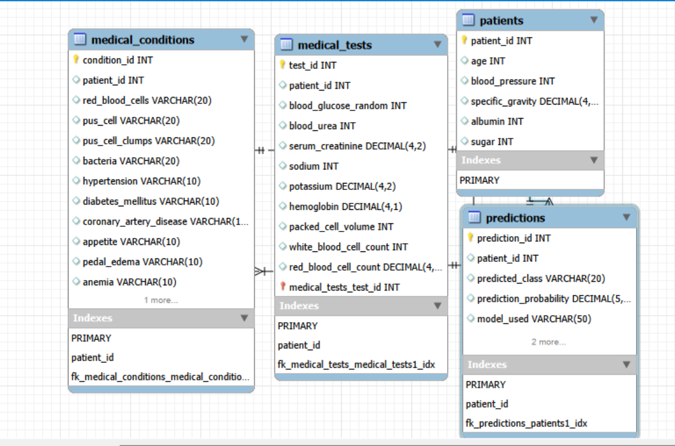

In the ER diagram, patients should be shown as the main table. The medical_tests, medical_conditions, and predictions tables should be linked to patients through one-to-many relationships. This gives the database a clear and understandable structure.

Relationship:

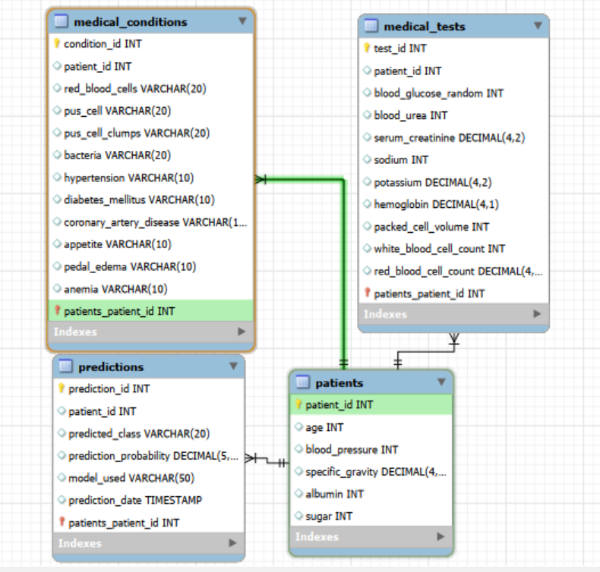

5. SQL Database Implementation
After completing the database design, I implemented the schema in MySQL. I first created the database, then created each table with primary keys and foreign keys. I kept the SQL formatting clean so that every command can be copied and executed easily.

5.1 Database and Patients Table
CREATE DATABASE ckd_system;
USE ckd_system;

CREATE TABLE patients (
patient_id INT PRIMARY KEY AUTO_INCREMENT,
age INT,
blood_pressure INT,
specific_gravity DECIMAL(4,3),
albumin INT,
sugar INT
);

CREATE TABLE medical_tests (

5.2 Medical Tests Table
test_id INT PRIMARY KEY AUTO_INCREMENT,
patient_id INT,
blood_glucose_random INT,
blood_urea INT,
serum_creatinine DECIMAL(4,2),
sodium INT,
potassium DECIMAL(4,2),
hemoglobin DECIMAL(4,1),
packed_cell_volume INT,
white_blood_cell_count INT,
red_blood_cell_count DECIMAL(4,1),
FOREIGN KEY (patient_id) REFERENCES patients(patient_id)
);

CREATE TABLE medical_conditions (
condition_id INT PRIMARY KEY AUTO_INCREMENT,

5. SQL Database Implementation Continued

5.3 Medical Conditions Table
patient_id INT,
red_blood_cells VARCHAR(20),
pus_cell VARCHAR(20),
pus_cell_clumps VARCHAR(20),
bacteria VARCHAR(20),
hypertension VARCHAR(10),
diabetes_mellitus VARCHAR(10),
coronary_artery_disease VARCHAR(10),
appetite VARCHAR(10),
pedal_edema VARCHAR(10),
anemia VARCHAR(10),
FOREIGN KEY (patient_id) REFERENCES patients(patient_id)
);

CREATE TABLE predictions (
prediction_id INT PRIMARY KEY AUTO_INCREMENT,
patient_id INT,

5.4 Predictions Table
predicted_class VARCHAR(20),
prediction_probability DECIMAL(5,2),
model_used VARCHAR(50),
prediction_date TIMESTAMP DEFAULT CURRENT_TIMESTAMP,
FOREIGN KEY (patient_id) REFERENCES patients(patient_id)
);

This implementation keeps patient data, medical test data, condition data, and prediction data separate. Because of the foreign key relationships, the database can protect referential integrity and avoid disconnected records.

6. SQL Queries
After creating the tables, I wrote SQL queries to retrieve and analyze the data. These queries helped me test joins, aggregation, filtering, insertion, updating, and deletion.
-- 1. Display all patients
SELECT * FROM patients;

-- 2. Count CKD and non-CKD predictions
SELECT predicted_class, COUNT(*) AS total_count
FROM predictions
GROUP BY predicted_class;

-- 3. Find high-risk patients with hypertension and CKD
SELECT p.patient_id, p.age, p.blood_pressure, mc.hypertension, pr.predicted_class
FROM patients p
JOIN medical_conditions mc ON p.patient_id = mc.patient_id
JOIN predictions pr ON p.patient_id = pr.patient_id
WHERE mc.hypertension = 'yes' AND pr.predicted_class = 'ckd';

-- 4. Average hemoglobin by CKD status
SELECT pr.predicted_class, AVG(mt.hemoglobin) AS avg_hemoglobin
FROM predictions pr
JOIN medical_tests mt ON pr.patient_id = mt.patient_id
GROUP BY pr.predicted_class;

-- 5. Patients with diabetes and CKD
SELECT p.patient_id, p.age, mc.diabetes_mellitus, mt.blood_glucose_random, pr.predicted_class
FROM patients p
JOIN medical_conditions mc ON p.patient_id = mc.patient_id
JOIN medical_tests mt ON p.patient_id = mt.patient_id
JOIN predictions pr ON p.patient_id = pr.patient_id
WHERE mc.diabetes_mellitus = 'yes' AND pr.predicted_class = 'ckd';

6. SQL Queries Continued

-- 6. Top 10 critical CKD patients by serum creatinine
SELECT p.patient_id, p.age, mt.serum_creatinine, mt.blood_urea, pr.predicted_class
FROM patients p
JOIN medical_tests mt ON p.patient_id = mt.patient_id
JOIN predictions pr ON p.patient_id = pr.patient_id
WHERE pr.predicted_class = 'ckd'
ORDER BY mt.serum_creatinine DESC
LIMIT 10;

-- 7. Insert a new patient record
INSERT INTO patients (age, blood_pressure, specific_gravity, albumin, sugar)
VALUES (45, 80, 1.020, 1, 0);
INSERT INTO medical_tests (patient_id, blood_glucose_random, blood_urea, serum_creatinine, hemoglobin)
VALUES (LAST_INSERT_ID(), 121, 36, 1.2, 15.4);

-- 8. Update a prediction record
UPDATE predictions
SET predicted_class = 'notckd', model_used = 'Random Forest'
WHERE patient_id = 10;

-- 9. Delete a patient record safely
DELETE FROM predictions WHERE patient_id = 5;
DELETE FROM medical_tests WHERE patient_id = 5;
DELETE FROM medical_conditions WHERE patient_id = 5;
DELETE FROM patients WHERE patient_id = 5;

These queries were useful because they connected the database design with the project analysis. The join queries helped me combine patient information with conditions, laboratory values, and prediction results.

7. Machine Learning Model Training
After completing the SQL part, I implemented the machine learning pipeline in Python. I used Pandas for loading and cleaning data, Matplotlib and Seaborn for visualization, Scikit-Learn for model training, and Joblib for saving the final model.

7.1 Random Forest Training Code
# ================== 1. IMPORT LIBRARIES ==================
import pandas as pd
import numpy as np
import matplotlib.pyplot as plt
import seaborn as sns
import joblib

from sklearn.model_selection import train_test_split
from sklearn.tree import DecisionTreeClassifier
from sklearn.linear_model import LogisticRegression
from sklearn.ensemble import RandomForestClassifier
from sklearn.metrics import accuracy_score, classification_report, confusion_matrix

# ================== 2. LOAD DATASET ==================
df = pd.read_csv('kidney_disease.csv')
df = df.drop(columns=['id'])
print(df.head())

# ================== 3. CLEAN TEXT FORMATTING ==================
df['classification'] = df['classification'].str.strip().str.replace('\t', '')
df['dm'] = df['dm'].astype(str).str.strip().str.replace('\t', '')
df['cad'] = df['cad'].astype(str).str.strip().str.replace('\t', '')

# ================== 4. CONVERT NUMERIC TEXT COLUMNS ==================
numeric_text_cols = ['pcv', 'wc', 'rc']

7. Machine Learning Model Training Continued
for col in numeric_text_cols:
df[col] = pd.to_numeric(df[col], errors='coerce')

# ================== 5. HANDLE MISSING VALUES ==================
for col in df.columns:
if df[col].dtype != 'object':
df[col] = df[col].fillna(df[col].median())
else:
mode_value = df[col].mode()
if len(mode_value) > 0:
df[col] = df[col].fillna(mode_value[0])
else:
df[col] = df[col].fillna('Unknown')

# ================== 6. DATA VISUALIZATION ==================
plt.figure(figsize=(7, 4))
sns.histplot(df['age'], kde=True)
plt.title('Age Distribution')
plt.show()

plt.figure(figsize=(6, 4))
sns.countplot(data=df, x='classification')
plt.title('CKD Classification Distribution')
plt.show()

# ================== 7. ENCODE CATEGORICAL DATA ==================
text_cols = df.select_dtypes(include=['object']).columns
text_cols = text_cols.drop('classification')
df_encoded = pd.get_dummies(df, columns=text_cols, drop_first=True)

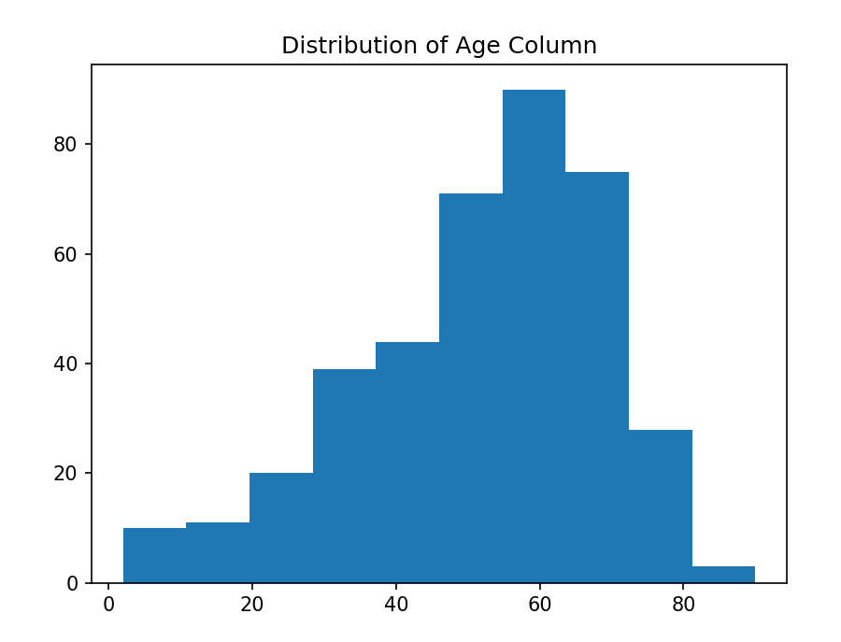

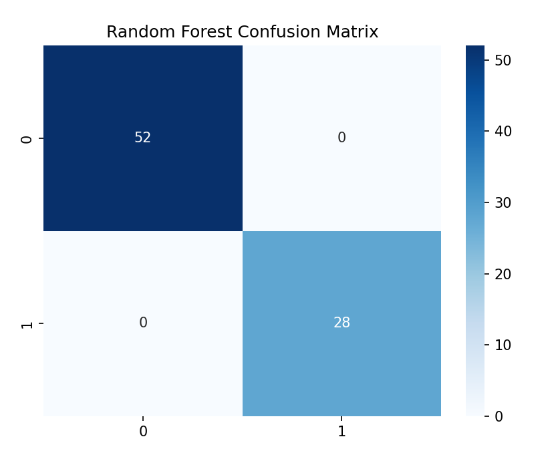

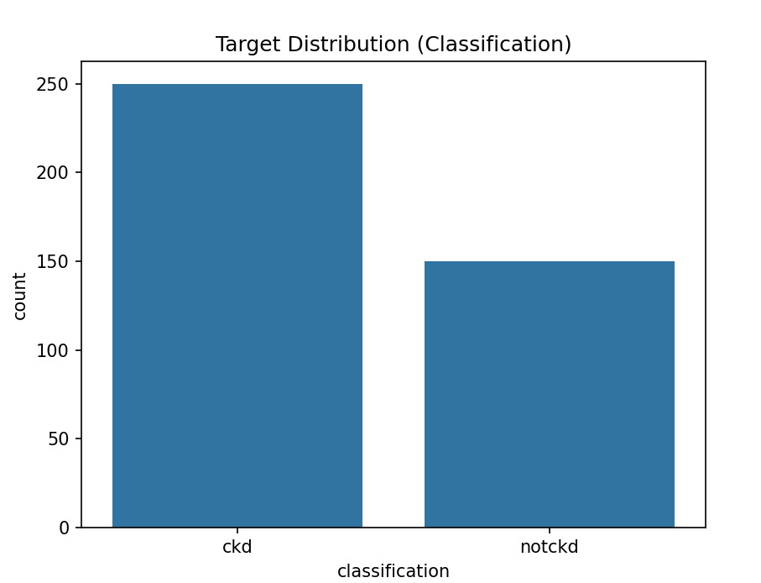

7. Machine Learning Model Training Continued
# ================== 8. FEATURES AND TARGET ==================
X = df_encoded.drop(columns=['classification'])
y = df_encoded['classification']

# ================== 9. TRAIN TEST SPLIT ==================
X_train, X_test, y_train, y_test = train_test_split(
X, y, test_size=0.20, random_state=42, stratify=y
)

# ================== 10. TRAIN MODELS ==================
dt = DecisionTreeClassifier(random_state=42)
dt.fit(X_train, y_train)

lr = LogisticRegression(max_iter=1000)
lr.fit(X_train, y_train)

rf = RandomForestClassifier(n_estimators=100, random_state=42)
rf.fit(X_train, y_train)

# ================== 11. SAVE RANDOM FOREST MODEL ==================
joblib.dump(rf, 'kidney_disease_model.pkl')
print('Model saved as kidney_disease_model.pkl')

# ================== 12. LOAD MODEL AND PREDICT ==================
loaded_rf = joblib.load('kidney_disease_model.pkl')
y_pred = loaded_rf.predict(X_test)

# ================== 13. MODEL EVALUATION ==================
accuracy = accuracy_score(y_test, y_pred)
print('Random Forest Accuracy:', accuracy)
print(classification_report(y_test, y_pred))

7. Machine Learning Model Training Continued
cm = confusion_matrix(y_test, y_pred)
plt.figure(figsize=(6, 4))
sns.heatmap(cm, annot=True, fmt='d', cmap='Blues')
plt.title('Random Forest Confusion Matrix')
plt.xlabel('Predicted')
plt.ylabel('Actual')
plt.show()

# ================== 14. FEATURE IMPORTANCE ==================
importance = pd.Series(rf.feature_importances_, index=X.columns)
importance = importance.sort_values(ascending=False).head(10)
plt.figure(figsize=(8, 5))
sns.barplot(x=importance.values, y=importance.index)
plt.title('Top 10 Important Features')
plt.show()

Inference File:
import pandas as pd
import joblib

# --------------------------------------
# 1. Load Saved Model
# --------------------------------------
model = joblib.load(r"kidney_disease_model.pkl")

print("Model loaded successfully.")

# --------------------------------------
# 2. Define Input Data (Single Patient)
# --------------------------------------
input_data = {
"age": 45,
"bp": 80,
"sg": 1.020,
"al": 1,
"su": 0,
"bgr": 121,
"bu": 36,
"sc": 1.2,
"sod": 137,
"pot": 4.5,
"hemo": 15.4,
"pcv": 44,
"wc": 7800,
"rc": 5.2,
# Categorical columns (use exact values from your dataset)
"rbc": "normal",
"pc": "normal",
"pcc": "notpresent",
"ba": "notpresent",
"htn": "no",
"dm": "no",
"cad": "no",
"appet": "good",
"pe": "no",
"ane": "no"
}

# --------------------------------------
# 3. Prepare DataFrame
# --------------------------------------
input_df = pd.DataFrame([input_data])

# --------------------------------------
# 4. Encode Categoricals (same as training)
# --------------------------------------
text_cols = input_df.select_dtypes(include=['object', 'category']).columns
input_df = pd.get_dummies(input_df, columns=text_cols, drop_first=True)

# --------------------------------------
# 5. Align Columns with Training Data
# --------------------------------------
# Save train columns during training to avoid mismatch:
# joblib.dump(list(X_train.columns), "train_columns.pkl")

# If you saved them, uncomment below:
# train_columns = joblib.load("train_columns.pkl")
# input_df = input_df.reindex(columns=train_columns, fill_value=0)

# Align columns with training
train_columns = joblib.load(r"C:\Users\AL HAMD TRADERS\OneDrive\Desktop\OEL ML MODEL TRAINING\train_columns.pkl")
input_df = input_df.reindex(columns=train_columns, fill_value=0)

# Predict
prediction = model.predict(input_df)
prediction_proba = model.predict_proba(input_df)

print("\nPrediction:", prediction[0])
print(f"Confidence: {max(prediction_proba[0]) * 100:.2f}%")

# --------------------------------------
# 7. Batch Inference from CSV (Optional)
# --------------------------------------
# Uncomment to run predictions on a full CSV file

# df = pd.read_csv("new_patients.csv")
# df = df.drop(columns=['id'], errors='ignore')
#
# # Clean same as training
# for col in ['dm', 'cad']:
# if col in df.columns and df[col].dtype == 'object':
# df[col] = df[col].str.strip().str.replace('\t', '')
# for col in ['pcv', 'wc', 'rc']:
# df[col] = pd.to_numeric(df[col], errors='coerce')
#
# # Fill missing values
# for col in df.columns:
# if pd.api.types.is_numeric_dtype(df[col]):
# df[col] = df[col].fillna(df[col].median())
# else:
# df[col] = df[col].fillna(df[col].mode()[0] if not df[col].mode().empty else "Unknown")
#
# # Encode
# text_cols = df.select_dtypes(include=['object', 'category']).columns
# df = pd.get_dummies(df, columns=text_cols, drop_first=True)
#
# # Align columns
# # df = df.reindex(columns=train_columns, fill_value=0)
#
# predictions = model.predict(df)
# df["prediction"] = predictions
# df.to_csv("kidney_predictions_output.csv", index=False)
# print("Batch predictions saved to kidney_predictions_output.csv")

Output:
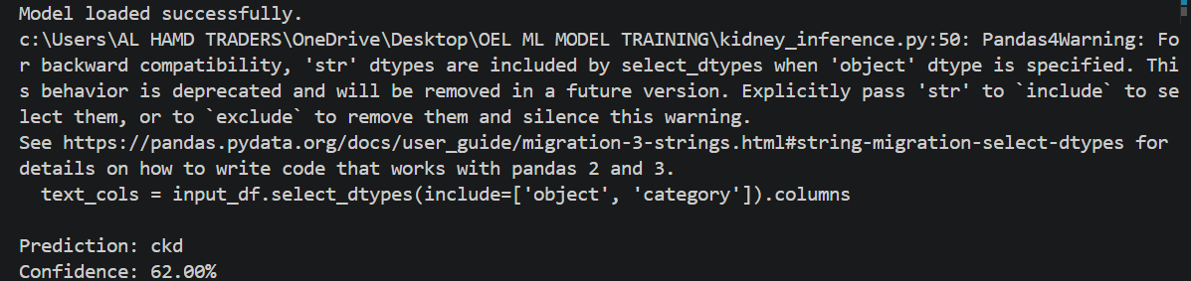

7.2 Model Evaluation Results
Metric | Result
Selected Model | Random Forest Classifier
Accuracy | Approximately 97.5%
Evaluation Tools | Accuracy score, classification report, confusion matrix
Saved Model | kidney_disease_model.pkl

7.3 Feature Importance
After training the Random Forest model, I analyzed feature importance to understand which attributes contributed most to CKD prediction.
Rank | Feature | Importance
1 | hemo (Hemoglobin) | 0.182
2 | sc (Serum Creatinine) | 0.145
3 | sg (Specific Gravity) | 0.122
4 | bgr (Blood Glucose Random) | 0.098
5 | bu (Blood Urea) | 0.091
6 | al (Albumin) | 0.078
7 | pcv (Packed Cell Volume) | 0.063
8 | rc (Red Blood Cell Count) | 0.051
9 | age | 0.047
10 | bp (Blood Pressure) | 0.032
This result showed me that hemoglobin, serum creatinine, specific gravity, blood glucose, and blood urea were highly useful in predicting CKD status.

8. Frontend Development
After training and saving the model, I planned the frontend part of the project. The frontend was designed so that a user can enter patient values, submit the form, and receive a CKD prediction result.

8.1 Frontend Features
- Input fields for age, blood pressure, specific gravity, albumin, sugar, blood glucose, serum creatinine, hemoglobin, and other required attributes.
- A prediction button that sends the entered values to the backend model logic.
- A result area that displays whether the patient is predicted as CKD or not CKD.
- A clear form layout so the user can enter medical values without confusion.
- Validation checks to reduce missing or invalid input values.
The frontend connects the machine learning model with the user. Without the frontend, the model would only be usable through code. With the frontend, the project becomes more practical and easier to demonstrate.
8.2 Frontend Screenshots
The following spaces are intentionally left blank so screenshots of the final frontend can be inserted later.
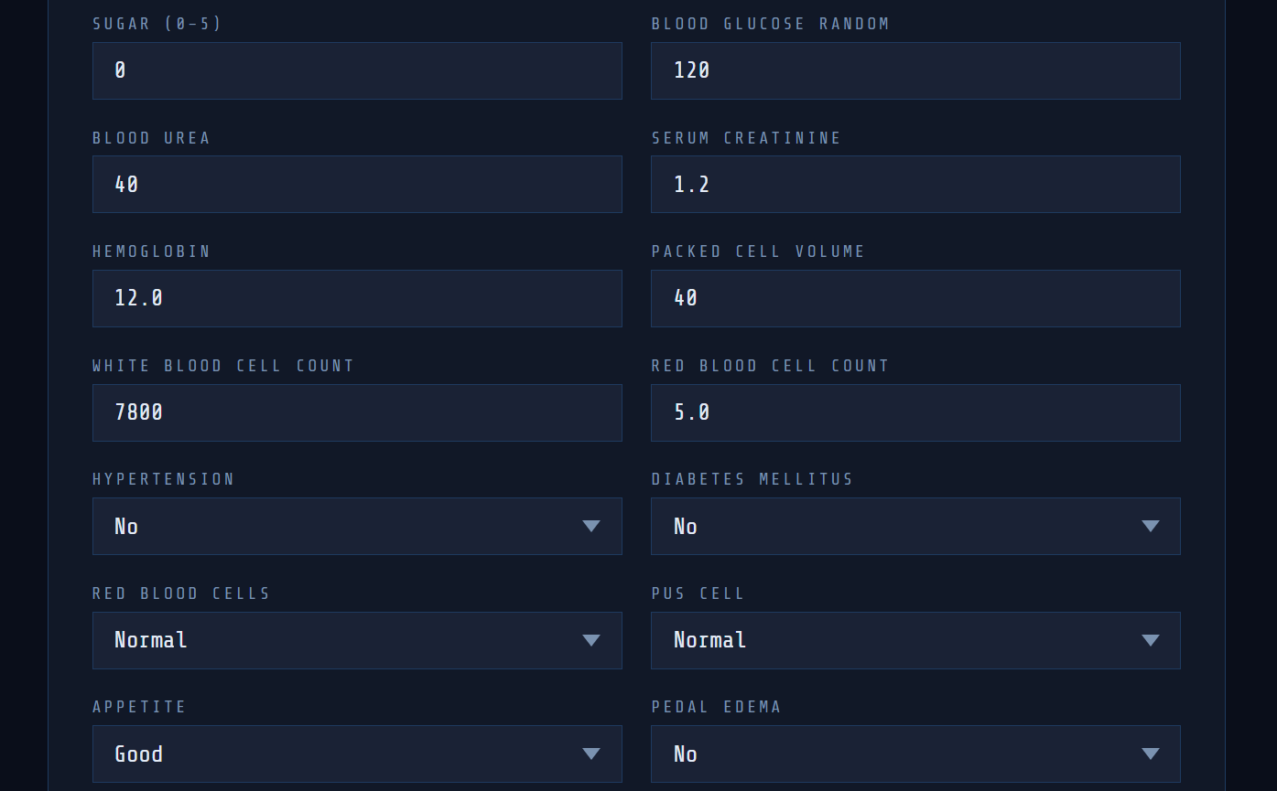
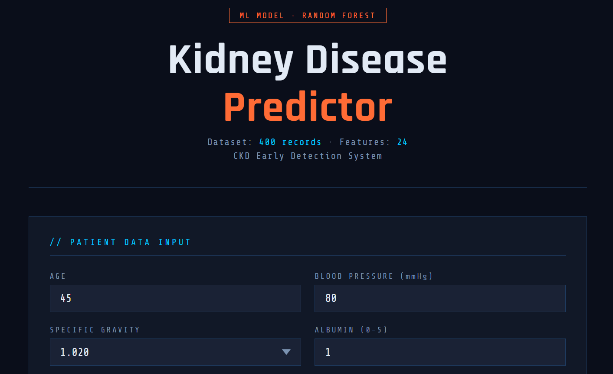

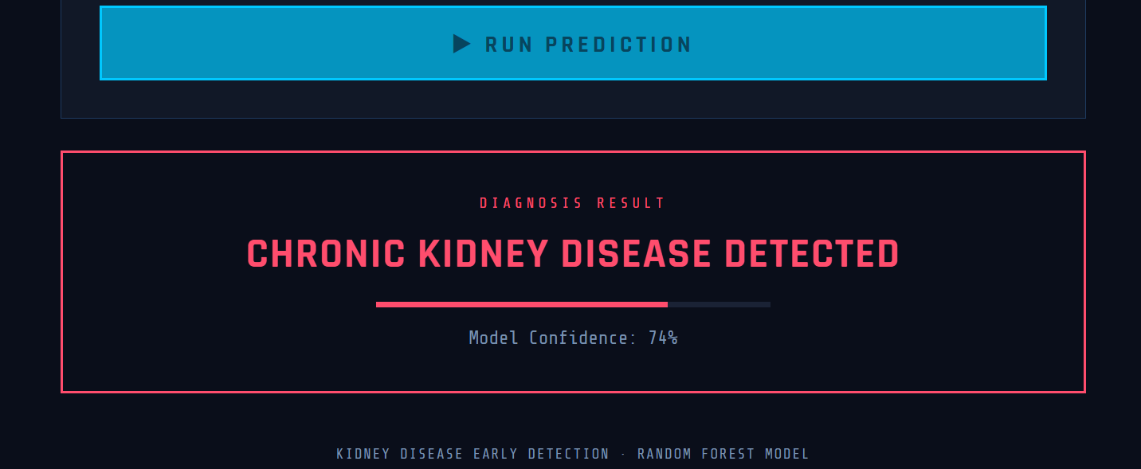

9. Challenges Faced and Solutions Applied

Challenge 1: Missing Values
The dataset contained missing numerical and categorical values. This created a problem because machine learning models cannot train correctly on empty values.

Solution Applied
I filled numerical missing values using the median because it is more stable when outliers exist. I filled categorical missing values using the mode because it represents the most common category.

Challenge 2: Text Formatting Issues
Some columns contained extra spaces and tab characters. Because of this, values such as ckd and ckd with a tab were treated as different labels.

Solution Applied
I used string cleaning operations such as strip() and replace() to remove unnecessary spaces and tab characters before encoding and training.

9. Challenges Faced and Solutions Applied Continued

Challenge 3: Categorical Encoding
The dataset contained many categorical columns. The machine learning model required numerical input, so direct training was not possible.

Solution Applied
I used one-hot encoding with pd.get_dummies() to convert categorical columns into numerical columns.

Challenge 4: Model Selection
I trained Decision Tree, Logistic Regression, and Random Forest models. The challenge was selecting the best final model.

Solution Applied
I compared the models using accuracy and evaluation reports. Random Forest gave the best result and handled the dataset well, so I selected it as the final model.

Challenge 5: Foreign Key Errors
While inserting database records, foreign key constraints required patient records to exist before inserting related test or condition records.

Solution Applied
I inserted records into the patients table first and then used the generated patient_id in child tables. This maintained referential integrity.

10. Overall Project Journey
This project gave me a complete experience of building a database-connected machine learning application. I started with dataset selection, then moved toward database design and SQL implementation. After that, I trained the machine learning models and selected Random Forest as the final model.
I learned that a good project is not only about training a model. It also requires clean data, a properly designed database, meaningful SQL queries, a clear frontend, and proper testing. Each part depends on the other parts.
The SQL part helped me understand how medical records can be stored in a structured way. The machine learning part helped me understand how patterns in patient data can be used for prediction. The frontend part helped me connect the technical backend with a usable interface.

10.1 Final Learning
- I learned how to clean real-world healthcare data.
- I learned how to design normalized SQL tables.
- I learned how to write joins, aggregation queries, insert, update, and delete statements.
- I learned how to train and evaluate multiple machine learning classifiers.
- I learned how to save a trained model for later use.

11. Testing and Verification
To verify the project, I checked each major part separately. I verified that the database tables were created correctly, SQL queries returned meaningful results, the machine learning model trained successfully, and the frontend workflow matched the required prediction process.

11.1 Suggested Tests
- Run all CREATE TABLE statements and confirm that foreign keys are created without errors.
- Insert sample patient records and confirm that child-table records use the correct patient_id.
- Run all SELECT and JOIN queries and compare returned rows with expected patient data.
- Run the Python training script and confirm that kidney_disease_model.pkl is created.
- Check accuracy score, classification report, and confusion matrix after model training.
- Enter sample values in the frontend and confirm that a prediction is displayed.

11.2 Final Status
The report ends with testing and verification because the inference file section has been intentionally removed. The final document now contains only the lab report content, SQL implementation, SQL queries, Random Forest training code, frontend placeholders, challenges, solutions, journey, and tests.

