# Name: Muhammad Bin Nasir

# Reg no: 220201012

**Task 1:**

**Code:**

#include <stdio.h>

#include <stdlib.h>

#include <string.h>

#include <errno.h>

int main(int argc, char *argv[], char *envp[]) {

printf("Program Name: %s\n", argv[0]);

if (argc != 2) {

fprintf(stderr, "Usage: %s <filename>\n", argv[0]);

return 1;

}

printf("Argument Received: %s\n", argv[1]);

// Attempt to open the file

FILE *file = fopen(argv[1], "r");

if (file == NULL) {

perror("Error opening file");

} else {

printf("File opened successfully.\n");

fclose(file);

}

printf("\nEnvironment Variables:\n");

printf("PATH: %s\n", getenv("PATH"));

printf("HOME: %s\n", getenv("HOME"));

printf("USER: %s\n", getenv("USER"));

return 0;

}

**Output:**

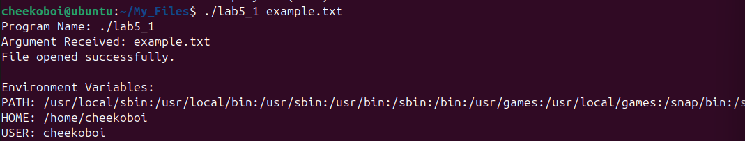

**Task 2:**

**Code:**

#include <stdio.h>

#include <stdlib.h>

#include <string.h>

#define MAX_EMPLOYEES 10

struct Employee {

char name[50];

int id;

float salary;

};

int main(int argc, char *argv[]) {

if (argc != 2) {

fprintf(stderr, "Usage: %s <number_of_employees>\n", argv[0]);

return 1;

}

int num_employees = atoi(argv[1]);

if (num_employees < 1 || num_employees > MAX_EMPLOYEES) {

fprintf(stderr, "Error: Enter a valid number of employees (1-10).\n");

return 1;

}

struct Employee employees[MAX_EMPLOYEES];

// Input details for each employee

for (int i = 0; i < num_employees; i++) {

printf("Enter details for Employee %d:\n", i + 1);

printf("Name: ");

scanf(" %[^\n]", employees[i].name);

printf("ID: ");

scanf("%d", &employees[i].id);

printf("Salary: ");

scanf("%f", &employees[i].salary);

}

printf("\nEmployee Details:\n");

for (int i = 0; i < num_employees; i++) {

printf("Employee %d:\n", i + 1);

printf(" Name: %s\n", employees[i].name);

printf(" ID: %d\n", employees[i].id);

printf(" Salary: %.2f\n", employees[i].salary);

}

printf("\nEnvironment Variables:\n");

printf("USER: %s\n", getenv("USER"));

printf("HOME: %s\n", getenv("HOME"));

return 0;

}

**Output:**

