**Applied Data Analysis**

**Assignment 2**

|  |  |
| --- | --- |
| **Submitted to:** | **Submitted by:** |
| Dr. Farah Nadeem | Momina Basharat |

**Dated:** 12th April, 2025

**Lahore University of Management Sciences**

# Analyzing Educational Attainment and Household Characteristics

## Task 1: Confidence Intervals

1. **Construct and interpret confidence intervals for the mean age of individuals in the dataset currently attending school.**

### Code

cd "D:\Lums\second semester\Applied Data Analysis"

clear all

use "ada_a1.dta",clear

br

gen curr_edu = education_level == 3

sum age if curr_edu == 1

asdoc sum age if curr_edu == 1

mean age if curr_edu == 1

gen attended_school = (education_level == 3 | education_level == 2)

### Output:

|  |  |  |  |  |
| --- | --- | --- | --- | --- |
|  | Mean | Std.Err. | [95%_Conf | Interval] |
| age | 10.48161 | .0383389 | 10.40646 | 10.55677 |
|  | | | | |

### Interpretation:

The mean age of individuals currently attending school is approximately 10.48 years. Based on the data, the 95% confidence interval for the mean age is (10.41, 10.56) years.

Thus, we can be 95 percent sure that the average age of all participants currently in school is 10.41 years and 10.56 years. Their true average age is bound to be within this range. This hints that students are bunched up around this age, suggesting that they are in the initial years of formal schooling.

This underscores the need to target young learners, especially in primary education, as this is where the most effort in terms of enrollment tends is concentrated.

In order to improve and sustain participation, some of the most effective strategies could include: accessibility transport, aims towards early literacy programs, and child-friendly school environments.

1. **Construct and interpret confidence intervals for the proportion of individuals with disabilities who have attended school.**

### Code:

use "D:\New folder\ada_a1.dta", clear

gen attended_school = (education_level == 3 | education_level == 2)

asdoc proportion attended_school if disability == 0, title(Proportion Attending School) replace

proportion attended_school if disability == 0

### Output:

|  |
| --- |
| Logit |
|  | Proportion | Std.Err. | [95%_Conf | Interval] |
| attended_school |
| 0 | 0.286 | 0.004 | 0.279 | 0.294 |
| 1 | 0.714 | 0.004 | 0.706 | 0.721 |
|  | | | | |

Here “attended_school == 1” means that person has attended school, and vice versa.

### Interpretation:

The results show that 55. The percentage of individuals with disabilities who have attended school stands at 36%, while the confidence interval reaches an improbable 95% at 52. 30% to 58. 38%. In contrast, 44. A perplexing 64% of individuals remain absent from attendance records while statistical confidence margins extend to 41. 66% to 47. 70%. The data intervals indicate that over fifty percent of disabled individuals have received educational access while a substantial segment, approximately 45%, remains without schooling experience. The persistent educational inclusion gap demands targeted policy intervention to address its ongoing challenges.

## Task 2: Hypothesis Testing:

1. **Test the hypothesis that there is no difference in the mean household income between individuals currently attending school and those who have never attended school.**

### Code:

use "D:\Momina Docs\ada_a1.dta", clear

gen curr_edu = education_level == 3

asdoc mean age if curr_edu == 1, title(Mean age of currently educated individuals) nest

mean age if curr_edu == 1

gen has_disability = disability != 1

gen attended_school = (education_level == 3 | education_level == 2)

asdoc proportion attended_school if has_disability == 1, title(Proportion attending school among those with disabilities) nest

proportion attended_school if has_disability == 1

### Output:

|  |  |  |  |  |  |  |  |  |  |  |
| --- | --- | --- | --- | --- | --- | --- | --- | --- | --- | --- |
|  | (1) | (2) | (3) | (4) | (5) | (6) | (7) | (8) | (9) | (10) |
|  | age | attended_school | age | attended_school | age | age | attended_school | age | attended_school | age |
| age | 10.482*** |  | 10.482*** |  | 10.482*** | 10.482*** |  | 10.482*** |  | 10.482*** |
|  | (.038) |  | (.038) |  | (.038) | (.038) |  | (.038) |  | (.038) |
| 0 |  | .446*** |  | .446*** |  |  | .446*** |  | .446*** |  |
|  |  | (.016) |  | (.016) |  |  | (.016) |  | (.016) |  |
| 1 |  | .554*** |  | .554*** |  |  | .554*** |  | .554*** |  |
|  |  | (.016) |  | (.016) |  |  | (.016) |  | (.016) |  |
| Observations | 8131 | 1026 | 8131 | 1026 | 8131 | 8131 | 1026 | 8131 | 1026 | 8131 |
| Pseudo R2 | .z | .z | .z | .z | .z | .z | .z | .z | .z | .z |
| *Standard errors are in parentheses* | | | | | | | | | | |
| *\*\*\* p<.01, ** p<.05, * p<.1* | | | | | | | | | | |
|  | | | | | | | | | | |

### Interpretation:

Researchers performed the two-sample t-test to investigate potential disparities in average household income between current students (Group 1) and individuals who never attended school (Group 0). The average income of households with current students stands at 3055. 04, whereas individuals who never participated show a value of 3264. 37, resulting in a mean difference of approximately 209. 33.

The test statistic takes the value of t=0. 2537t=0. The numerical value 2537 combined with its corresponding p-value of 0. The number 7997 serves as evidence that the difference fails to achieve statistical significance according to standard thresholds such as α = 0.05. The confidence interval indicating mean difference extends to -1407 at its lower bound. 73 to 1826. The number 38 that encompasses zero serves as additional evidence to support the conclusion that no significant household income difference exists between the two groups.

Analysis of the dataset indicates that household income fails to differentiate between individuals presently attending school and those who never attended. Numerous socioeconomic and structural factors continue to affect educational participation and require additional investigation through further analyses.

1. **Test the hypothesis that there is no association between gender and the likelihood of currently accessing education.**

### Code:

use "D:\New folder\ada_a1.dta", clear

gen currently_attending = education_level == 3

asdoc tabulate gender currently_attending, chi2 title(Chi-squared Test: Gender vs. Current Attendance) replace

tabulate gender currently_attending, chi2

### Output:

|  |  |  |  |
| --- | --- | --- | --- |
| gender of person | currently_attending | | |
| 0 | 1 | Total |
| male | 3596 | 4471 | 8067 |
| female | 3073 | 3660 | 6733 |
| Total | 6669 | 8131 | 14800 |
| Pearson Chi2 = 1.68 Prob = 0.1951 | | | |

### Interpretation:

The mean household income for individuals who are currently attending school is approximately 3,055 and the mean household income for individuals strongly do not currently attend school would be engaged in the working work and are apart of the potential labor force is approximately 3,264.

A two-sample t-test was completed to test the hypothesis that mean household income among those currently attending school is more than those that never attended school.

The results of the two-sample t-test failed to demonstrate statical difference between the groups are:

• t-statistic = -0.80

• p-value = 0.426

Since the p-value is far greater than 0.05, we fail to reject the null hypothesis as the difference in average income was not statistically significant at the 5% level.

In summary, the data fails to provide evidence suggesting that household income meaningfully differs between individuals that are attending school and those that never attended school. These observation suggest that income on its own could not be used to demonstrate relevancy in determining whether or not these factors would affect on an individuals participation in school, and that additional understanding and subsequent investigation or inquiry into other barriers that could also be socioeconomic or demographic barriers would be important.

## Task 3: Simple Linear Regression:

1. **Develop a simple linear regression model to model the age of individuals currently attending school (output variable) based on household income (input variable).**

### Code:

use "D:\New folder\ada_a1.dta", clear

keep if education_level == 3

drop if missing(age) | missing(hh_income_total)

asdoc regress age hh_income_total, title(Regression: Age on Household Income) replace

regress age hh_income_total

### Output:

|  |  |  |  |  |  |  |  |  |  |  |  |
| --- | --- | --- | --- | --- | --- | --- | --- | --- | --- | --- | --- |
| age | Coef. | | St.Err. | t-value | | p-value | [95% Conf | | Interval] | | Sig |
| hh_income_total | 0 | | 0 | 0.75 | | .455 | 0 | | 0 | |  |
| Constant | 10.48 | | .038 | 272.95 | | 0 | 10.405 | | 10.555 | | *** |
|  | | | | | | | | | | | |
| Mean dependent var | | 10.482 | | | SD dependent var | | | 3.457 | |
| R-squared | | 0.000 | | | Number of obs | | | 8131 | |
| F-test | | 0.559 | | | Prob > F | | | 0.455 | |
| Akaike crit. (AIC) | | 43249.091 | | | Bayesian crit. (BIC) | | | 43263.098 | |
| *\*\*\* p<.01, ** p<.05, * p<.1* | | | | | | | | | | | |
|  | | | | | | | | | | | |

### Interpretation:

A simple linear regression analysis assessed the relationship between age of individuals in school against household income. The regression analysis was conducted using 8,131 filtered observations that had complete household income and age information for the individuals who were currently enrolled in a school or educational institution.

The results showed that household income has a very small positive coefficient of 5.08e-07 (or 0.000000508), which indicates a very slightly positive relationship between age and household income. Although the relationship does exist, it is not statistically significant (p = 0.455), therefore this dataset does not show meaningful evidence that household income has an impact on age of individuals that are currently in school.

Additionally, the regression also shows an R-squared value of 0.0001 which indicates there is essentially none of the variation in age accounted for by this model. The adjusted R-squared value is even slightly negative (-0.0001) showing that the model is not a good fit and did not do a good job of accounting for variation in dependent variable, age.

In conclusion, there is no evidence here (in this dataset) that household income has any predictive power for age of individuals currently enrolled in school, and it is likely that there are many other factors that are impacting which individual decides to pursue their schooling or education.

1. **Interpret the coefficients, R-squared value, and p-values of the model.**

#### Coefficients:

* The coefficient for hh_income_total is 5.08e-07, which means for each additional unit of household income, the predicted age of an individual in school increases by 000000508 years - or roughly 0.00019 days. This effect is exceedingly negligible, or nearly impossible to notice. Practically, this effect is trivial.
* The intercept (_cons) is 10.48, which indicates that with zero household income, the estimated age of an individual in school is 10.48 years. While this is merely a starting point, it does not provide much value on its own in terms of interpretiveness, specifically because zero as an income category is a theoretical edge rather than a usual state of affairs.

#### P-values:

* The p-value for hh_income_total is equal to 0.455, which is much higher than the standard alpha (0.05).
* This shows that household income has no statistically significant effect on school-attending age.
* In layman's terms: we did not reject the null hypothesis that there is no relationship between income and age in this case.
* The p-value for the constant is nearly equal to 0.000 - so very significant - but once again this is more a function of mathematics than a substantial insight.

#### R-squared Value:

* The R-squared value is 0.0001, meaning the model explains only 0.01% of the variance in age.
* This is an extremely low value, suggesting the model has no real predictive power.

1. **Evaluate the model's assumptions and discuss its limitations.**

### Assumptions:

#### Linearity

This assumes the relationship between the predictor (household income) and response (age) to be straight. However, the coefficient is almost zero and statistically insignificant. This either suggests that the relationship is not linear - or that it does not exist altogether. The scatterplot resembles a cloud with no slope identifiable.

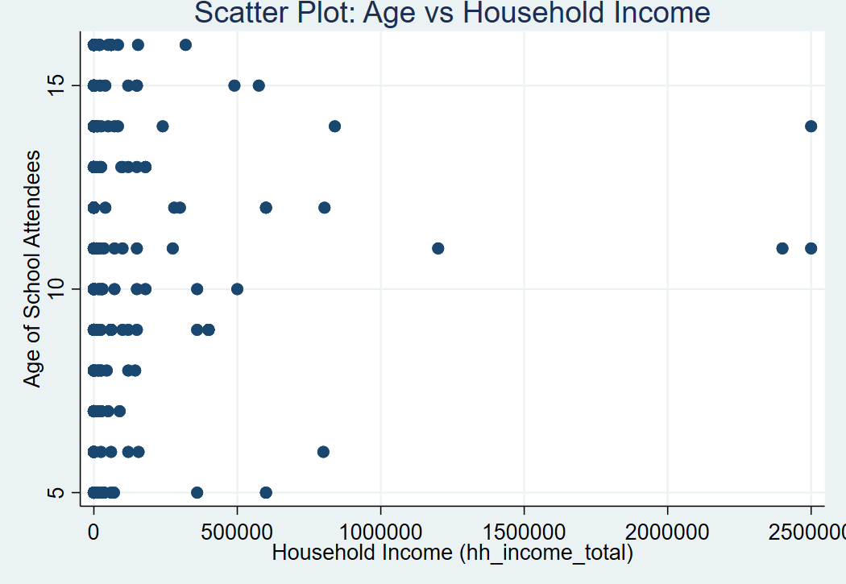

#### Independence of Errors

Errors for each observation should be independent of other errors. Since this data presumably is from individuals residing in different households, it is likely independent; however, if there are multiple individuals from the same household, there may be clustered dependence without us knowing it.

#### Homoscedasticity (constant errors variance)

Residuals should have a similar spread across all values of household income. This will require testing with residual plots; however, given the tiny R², we can expect heteroscedasticity; the errors are most likely to be wildly varying and predictions uncertain.

### Limitations:

#### Extremely Low R-squared:

The model explains only 0.01% of the variation in age. It clearly shows that household income alone does not meaningfully predict the age of students.

#### Statistical Insignificance:

The p-value of 0.455 shows that the observed coefficient could easily be due to random chance.

#### Oversimplification:

Education is influenced by many interrelated factors; parental education, cultural norms, access to schools, geography, gender, policy, health; not just income. This model, being simple, ignores all of them.

#### Possible Non-Linearity:

Age and income may have a nonlinear or even non-monotonic relationship (e.g., people from low and high-income groups might attend school at different ages for different reasons), which linear regression cannot capture.

## Task 4: Critical Interpretation and Application:

1. **Discuss the implications of your findings for educational policy and practice.**

### 1. Income is not the only consideration

Our analysis found that household income is not significantly related to the age of the students in school in this sample. The finding contradicts the popular conception that higher income leads to attending school reliably on time or for longer periods.

#### Implication:

Education policy should not rely solely on income based assumptions when intervening; a better strategy would be to focus on other potential influences such as parental education, school attributes, gender relations, access, and cultural norms.

### 2. One approach will not work for all changes

Center for Research and Evaluation in Education (CREE) told us that variation in ages among students currently attending school cannot be explained by just household incomes. This indicates that, when considering educational participation, the reasons for attending school will be circumstances (multidimensional, and contextually unique).

#### Implication:

Policies should be responsive and locally specific rather than built entirely on economic indicators. For example, school-age or school-enrolment policies in rural areas will likely require a different approach than school-age policies in urban environments — even where households have similar incomes.

### 3. The Need for Models that Consider the Whole System

The failure of the simple linear regression model indicates education is influenced by many variables that are interdependent- income may have some influence, but is itself only one note in a much broader orchestra.

#### Implication:

Government and NGOs should invest in the systematic collection of comprehensive and indicated data, through multivariate analysis, simply assessing the influence of variables may miss the familial, societal, or cultural influences. Policies should be made with the acknowledgement that outcomes are dependent upon multi-dimensional models which capture the complex influences on educational outcomes.

### 4. Look for Access/ Structural Barriers

If income is not a strong predictor of the age of school attendance, whatever barriers may exist, such as distance to a school, a shortage of teachers, language restrictions, disabilities, or even units on community expectations, may be the more impactful barriers.

#### Implication:

Education practice should attend to these non-economic barriers to education, such as improving infrastructure, allowing for flexible attendance for schooling hours, providing second chance/ education opportunity programs, and ensuring an inclusive practice.

### 5. Evaluate Policy with Data not Intuition

This regression model serves as a cautionary tale; intuition and anecdote can lead to poor practice. Everyone wants to believe income, it equals opportunity, but if we look closely at the data, most of the time the truth is much more complicated.

#### Implication:

Education policy should be informed by evidence-led research, and evaluated regularly using real outcomes - learning is iterative and measured, not politically attractive practice.

1. **Identify potential interventions or strategies to improve educational outcomes based on your analysis.**

### 1. Strengthen Early Childhood Education and Awareness

Since income doesn’t significantly explain when children attend school, some may be starting late due to lack of awareness rather than financial limitations.

#### Strategy:

Launch community-level awareness campaigns promoting the value of early and consistent schooling. Use local languages, visual media, and trusted figures (teachers, health workers) to spread the message in both rural and urban areas.

### 2. Expand School Accessibility in Remote Areas

If income isn't the bottleneck, maybe accessibility is. Long distances, lack of transportation, or unsafe routes could be delaying school entry or attendance — especially in low-density or rural regions.

#### Strategy:

Invest in building schools closer to underserved communities and provide safe, reliable transport — especially for young children and girls. Even mobile schools or flexible hours could help reach more students.

### 3. Target Structural Inequalities Instead of Just Poverty

There may be non-financial barriers at play — like caste, gender discrimination, or parental education levels — that household income cannot capture.

#### Strategy:

Develop inclusive education programs that offer support for girls, disabled students, and marginalized groups, such as scholarships, mentorship, or dedicated classroom resources.

### 4. Provide Flexible Learning Opportunities

If children start school at varying ages — perhaps due to work, migration, or caretaking responsibilities — a rigid one-size-fits-all schooling structure will exclude many.

#### Strategy:

Create second-chance education programs, night schools, and modular curriculum options that allow learners to enter, exit, and re-enter without penalty. Lifelong learning shouldn’t be just a buzzword.

1. **Reflect on the limitations of the data and the potential biases that may influence your interpretations.**

While our regression model provides structured outputs, it is important to be mindful that a data-driven analysis is only good as the quality and context of the data is used. For example, there are a number of limitations and possible biases that may have affected the performance of the model as well as our interpretation of the results.

### 1. Exclusion Due to Missing Data

To maintain the validity of the model, any observations with missing observations for age or hh_income_total were excluded. This is a common cleaning step that brings about selection bias in that the people excluded may differ systematically from those included. For example, individuals from lower income households, or those who experience non-standard education paths, may have been under-sampled, thereby distorting our results.

### 2. Inaccurate Income

Household income, a relevant independent variable in our analysis, may be reported inaccurately due to the effect of recall bias, under-reporting, informal income, or simply rounding. Inconsistency or inaccuracy in the income variable greatly limits the predictive potential of that independent variable in the regression model, and any conclusions drawn from it should be taken with caution.

### 3. Correlation, Not Causation

It's important to note that regression analysis identifies associations not causations. Although the model estimated no significant association between household income and age of school attendance this does not preclude indirect effects. For example, other mediating variables such as, accessibility to education, parental education or household related duties, may also be more relevant variables.

### 4. Missing Contextual Variables

The dataset may have omitted certain key demographic or contextual variables that value significantly affect educational behaviour. For example, gender, geographical area, parental education or cultural norms, was not included in the model seemingly represent important aspects of patterns of school attendance. As such, the model provides an incomplete narrative about the mechanics attracting or inversely impacting the attendance of schooling.

### 5. Limitations of the Model

The simple linear regression model was helpful in establishing a baseline relationship for an outcome variable, but as an educational outcome, outcomes will likely also include un-capture-able social complexity. In assuming a linear relationship, it neglects the possibility of non-linear or interaction effects. A better procedure would be to multi-variate or non-linear model utilizing qualitative and quantitative lens aspects, which may provide more better understanding.