

Name: Muhammad Fahad

SAP ID: 37125

Section: BSCS-6A

Course: Mobile Application Development

Assignment#1

1. **Write a program to print your name in Dart.**

**Program Screenshot**

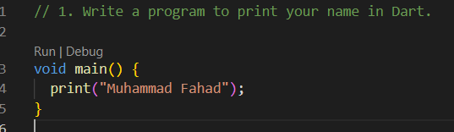

**Output Screenshot**

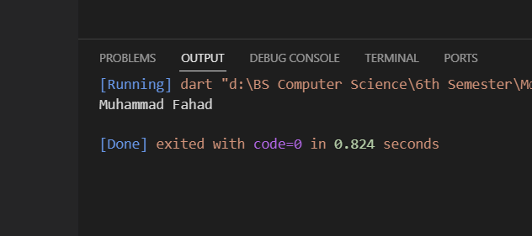

1. **Write a program to print Hello I am “John Doe” and Hello I’am “John Doe” with single and double quotes.**

**Program Screenshot**

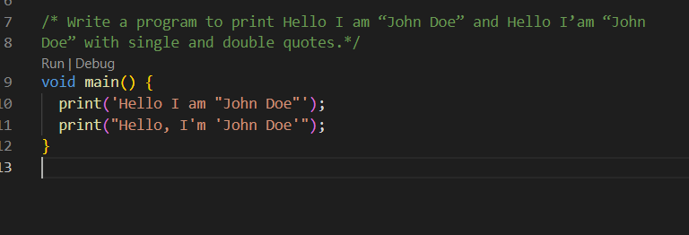

**Output Screenshot**

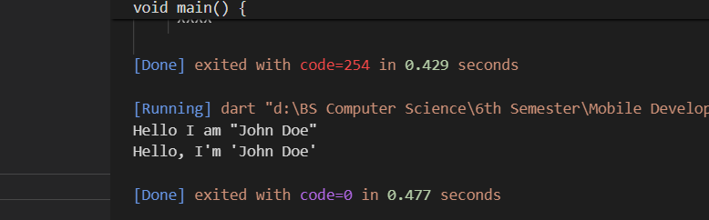

1. **Declare constant type of int set value 7.**

**Program and Output Screenshot:**

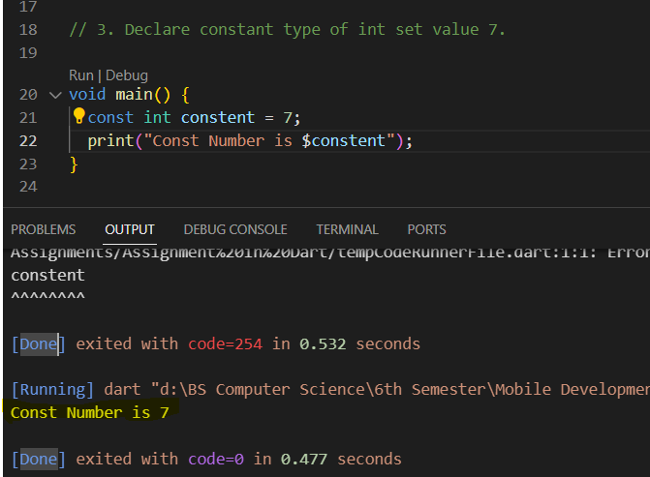

1. **Write a program in Dart that finds simple interest. Formula= (p * t * r) / 100**

**Program and Output Screenshot:**

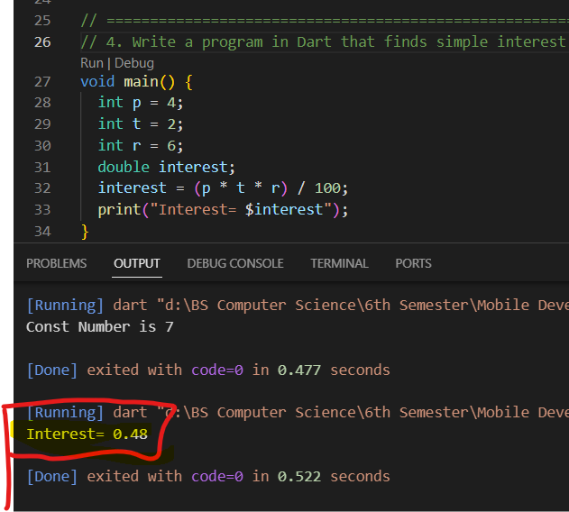

1. **Write a program to print a square of a number using user input.**

**Program and Output Screenshot:**

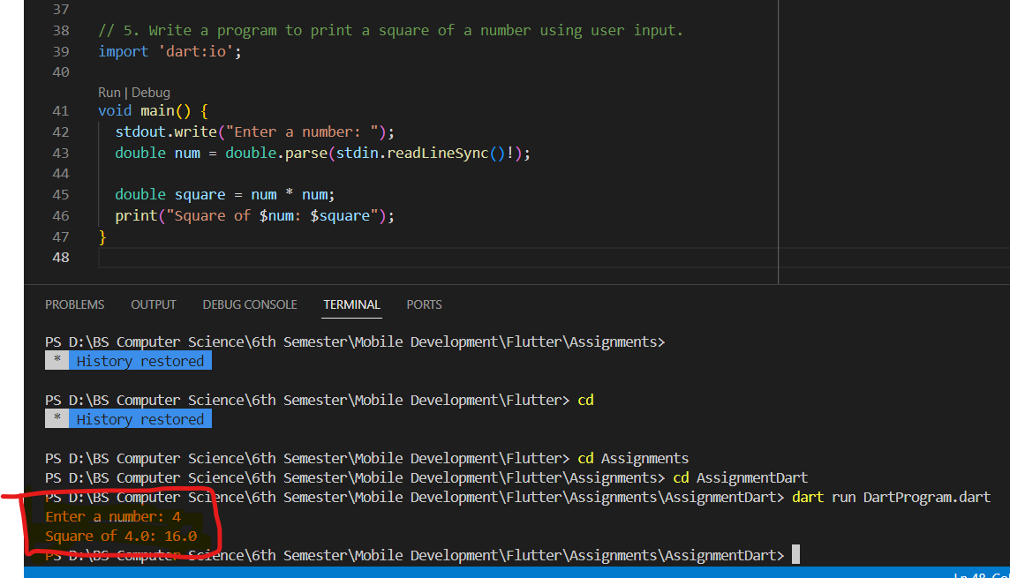

1. **Write a program to print full name of a from first name and last name using user input. Program and Output Screenshot:**

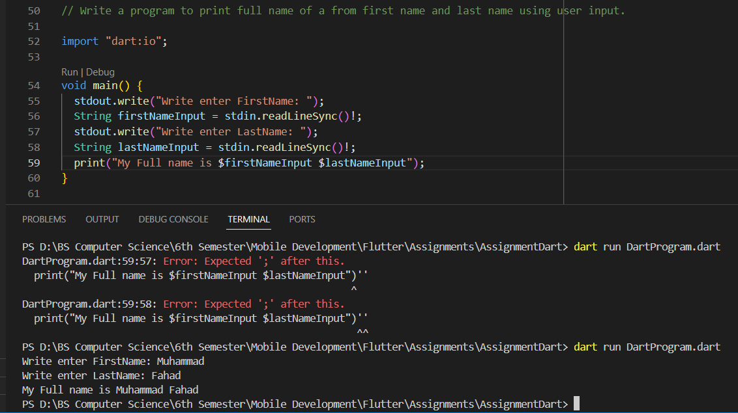

1. **Write a program to find quotient and remainder of two integers.**

**Program and Output Screenshot:**

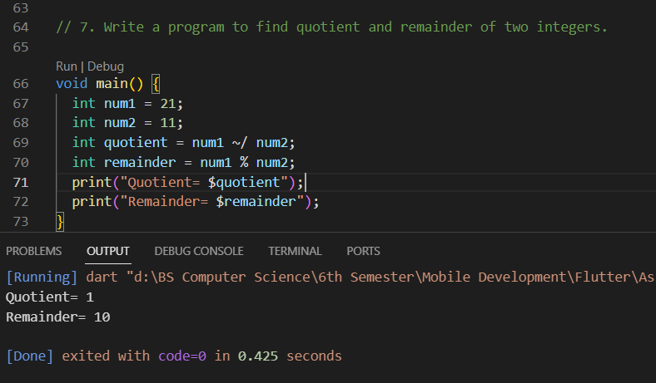

1. **Write a program to swap two numbers.**

**Program and Output Screenshot:**

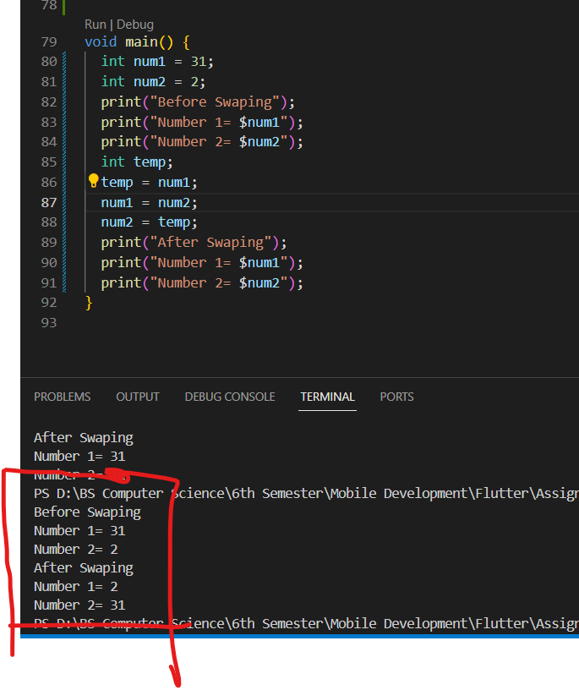

1. **Write a program in Dart to remove all whitespaces from String.**

**Program and Output Screenshot:**

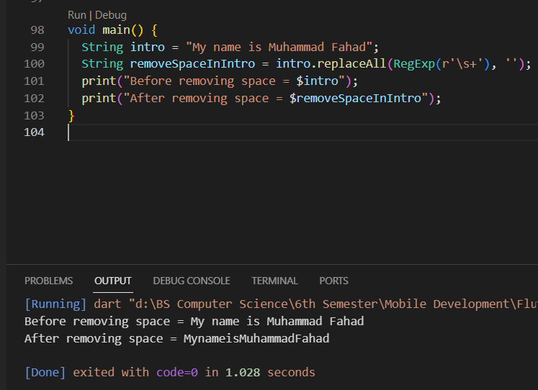

1. **Write a Dart program to convert String to int.**

**Program and Output Screenshot:**

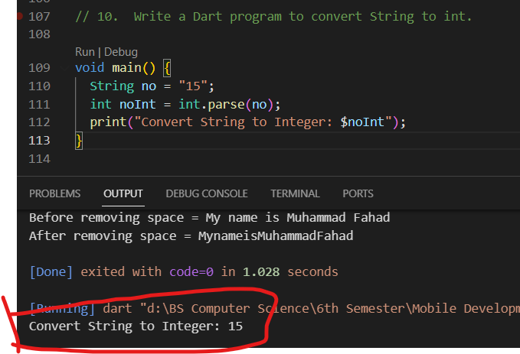

1. **Suppose, you often go to restaurant with friends and you have to split amount of bill. Write a program to calculate split amount of bill. Formula= (total billamount) / number of people.**

**Program and Output Screenshot:**

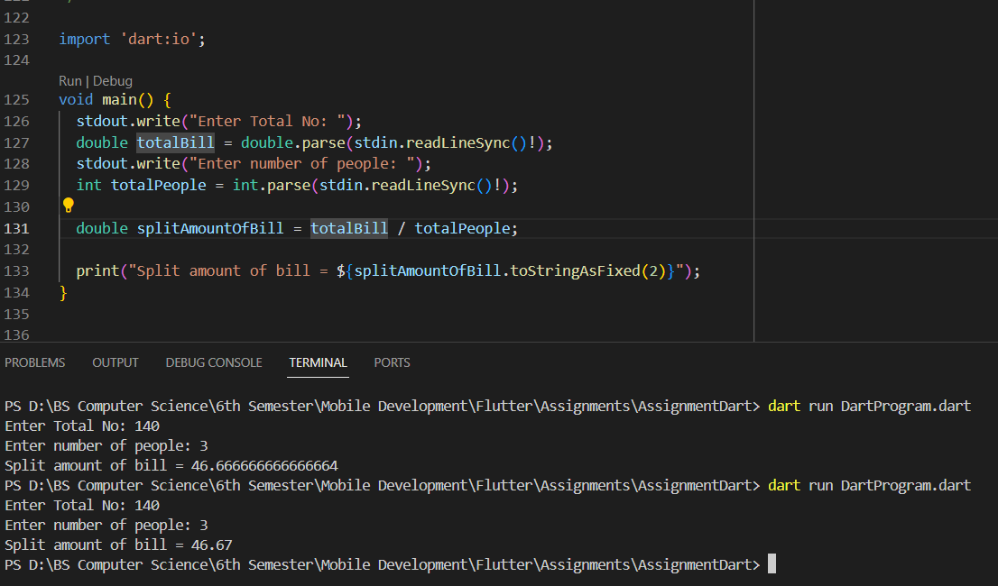

1. **Suppose, your distance to office from home is 25 km and you travel 40 km per hour. Write a program to calculate time taken to reach office in minutes. Formula= (distance) / (speed).**

**Program and Output Screenshot:**

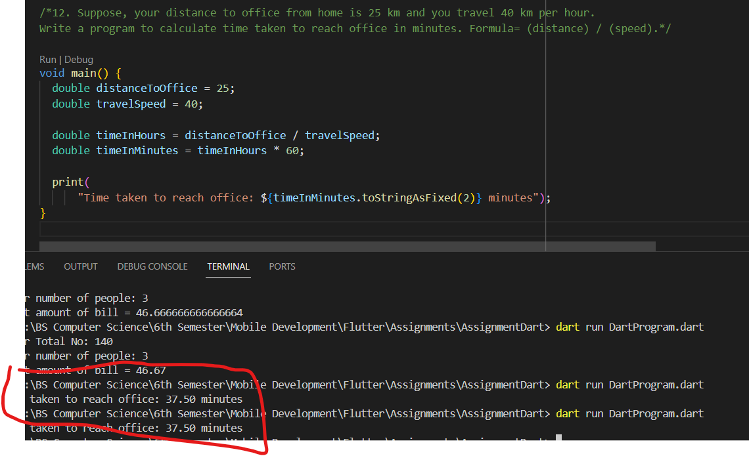

1. **Write a dart program to check if the number is odd or even.Program and Output Screenshot:**

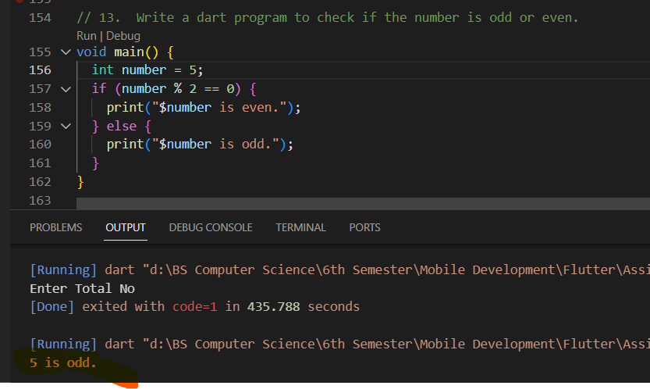

1. **Write a dart program to check whether a character is a vowel or consonant.**

**Program and Output Screenshot:**

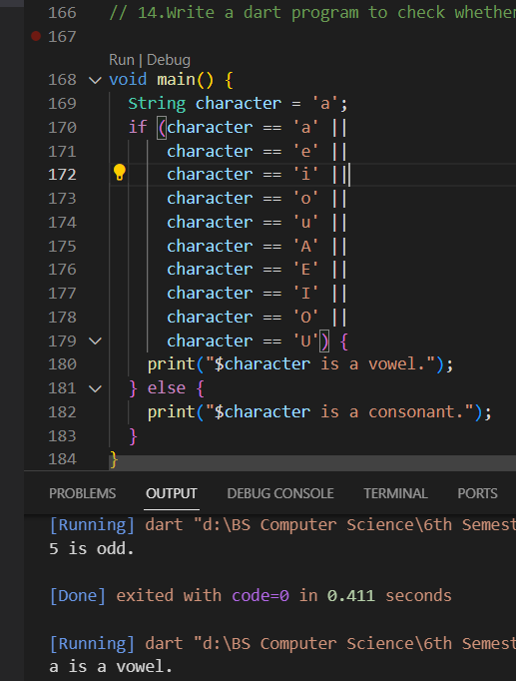

1. **Write a dart program to check whether a number is positive, negative, or zero.**

**Program and Output Screenshot:**

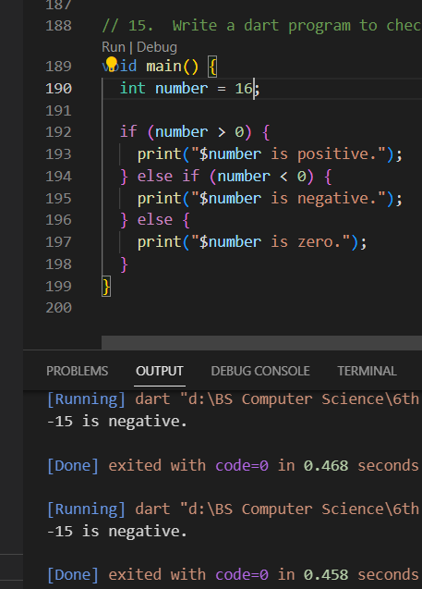

1. **Write a dart program to print your name 100 times.**

**Program and Output Screenshot:**

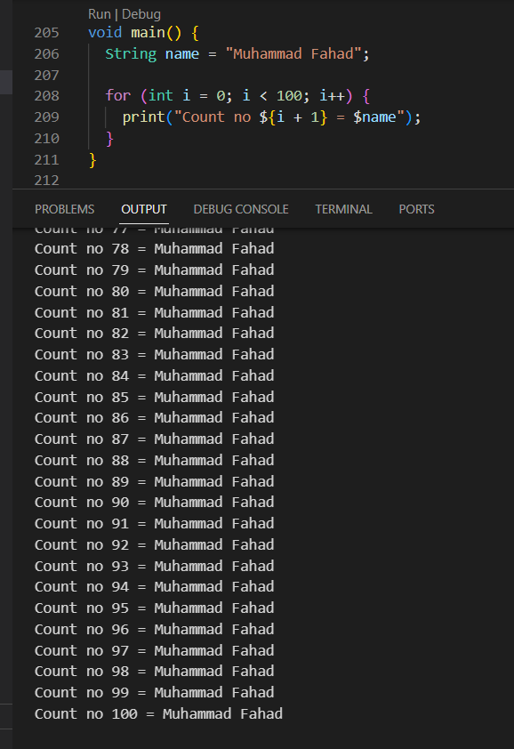

1. **Write a dart program to calculate the sum of natural numbers.**

**Program and Output Screenshot:**

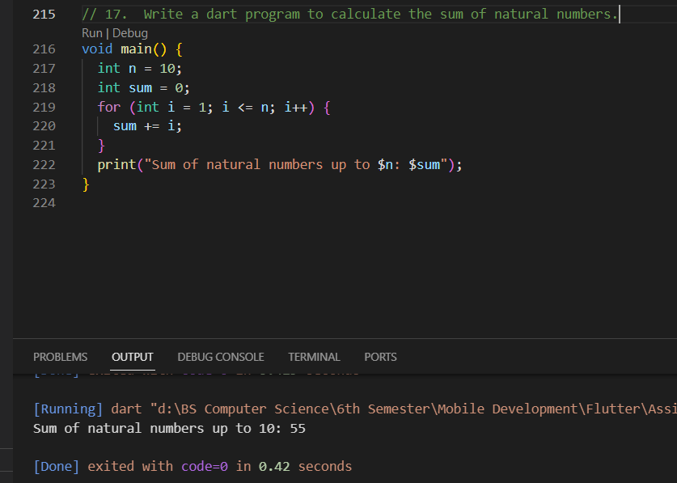

1. **Write a dart program to generate multiplication tables of 5.**

**Program and Output Screenshot:**

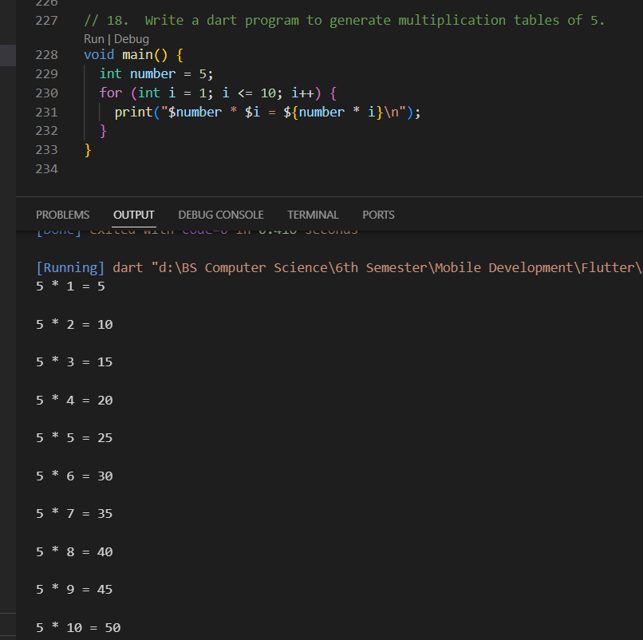

1. **Write a dart program to generate multiplication tables of 1-9.**

**Program and Output Screenshot:**

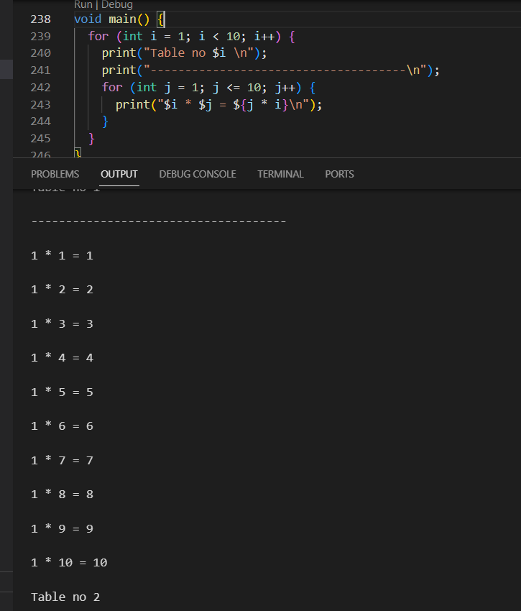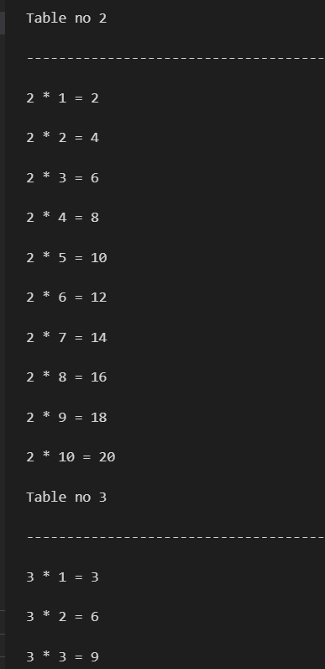

Printed the Table 1 -9

1. **Write a dart program to create a simple calculator that performs addition, subtraction, multiplication, and division.**

**Program and Output Screenshot:**

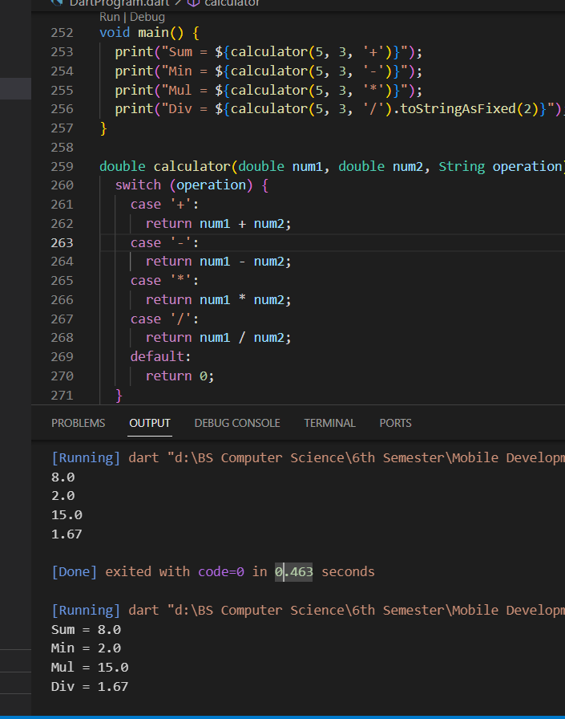

1. **Write a dart program to print 1 to 100 but not 41.**

**Program and Output Screenshot:**

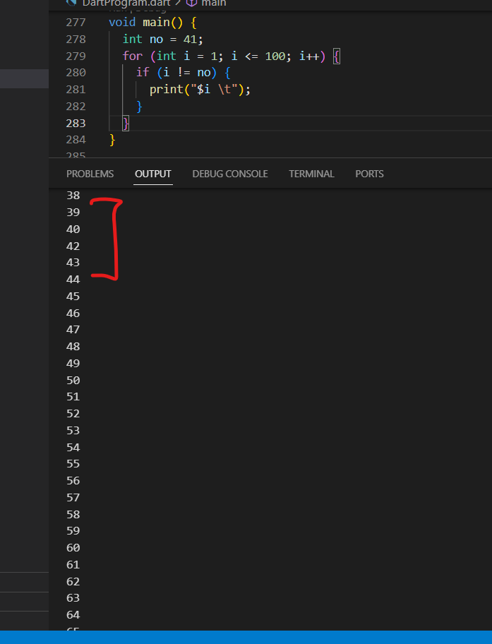

1. **Write a program in Dart to print your own name using function.**

**Program and Output Screenshot:**

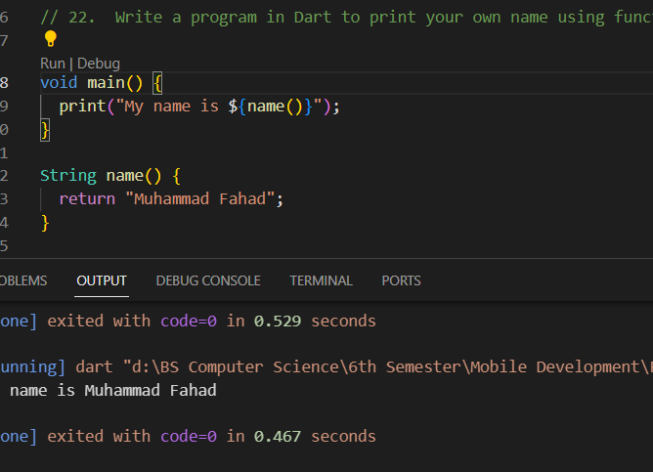

1. **Write a program in Dart to print even numbers between intervals using function.**

**Program and Output Screenshot:**

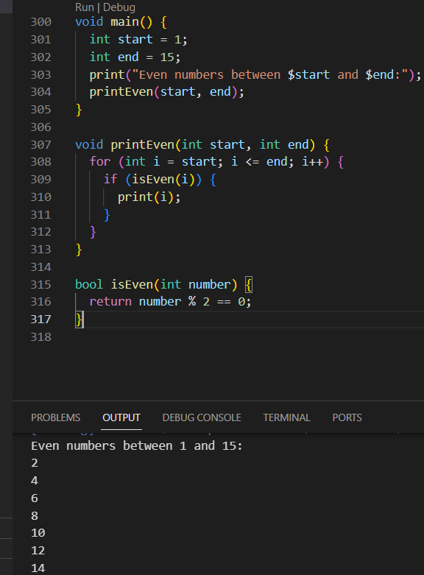

1. **Create a function called greet that takes a name as an argument and prints a greeting message. For example, greet(“John”) should print “Hello, John”.**

**Program and Output Screenshot:**

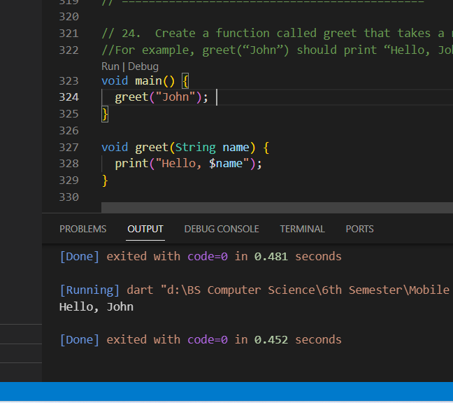

1. **Write a program in Dart that generates random password.**

**Program and Output Screenshot:**

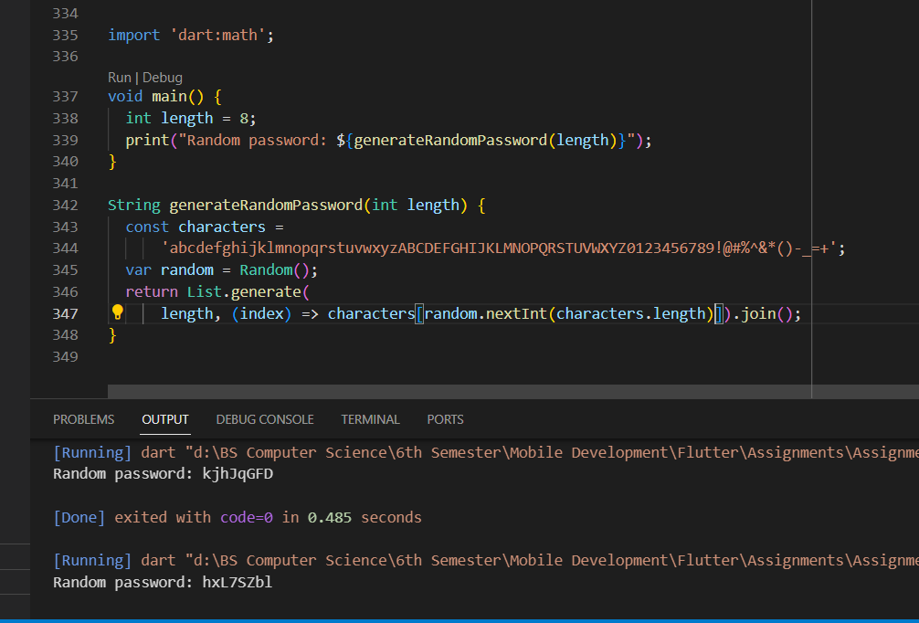

1. **Write a program in Dart that find the area of a circle using function. Formula: pi * r * r**

**Program and Output Screenshot:**

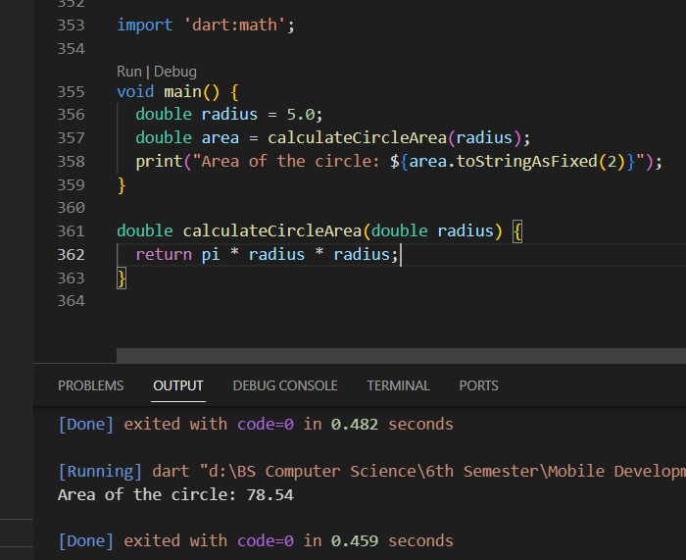

1. **Write a program in Dart to reverse a String using function.**

**Program and Output Screenshot:**

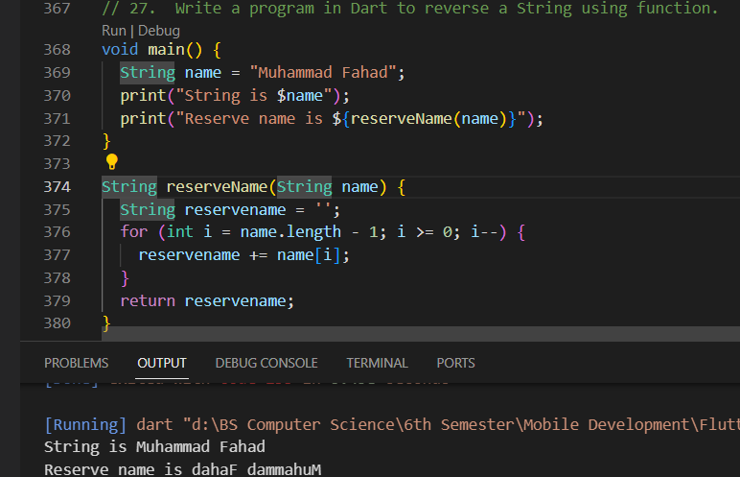

1. **Write a program in Dart to calculate power of a certain number. For e.g 5^3=125**

**Program and Output Screenshot:**

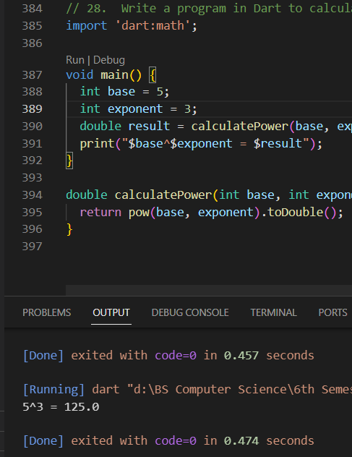

1. **Write a function in Dart named add that takes two numbers as arguments and returns their sum.**

**Program and Output Screenshot:**

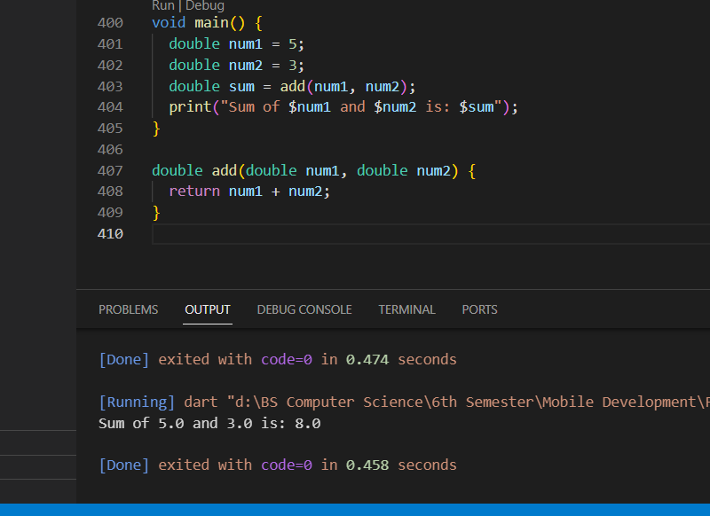

1. **Write a function in Dart called maxNumber that takes three numbers as arguments and returns the largest number.**

**Program and Output Screenshot:**

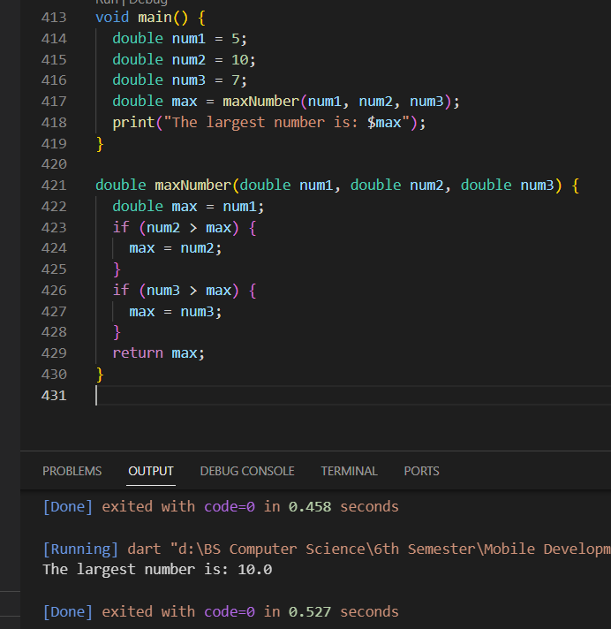

1. **Write a function in Dart called isEven that takes a number as an argument and returns True if the number is even, and False otherwise.**

**Program and Output Screenshot:**

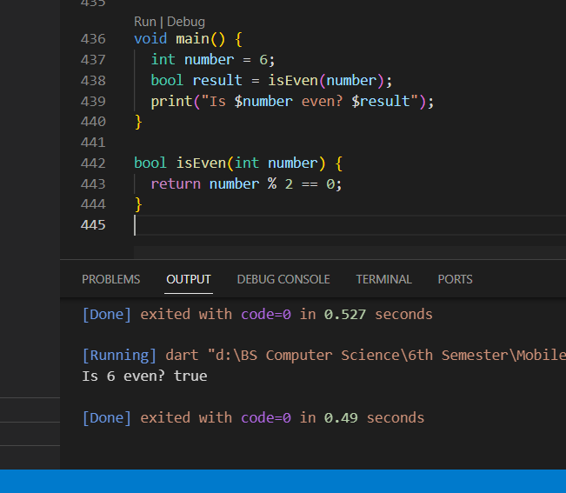

1. **Write a function in Dart called createUser with parameters name, age, and isActive, where isActive has a default value of true.**

**Program and Output Screenshot:**

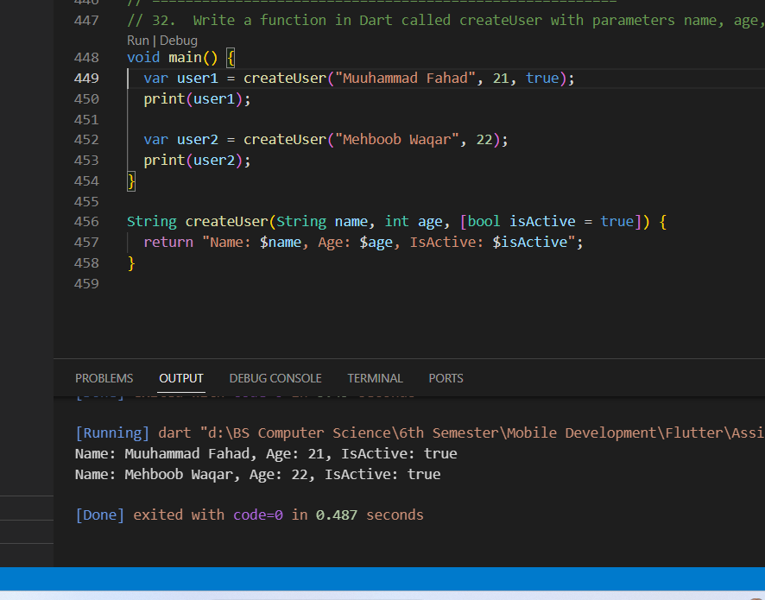

1. **Write a function in Dart called calculateArea that calculates the area of a rectangle. It should take length and width as arguments, with a default value of 1 for both. Formula: length * width.**

**Program and Output Screenshot:**

1. **Create a list of names and print all names using list.**

**Program and Output Screenshot:**

1. **Create a set of fruits and print all fruits using loop.**
2. **Create a program thats reads list of expenses amount using user input and print total.**
3. **Create an empty list of type string called days. Use the add method to add names of 7 days and print all days.**
4. **Add your 7 friend names to the list. Use where to find a name that starts with alphabet a.**
5. **Create a map with name, address, age, country keys and store values to it. Update country name to other country and print all keys and values.**
6. **Create a map with name, phone keys and store some values to it. Use where to find all keys that have length 4.**
7. **Create a simple to-do application that allows user to add, remove, and view their task.**
8. **Write a dart program to create a class Laptop with properties [id, name, ram] and create 3 objects of it and print all details.**
9. **Write a dart program to create a class House with properties [id, name, price].**
10. **Create a constructor of it and create 3 objects of it. Add them to the list and print all details.**
11. **Write a dart program to create an enum class for gender [male, female, others] and print all values.**
12. **Write a dart program to create a class Animal with properties [id, name, color].**
13. **Create another class called Cat and extends it from Animal. Add new properties sound in String. Create an object of a Cat and print all details.**
14. **Write a dart program to create a class Camera with private properties [id, brand, color, price]. Create a getter and setter to get and set values. Also, create 3 objects of it and print all details.**
15. **Create an interface called Bottle and add a method to it called open(). Create a class called CokeBottle and implement the Bottle and print the message “Coke bottle is opened”. Add a factory constructor to Bottle and return the object of CokeBottle. Instantiate CokeBottle using the factory constructor and call the open() on the object.**
16. **Create a simple quiz application using oop that allows users to play and view their score.**
17. **What is the purpose of the ? operator in Dart null safety?**
18. **Create a late variable named address, assign a US value to it and print it.**
19. **How do you declare a nullable type in Dart null safety?**
20. **Write a program in a dart to create an age variable and assign a null value to it using ?.**
21. **Write a function that accepts a nullable int parameter and returns 0 if the value is null using null coalescing operator ??.**
22. **Write a function named generateRandom() in dart that randomly**
23. **returns 100 or null. Also, assign a return value of the function to a variable named status that can’t be null. Give status a default value of 0, if generateRandom() function returns null**