 

**Group Members:**

MUHAMMAD FURQAN WASEEM (28)

SYED MUZAMIL ALI KAZMI (30)

SYED HAMZA ILYAS (32)

TALHA SHEIKH (44)

**Subject:** Data Structure and Algorithm

**Semester:** 3rd

**Batch:** 10

**Discipline:** Bs. Cs

**Resource Person:** Sir Wahab

**Project Title:** Rent a Car System

**Contents:**

INTRODUCTION: ……………………….……………………………. 1

HEADER FILES: ...................................................................................... 2

VARIABLES: ........................................................................................... 3

CLASSES: ................................................................................................. 4

MEMBER FUNCTIONS: ......................................................................... 5

CLASS DIAGRAM: ................................................................................. 6

LOGIN SYSTEM: .................................................................................... 7

RENT A CAR SYSTEM: ........................................................................ 8

CONCULUSION: ………………………………………………………. 9

# INTRODUCTION:

Our group choose to work on a project “Rent a Car System”. We make this project using “DSA”

Principles. During this project we revised “Data Structure and Algorithms” principles but our project basically works on a “Linked List” principle. We also use “Inheritance” and “File Handling” principle.

# Linked List:

Linked List contains a link element called first. Each link carries a data field(s) and a link

field called next. Each link is linked with its next link using its next link. Last link carries a

link as null to mark the end of the list.

We use single linked list in our code because it easily handle and it use less space to

store data.

# **Security System:**

In this program, we used login system so that no one can access the system except the people who know

the password. The passwords are stored in a text file. There is also a system present in case the user

forgets his password. The user can change his password by simply clicking "forgot password" and then

entering the correct pin code and writing the new password.

# Rent a Car System:

This is the second part of our program. In this part, we used “Linked List” of “DSA” to store data,

retrieve data, delete data. This part firstly takes “Personal Information” like (name, phone no.,

CNIC, your home address). Then gives you output now this part is a decision-making part in it

asked for time duration and what car is you need. Then generate bill according to requirements.

Its next part is to delete pervious data when client, customer return car. After this next step is to

generate new “Linked List” for new data entry.

# File Handling:

File Handling is like a “File Management” process. Its main purpose is to keep data of new and

old entries. It is directly linked with “txt file”. So, whenever we use this software it automatically

stores data. It is very use full in to keep record of data.

HEADER FILES:

1. **#include <iostream>**

This is used for taking input/output from the user.

**2. #include <fstream>**

This header file is used for reading and writing purpose from the text file. **3. #include <stdio.h>**

This header file is used for clearing the screen.

**4. #include<stdlib.h>**

This **is a** library**that is used to manipulate the output of** C++

VARIABLES:

1. **String type variables:**

string caar_name, cost , duration , car_No, cost_per, caar , name , phone , cnic , address.

1. **Integer type variable**

int suv(), cuv(), sedan(), hatchBack(), buses().

CLASSES:

We used two classes in this project:

1. **Class LinkeList**
2. **Class Car**

MEMBER FUNCTIONS:

Member functions of the classes:

void insertData()

void writeFile()

void deleteEntery();

void display();

void readFile();

CLASS DIAGRAM: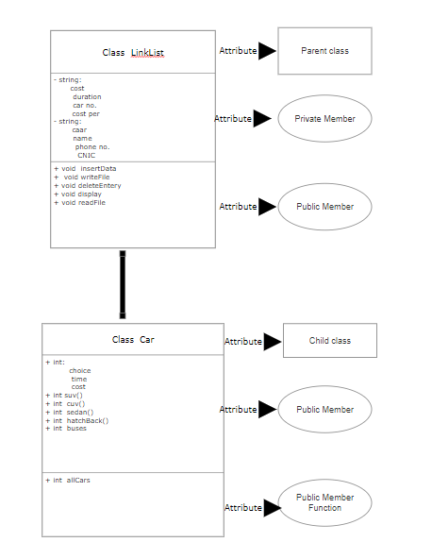

CODE OUTPUT:  
LOGIN SYSTEM:

First of all, it will ask the user enter password. And the program will read the password from the password.txt from the back end of the program (figure 1.1).

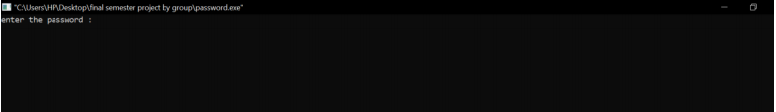

Figure (1.1, login screen)

# PASSWORD:

When our system is disabled for 5 sec after this it shows the option of pin code.

When pin code is enter 5 times wrong then it will stops the execution of the program (figure 1.2 a & 1.2 b).

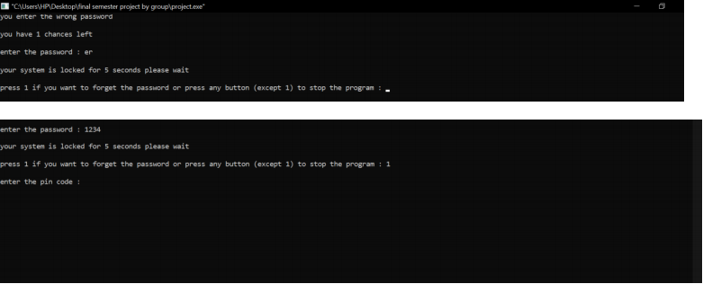

Figure (1.2 a, password)

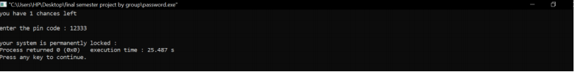

Figure (1.2 b, password)

# CODE USER INTERFACE (Main Menu):

This is the user interface of our program. When it runs it display 4 options which are following below (figure 1.3):

1. Rent a Car
2. Return Car
3. Display the Record
4. Quit

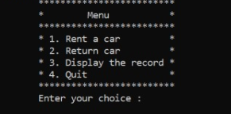

Figure (1.3, main menu of the program)

# CONCULUSION:

In this project we use different “DATA STRUCTURE AND ALGORITHMS” principles and learn what linked list works and also file handling works. Our project “Rent a Car System” helps us to understand better “DSA” principles and gave an idea of “DATA BASE”. How it works and how it helps us? Now we are able to understand better problem-solving techniques. Now we can create program like “airport management system, super market management system, bank management system”. **“IN SHA ALLAH” we** will make more advance and more accurate software’s.