Bees!

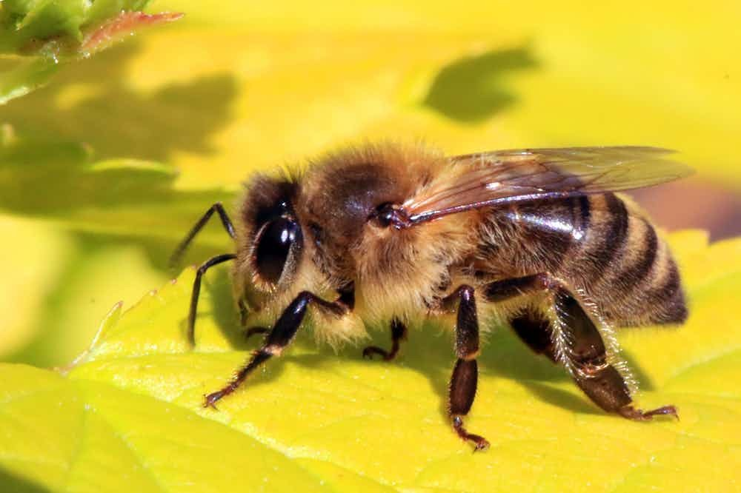

Bees are social insects that live in colonies consisting of worker bees, queen bees and males. They play an important role in plant pollination and honey production. Worker bees collect nectar and pollen from flowers and use it to make honey and beeswax. They are also responsible for caring for the larvae and protecting the colony from external threats. The queen bee is the main reproductive organ in the colony. She lays eggs that become worker bees or males, depending on conditions. Male bees perform no tasks in the colony other than reproduction. They die after mating with the queen. Bees have a complex system of communicating with each other, using dances and pheromones to give directions to flowering plants or alert other bees to danger.

Bees are important pollinators in the plant world. Without them, many plants cannot produce seeds or fruit. However, bee populations have been severely affected by pesticides, habitat loss and disease, with serious consequences for the ecosystem as a whole. All in all, bees are amazing and important creatures that play an important role in sustaining life on our planet.