DESIGN AND VERIFICATION OF A 2-WAY
SET-ASSOCIATIVE CACHE CONTROLLER
Verilog RTL Project Report
━━━━━━━━━━━━━━━━━━━━━━━━

POLICIES TO IMPLEMENT

- 2-Way Set Associative
- LRU
- Write-Through
- No-Write-Allocate

Prepared by: Muhammad Hammad
Project: Cache Controller RTL Design
Language: Verilog
Date: 23 September 2026

TABLE OF CONTENTS

1. OBJECTIVE AND PROBLEM STATEMENT 3
2. INTRODUCTION AND CACHE THEORY 4
3. SYSTEM ARCHITECTURE 5
4. MODULE DESCRIPTION 6
5. CACHE CONTROLLER FSM 7
6. CACHE OPERATIONS AND POLICY IMPLEMENTATION 8
7. RTL IMPLEMENTATION DETAILS 9
8. VERIFICATION METHODOLOGY 9
9. DIRECTED TEST PLAN 11
10. EXPECTED SIMULATION BEHAVIOR AND CONCLUSION 12

1. OBJECTIVE AND PROBLEM STATEMENT

1.1 Objective
The objective of this project is to design and verify a modular cache controller in Verilog. The controller must demonstrate set-associative cache operation, hit/miss detection, LRU replacement, write-through behavior, and no-write-allocate handling while remaining easy to understand and verify through directed simulation.
.

1.2 Assigned Problem
The project specification assigns Hammad a 2-way set-associative cache using LRU replacement and a Write-Through + No-Write-Allocate policy. The memory address width is 16 bits, the cache contains eight total lines, and each cache line stores 32 bits of data.

PARAMETER | IMPLEMENTED VALUE
Address width | 16 bits
Total cache lines | 8
Organization | 4 sets × 2 ways
Data per line | 32 bits
Replacement policy | Least Recently Used (LRU)
Write policy | Write-Through
Write-miss policy | No-Write-Allocate
RTL language | Verilog

1.3 Functional Requirements
- Read hit: return data directly from cache and update LRU information.
- Read miss: fetch data from main memory, allocate a cache line, and replace the LRU line only when both ways are valid.
- Write hit: update the cached copy and main memory.
- Write miss: write directly to main memory without allocating a cache line.
- Use a clear control FSM for cache operations and a simple main-memory model without its own FSM.
- Verify the design using a directed testbench with clear PASS/FAIL reporting.

2. INTRODUCTION AND CACHE THEORY

2.1 Introduction
A cache is a small, fast storage structure placed between a processor and a larger main memory. Its purpose is to keep recently used data close to the processor so that repeated accesses can be served without repeatedly reading main memory. This project focuses on the control logic required to determine whether an address is present in the cache and what action must be taken on a hit or miss.

2.2 2-Way Set-Associative Organization
The eight cache lines are divided into four sets, with two ways in each set. For any requested address, the index selects exactly one set and the tag is compared against both ways in that set. A match in either valid way produces a cache hit.

PARAMETER | IMPLEMENTED VALUE
Number of sets | 4
Ways per set | 2
Index bits | 2 bits: address[1:0]
Tag bits | 14 bits: address[15:2]
Hit condition | Valid way AND matching tag
Miss condition | No valid tag match in either way

2.3 Address Breakdown

Tag = address[15:2] // 14 bits
Index = address[1:0] // 2 bits

2.4 Cache-Line Information
Each implemented cache entry stores a 14-bit tag, a 32-bit data value, and one valid bit. A dirty bit is not required because the assigned policy is Write-Through rather than Write-Back. Each set also stores one LRU bit because only two ways are present.

3. SYSTEM ARCHITECTURE
The design is modular. The testbench communicates with a top-level DUT using simple CPU-like read/write controls. Inside the DUT, the CPU model creates a one-cycle cache request, the cache controller performs all cache decisions, and the main-memory model provides backing storage.
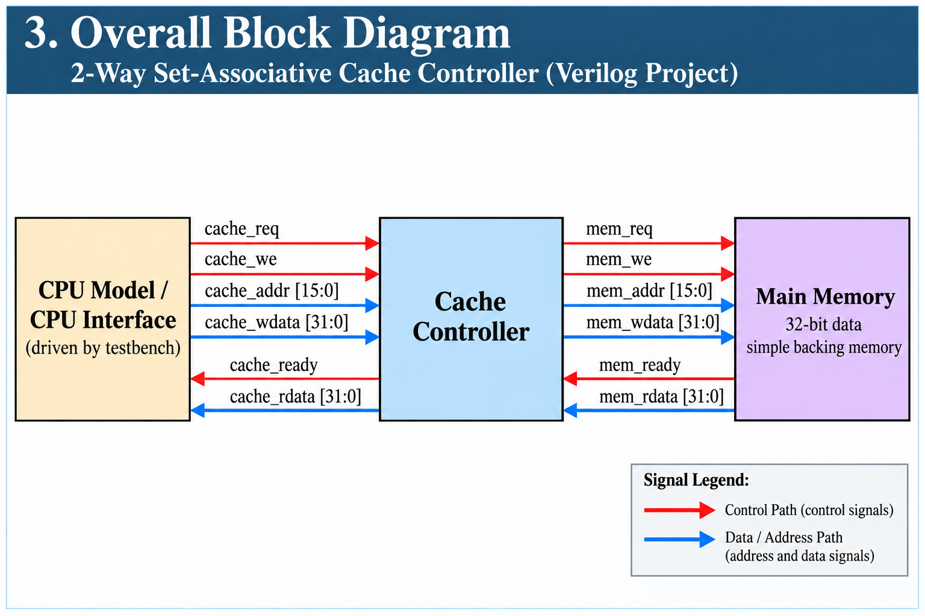

Figure 1. Overall cache-controller project architecture.

3.1 Data and Control Flow
Signal flow is: testbench cpu_model cache_controller main_memory. Responses return in the opposite direction through cache_ready/cache_rdata and finally cpu_read_data.

4. MODULE DESCRIPTION

FILE | ROLE | DESCRIPTION
cpu_model.v | CPU-side adapter | Uses a request_sent flag to generate one cache_req pulse for each CPU read/write command, latches address/write data, and captures returned read data when cache_ready is asserted.
cache_controller.v | Main cache control | Implements separate Way-0/Way-1 tag, data, and valid memories, hit detection, LRU replacement, request latching, a four-state FSM, and memory-control signals.
main_memory.v | Backing memory model | Implements a 65,536-entry × 32-bit memory, combinational read, mem_ready = mem_req, and synchronous writes.
cache_system_top.v | Integration | Instantiates cpu_model, cache_controller, and main_memory and connects all internal request/response signals.
cache_system_top_tb.v | Verification | Provides clock/reset, Verilog read_test and write_test tasks, memory-access counters, 15 directed tests, waveform dump, and final PASS/FAIL summary.

4.1 CPU Model
The CPU model does not contain an FSM. It uses a request_sent flag to issue only one cache_req pulse while cpu_read or cpu_write remains asserted. When both CPU controls return low, request_sent is cleared so the next operation can be accepted. When cache_ready is asserted for a read request, cache_rdata is captured in cpu_read_data.

4.2 Main Memory
The main memory is deliberately simple: read data is combinational, mem_ready follows mem_req, and writes occur on the rising clock edge when mem_req and mem_we are both asserted. Its simplicity keeps the focus on cache-controller behavior.

5. CACHE CONTROLLER FSM
The cache controller is the only module that contains a finite state machine. Its four states separate request acceptance, cache lookup, read-miss handling, and write-through memory handling.

STATE | PURPOSE | MAIN TRANSITION BEHAVIOR
IDLE | Wait for request | On cpu_req, latch cpu_addr/cpu_wdata/cpu_we and move to LOOKUP.
LOOKUP | Check cache | Read hit returns to IDLE; read miss goes to MEM_READ; every write goes to MEM_WRITE after optional cache update.
MEM_READ | Handle read miss | When mem_ready=1, fill an invalid way or replace the LRU way, return mem_rdata, assert cpu_ready, then go to IDLE.
MEM_WRITE | Handle write-through | When mem_ready=1, assert cpu_ready and return to IDLE. Memory write control is active while this state is selected.

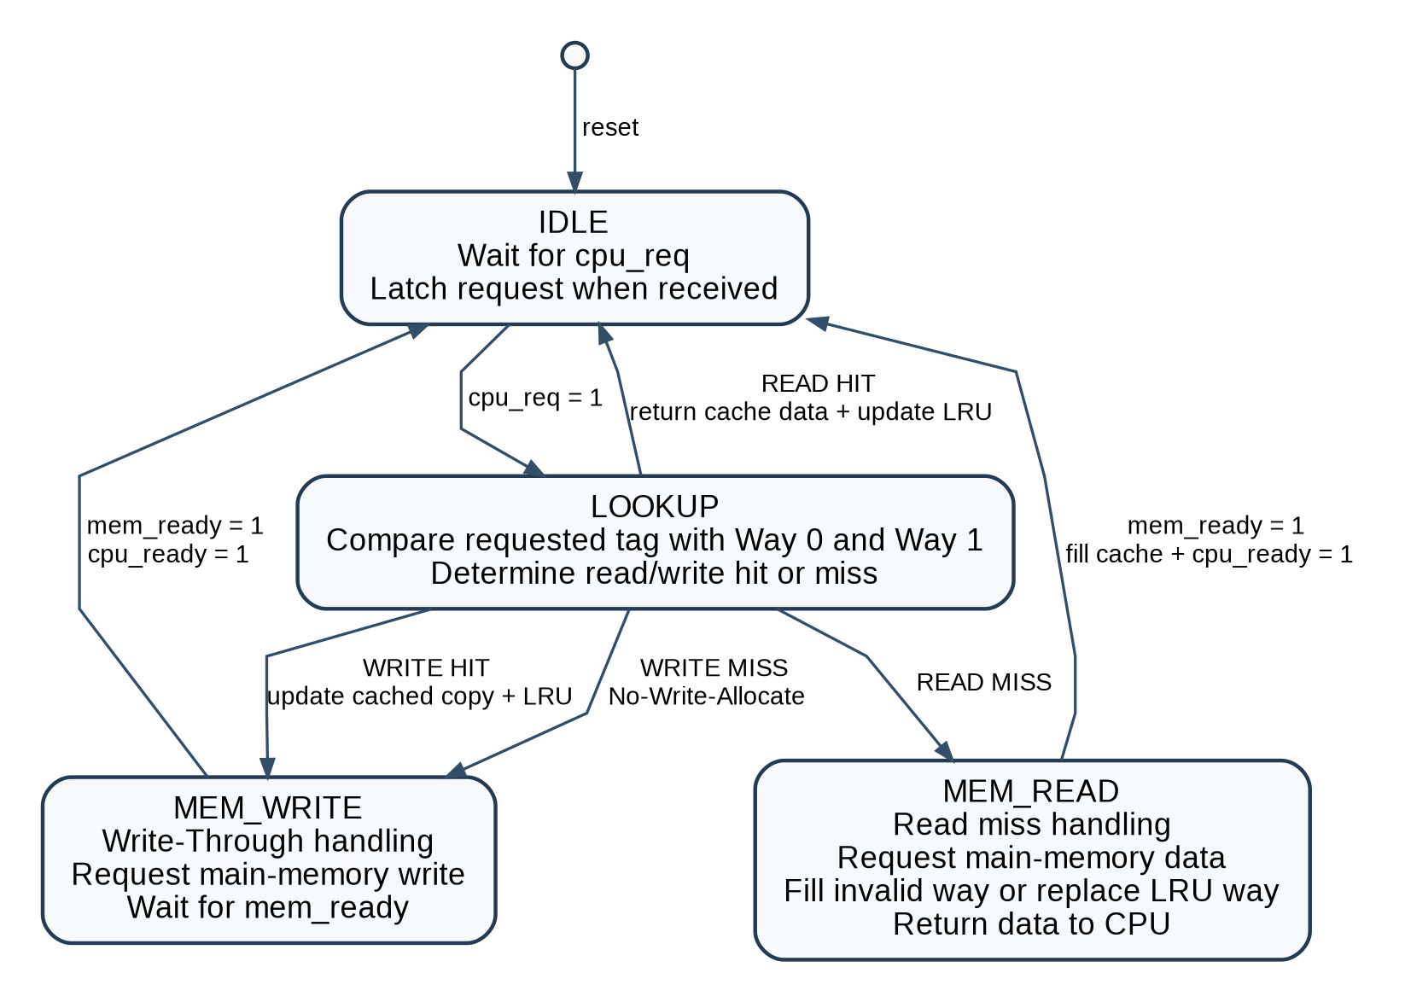

Figure 2. Cache controller finite state machine.

6. CACHE OPERATIONS AND POLICY IMPLEMENTATION

OPERATION | CONDITION | CONTROLLER ACTION
Read Hit | Requested tag matches a valid way. | Return cached data, assert cpu_ready, update LRU. Main memory is not read.
Read Miss | No valid tag match in either way. | Enter MEM_READ, fetch from memory, fill invalid way if available; otherwise replace LRU way. Return fetched data.
Write Hit | Requested tag matches a valid way. | Update cached data and LRU, then enter MEM_WRITE so the same value is written to main memory.
Write Miss | Address is not cached. | Do not allocate cache. Enter MEM_WRITE and write directly to main memory.

6.1 LRU Replacement
Because each set contains two ways, only one LRU bit is required. The bit identifies which way should be replaced next when both ways are valid. Accessing Way 0 makes Way 1 the LRU victim; accessing Way 1 makes Way 0 the LRU victim.

lru_way[set] = 0 -> Way 0 is the replacement victim
lru_way[set] = 1 -> Way 1 is the replacement victim

6.2 Write-Through
Every CPU write eventually enters MEM_WRITE. While the FSM is in MEM_WRITE, mem_req=1 and mem_we=1. A write hit updates the cached copy first; a write miss leaves the cache unchanged. In both cases, main memory receives the new value.

6.3 No-Write-Allocate
On a write miss, no cache line is fetched or created. The requested address remains absent from the cache until a later read miss causes an allocation.

7. RTL IMPLEMENTATION DETAILS

7.1 Cache Storage
reg [13:0] tag_way0 [0:3], tag_way1 [0:3];
reg [31:0] data_way0 [0:3], data_way1 [0:3];
reg valid_way0 [0:3], valid_way1 [0:3];
reg lru_way [0:3];
The Verilog implementation uses separate Way-0 and Way-1 memories for tag, data, and valid information, with four entries in each way. On reset, both valid memories are cleared and each LRU bit is initialized.

7.2 Request Latching and Hit Detection
The IDLE state captures the CPU request into req_addr, req_wdata, and req_we. The selected set and tag are then derived from the latched request. Hit logic checks the valid bit and tag of both ways in parallel.

assign req_index = req_addr[1:0];
assign req_tag = req_addr[15:2];
assign hit_way0 = valid_way0[req_index] && (tag_way0[req_index] == req_tag);
assign hit_way1 = valid_way1[req_index] && (tag_way1[req_index] == req_tag);

7.3 Memory Handshake
Memory command signals are generated combinationally from the FSM state. MEM_READ asserts mem_req with mem_we=0, while MEM_WRITE asserts mem_req with mem_we=1. The controller completes either transaction when mem_ready is observed.

7.4 Reset Behavior
Reset returns the FSM to IDLE, clears the latched request/control outputs, invalidates all cache entries, and initializes LRU metadata. Main memory is not cleared by cache reset and the synthesizable main_memory RTL has no initial block; required test values are initialized only by the simulation testbench.

8. VERIFICATION METHODOLOGY
The verification environment uses a directed Verilog testbench. Its goal is not only to obtain the correct returned data, but also to prove that each policy is being exercised: read hits must avoid memory reads, read misses must access memory once, write-through must update memory, and write misses must not allocate a cache line.

8.1 Testbench Structure
- 10 ns clock generation and active-high reset.
- VCD waveform generation through $dumpfile and $dumpvars.
- memory_read_count and memory_write_count counters to observe actual backing-memory activity.
- read_test(...) task for read hit/miss checking and returned-data verification.
- write_test(...) task for write-through and no-write-allocate verification.
- test_pass[1:15] array and print_summary() task for a compact final report.

8.2 Read Test Task
Before driving the request, read_test calculates the index/tag and inspects both ways to determine the expected current cache state. It then applies cpu_read, waits for the operation to complete, measures memory-read activity, checks cpu_read_data, and records PASS or FAIL.

8.3 Write Test Task
write_test similarly determines whether the address is already cached, applies cpu_write and the write data, counts memory writes, checks that main memory contains the new value, and verifies whether the cache should remain allocated (write hit) or remain unallocated (write miss).

8.4 Waveform Signals
Figure 3 shows a representative EPWave output from the Verilog testbench. The waveform captures CPU requests, cache request/ready behavior, memory interface activity, returned data, and the cache-controller FSM state transitions during the directed-test sequence.
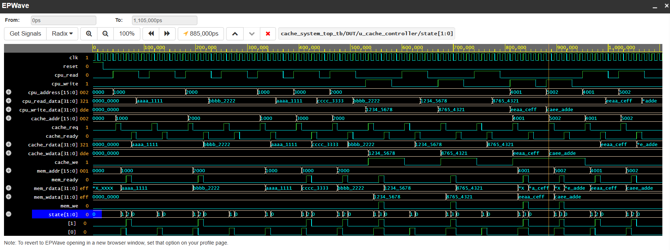

Figure 3. EPWave simulation output showing CPU, cache, memory, and FSM-state activity for the directed Verilog testbench.

9. DIRECTED TEST PLAN
The current testbench contains 15 directed tests. The sequence is intentionally ordered so that earlier accesses establish the cache state needed by later LRU and write-policy tests.

# | TEST | STIMULUS | EXPECTED BEHAVIOR
1 | First Read / Read Miss | Read 0x1000 | Miss; fetch 0xAAAA1111 from memory and allocate.
2 | Same Address / Read Hit | Read 0x1000 again | Hit; no memory read.
3 | Second Way Fill | Read 0x2000 | Miss; fill second way of Set 0.
4 | Multiple Read Hit | Read 0x2000 again | Hit; repeated cached access.
5 | Read Hit / LRU Update | Read 0x1000 | Hit; make 0x1000 MRU and 0x2000 LRU.
6 | LRU Replacement | Read 0x3000 | Miss; full Set 0 replaces LRU line.
7 | Read Evicted Address | Read 0x2000 | Miss; confirms LRU eviction.
8 | Write Hit | Write 0x12345678 to 0x2000 | Update cache and main memory.
9 | Read After Write Hit | Read 0x2000 | Hit; return 0x12345678.
10 | Multiple Write Hit | Write 0x87654321 to 0x2000 | Second write hit; cache and memory updated.
11 | Read After Multiple Writes | Read 0x2000 | Hit; return latest value 0x87654321.
12 | Write Miss | Write 0xEEAACEFF to 0x4001 | Memory only; no cache allocation.
13 | Multiple Write Miss | Write 0xCAEEADDE to 0x5002 | Memory only; repeated no-write-allocate behavior.
14 | Read After Write Miss | Read 0x4001 | Miss; fetch EEAACEFF, proving prior write did not allocate.
15 | Read After Multiple Write Miss | Read 0x5002 | Miss; fetch CAEEADDE, then allocate on read.

10. EXPECTED SIMULATION BEHAVIOR AND CONCLUSION

10.1 Expected Simulation Behavior
When the testbench is executed, each test prints the address, index, tag, way-hit information, memory activity, operation type, returned or written data, and a PASS/FAIL result. The final summary reports the status of all 15 directed tests.
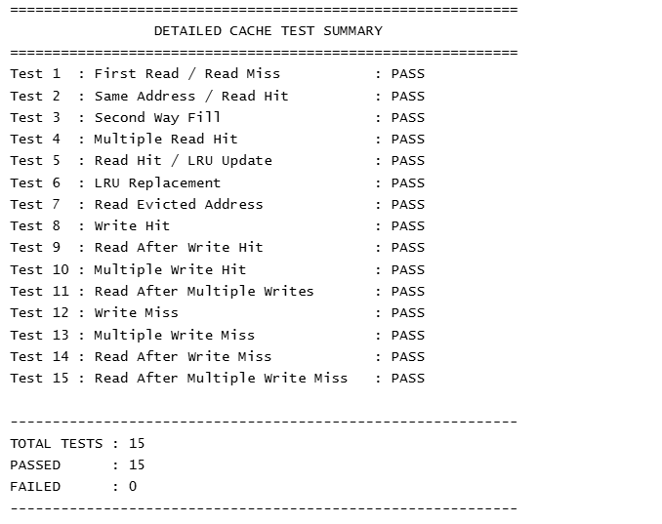

Figure 4. Console Output Showing all the directed tests passed with success.

10.2 Key Behaviors Demonstrated
- Read misses allocate cache lines and read hits are served without main-memory access.
- Two independent ways are used in each set before replacement is required.
- LRU metadata is updated on hits and is used to select the victim in a full set.
- Write hits update both cache and main memory.
- Write misses update only main memory and do not allocate cache entries.
- A read after a write miss still misses, which directly demonstrates No-Write-Allocate.
- A read after a write hit returns the latest cached value.

10.3 Conclusion
The project implements a clear and modular 2-way set-associative cache controller using synthesizable Verilog RTL. The design satisfies the assigned LRU, Write-Through, and No-Write-Allocate requirements while keeping the memory model and verification environment intentionally simple. The four-state FSM cleanly separates lookup, read-miss service, and write-through service, and the 15 directed Verilog tests exercise the main functional behaviors needed to explain and review the design.

