Register

* Property Agent
* Town Owner
* Local Services
  + Home developer
  + Interior Designer
  + Architecture
  + Home Inspection
* Marketing agencies
* Individual Account
  + Sale One Product at a time If user set one property first remove it or change status into unsold then add new property

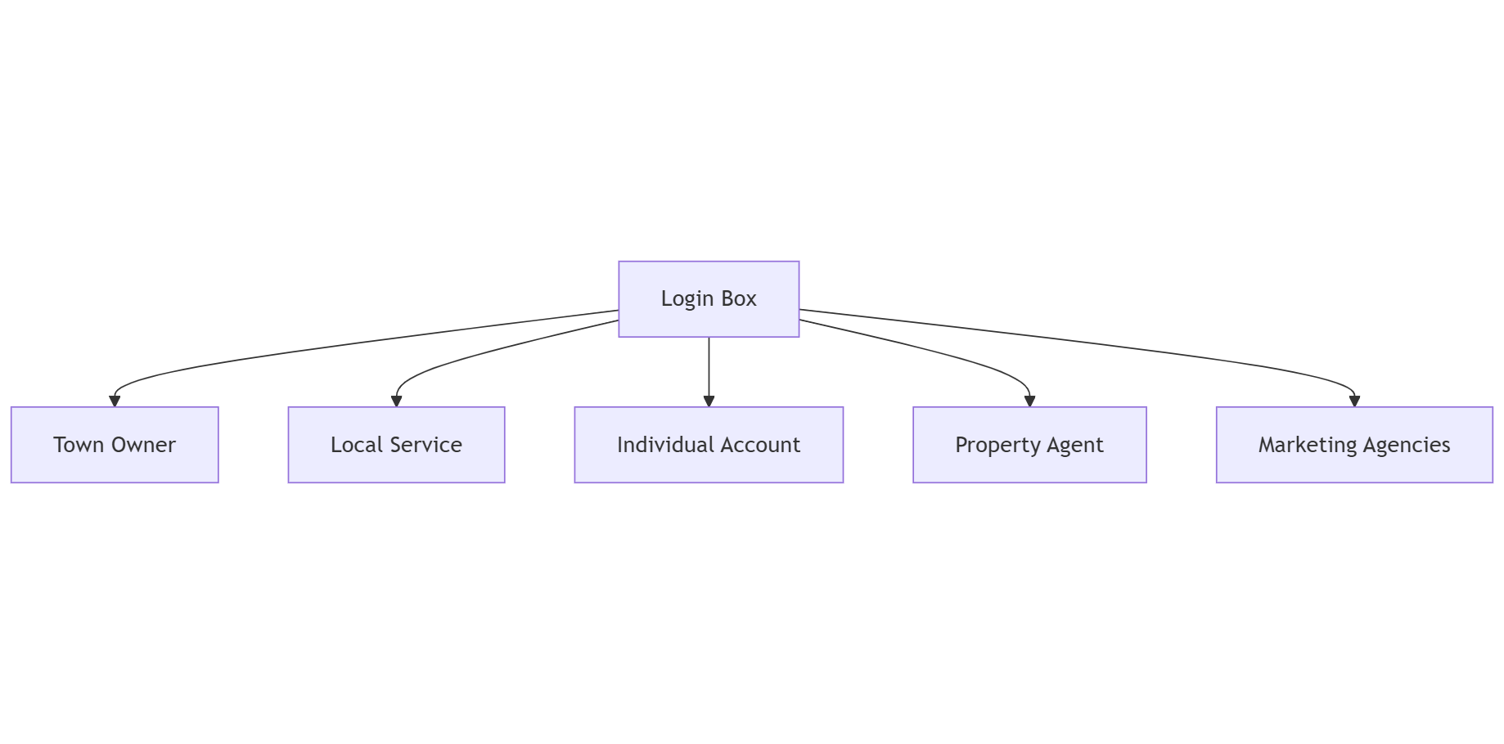

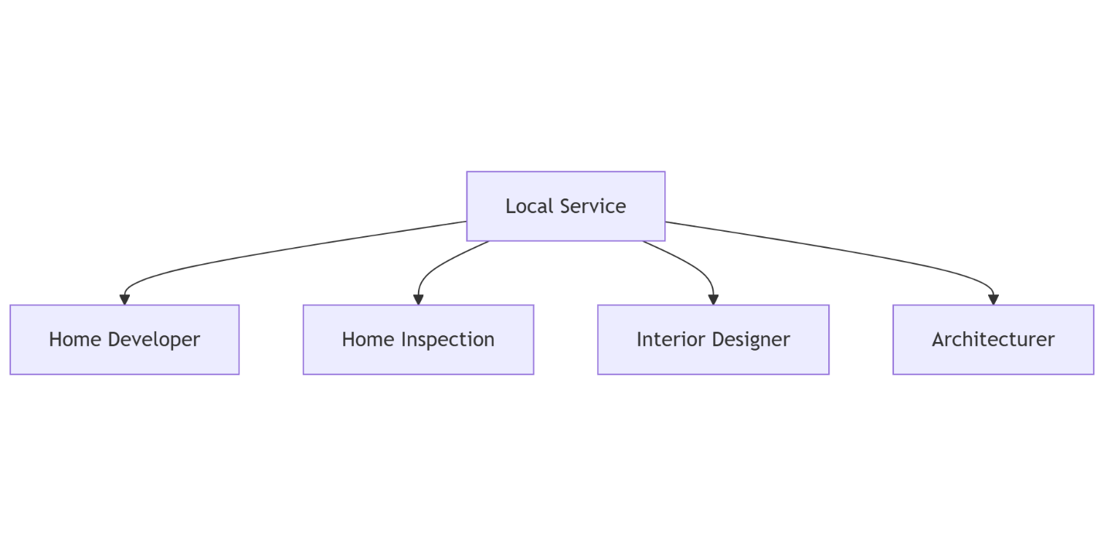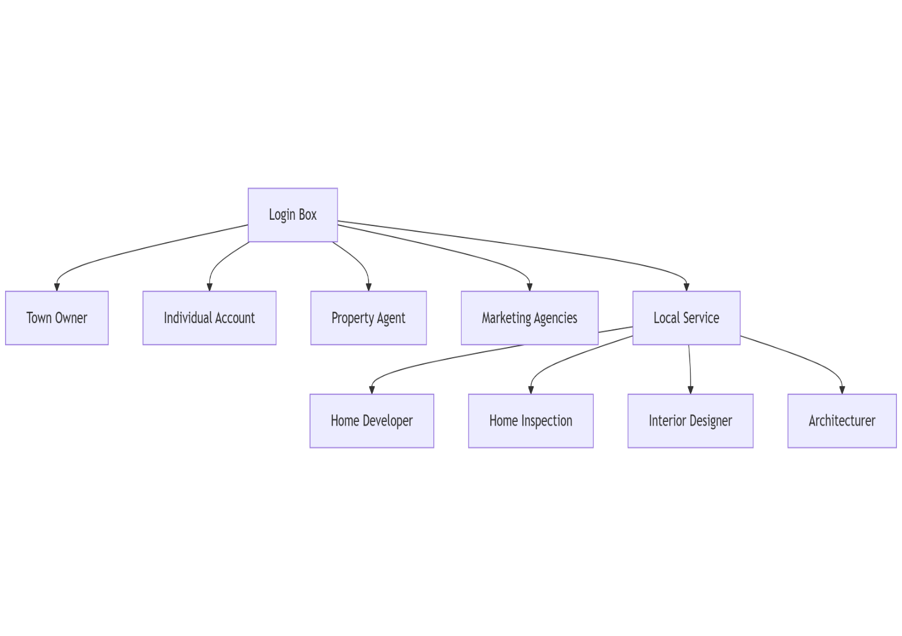

Profile

Seller Profile after login move to this

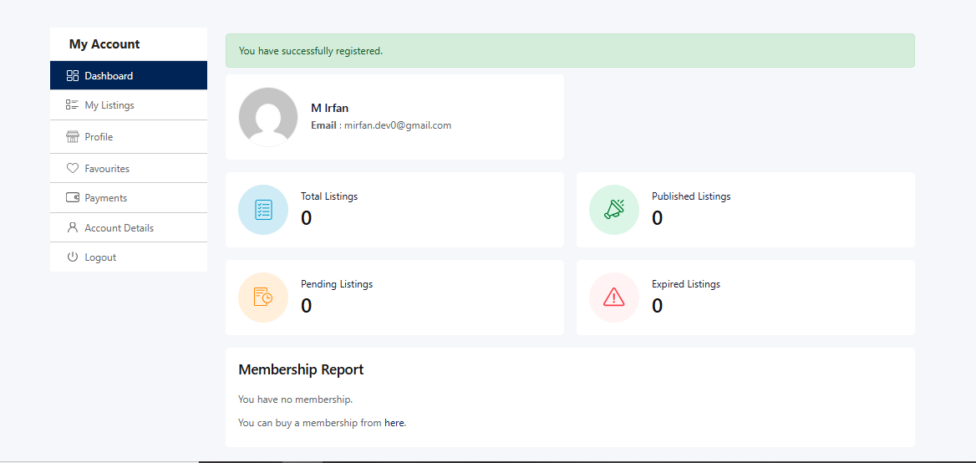

Property Agent, Local Service and Individual services profile show like this

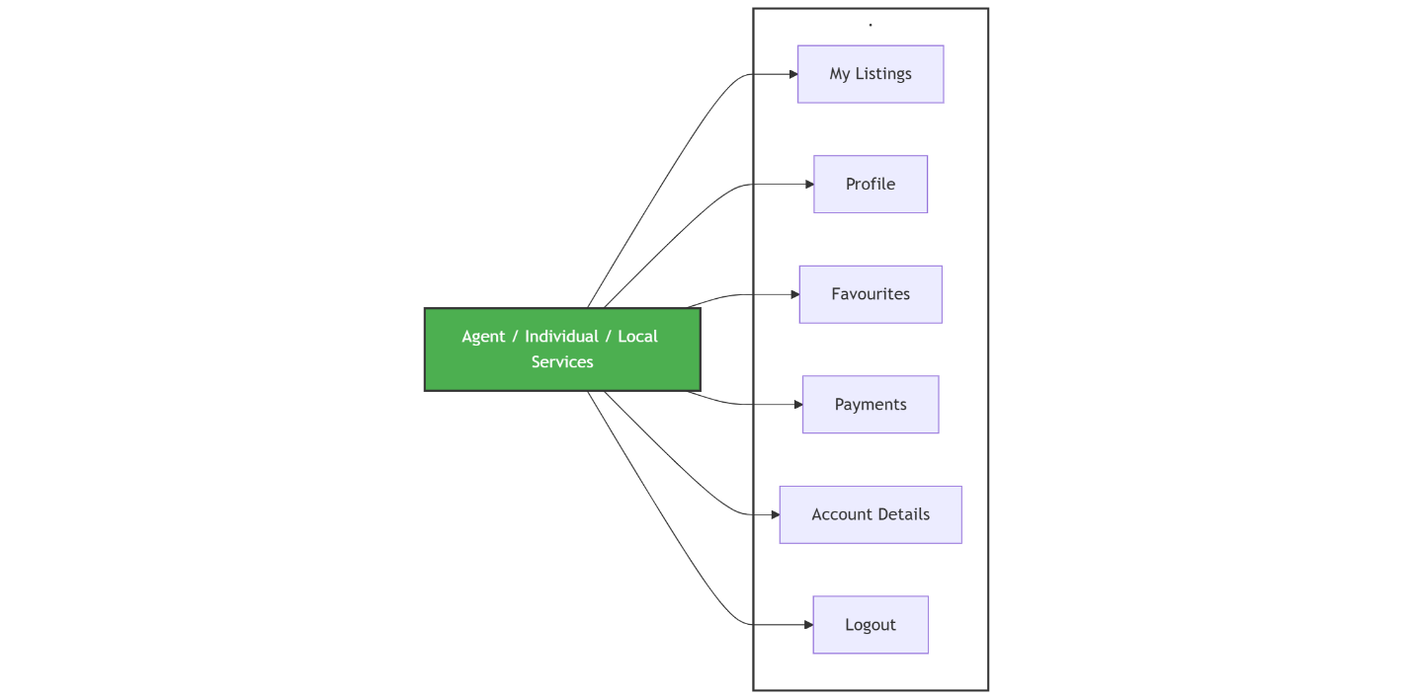

Town owner Dashboard List

