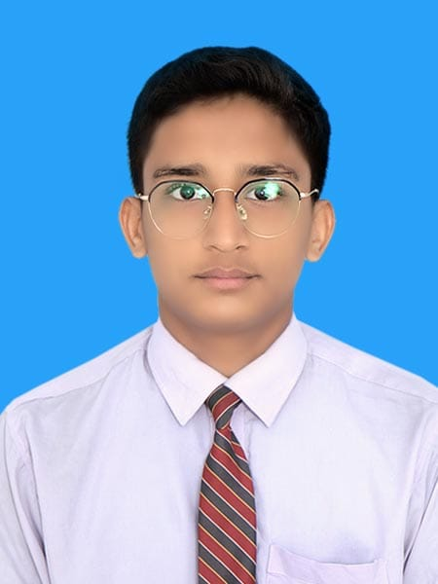

**MUHAMMAD**

Responsive Web Developer

**CONTACT**

🖀**Phone**

+92 3303537918

🖄 **Email**

muhammadmansoor5253@gmail.com

🌍 **Address**

Karachi, Pakistan

**Technical Skills**

* Computer Skills
* Internet Browsing
* Email Communication
* File Management
* Office Automation
* Web designing

**HOBBIES**

* Reading Books
* Sports and Fitness
* Music Enthusiast
* Cooking

**Languages**

* Urdu
* English

**Career Objective**

Seeking a challenging role as a web developer in a leading organization or startup to utilize my knowledge. I pride myself on my management, technical, and database management skills and want an opportunity where I can use my capabilities for the growth and success of the organization.

**Education**

**Higher Secondary Education (12th Grade) 2025**

Adamjee science college, Karachi, Pakistan

**Secondary Education (10th Grade) 2023**

Karachi Public School, Karachi, Pakistan

**Personal Skills**

* Communication Skills
* Teamwork
* Adaptability
* Problem Solving
* Time Management
* Organizational Skills
* Initiative
* Dependability
* Positive Attitude