MAlang Lexical Analyzer
Automata Design
CS4031 — Compiler Construction | Assignment 01 | Spring 2026
Moiz Ansari (23i-0523) | Abdullah Siddiqui (23i-0617)

Regular Expressions

Keywords (Case-Sensitive, Exact Match)
Regex: (start|finish|loop|condition|declare|output|input|function|return|break|continue|else)
Required Keywords: start, finish, loop, condition, declare, output, input, function, return, break, continue, else

Identifiers
Regex: [A-Z][a-z0-9 ]{0,30}
Rules: Must start with uppercase letter (A-Z), followed by lowercase letters, digits, or underscores. Maximum 31 characters total.
Valid: Count, Variable name, X, Total sum 2024
Invalid: count, Variable, 2Count, myVariable

Integer Literals
Regex: [+-]?[0-9]+ Valid: 42, +100, -567, 0
Invalid: 12.34, 1,000

Floating-Point Literals
Regex: [+-]?[0-9]+\.[0-9]{1,6}([eE][+-]?[0-9]+)?
Valid: 3.14, +2.5, -0.123456, 1.5e10, 2.0E-3
Invalid: 3., .14, 1.2345678 (¿6 decimals)

String Literals
Regex: "([ ^"\\\n]|\\["\\ntr])*"
Escape Sequences: \", \\, \n, \t, \r

Character Literals
Regex: ’([ ^’\\\n]|\\[’\\ntr])’

Boolean Literals
Regex: (true|false) (case-sensitive)

Operators
Arithmetic: (\*\*|[+\-*/%])
+, -, *, /, %, ** (exponentiation)
Relational: (==|!=|<=|>=|<|>)
Logical: (&&|\|\||!)
Assignment: (\+=|-=|\*=|/=|=)
Inc/Dec: (\+\+|--)

Punctuators
Regex: [(){}[\][,;:]]
Characters: ( ) { } [ ] , ; :

Comments
Single-line: ##[ ^\n]*
Multi-line: #\*([ ^*]|\*+[ ^*#])*\*+#

Whitespace
Regex: [ \t\r\n]+ (skip but track line numbers)

NFA
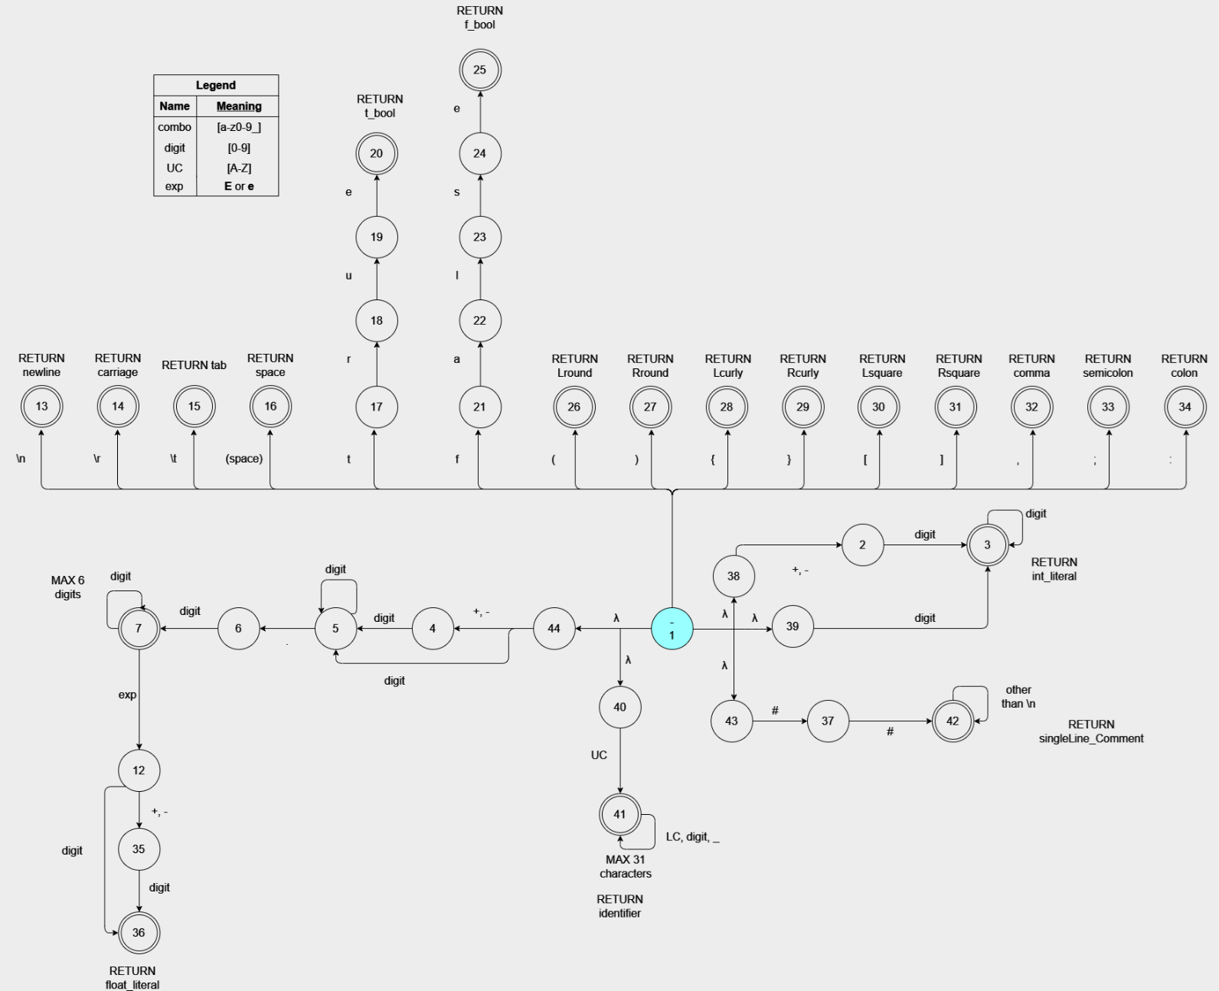

Minimized DFA
