Semester project
Multi-Variable Calculus

Group Members:
Moiz Ansari - 23i-0523
Abdullah Siddique - 23i-0617
Faizan Ur Rehman Khan - 23i-3021
Institute: FAST NUCES Islamabad
Instructor: Sir Imran Shehzad

Table of Contents
Objective of the Problem 2
By-Hand Solution of the Problem 2
Code Flow Diagram 5
Explanation of Major Software Commands Used 5
Example to run the Program 6
Conclusions and Analysis 7
Contributions 7
Difficulties faced 7
2D-Plot 8
Annexure A 8

Objective of the Problem
The main objective of this problem is to have us analyze the behavior of the demand and price of BnB with multiple factors influencing it. This not only includes the price of the product itself which may affect its demand but also the behaviors of products competing with BnB. We are to produce a multivariable function that details the demand of BnB and analyzes its behavior when the price of its competitors is the same as BnB itself and when its price is increased while the competitors stay the same. We are also to observe and report the effects of the increase in price of product A on the demand for BnB. After that, we have to suggest measures to the company that will help increase BnB’s demand.

By-Hand Solution of the Problem
Task 1:
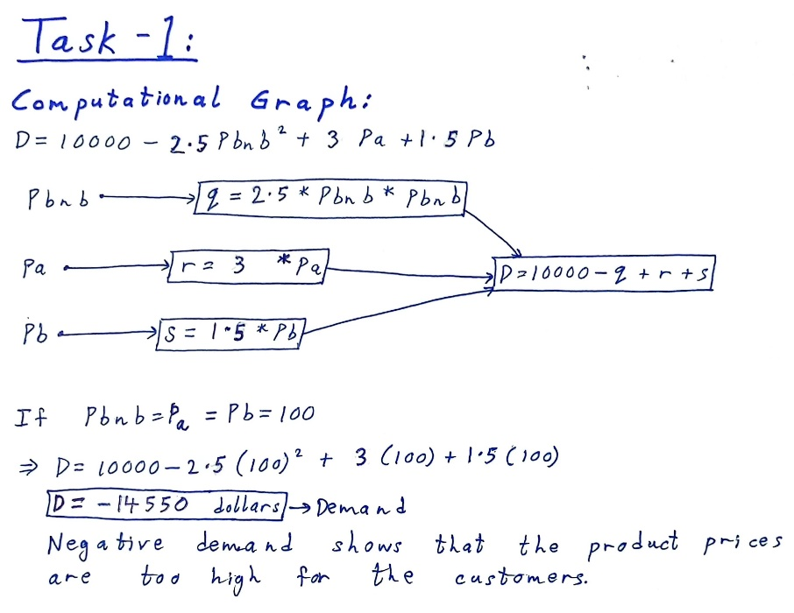

Task 2 & 3:
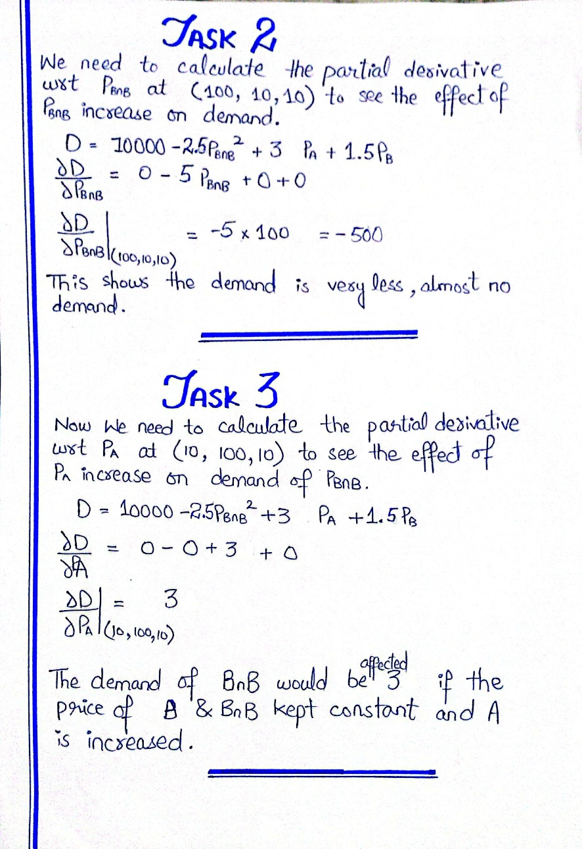

Task 4:
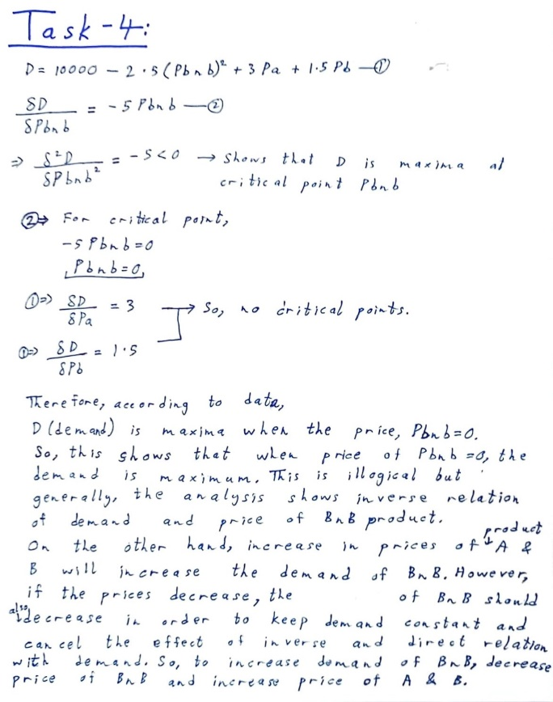

Code Flow Diagram
Importing Library

Printing Member's Name

User's consent to continue

Assuming the Prices of the Product

Calling Demand Automatic Differentiation function

Backend Automatic Computation of function concerning a variable

Returns result

Prints Result

Asking to run another time

If Yes, Continue...else, the Program terminates

Explanation of Major Software Commands Used
We’ve used Python as our platform of choice for writing the software. The main library that’s been used is TensorFlow. This library was chosen due to its features of allowing the user to implement Automatic Differentiation functions like GradientTape()/tape.watch(). After importing the library, one of the major software commands is the declaration of a function Derivative(P_BnB, P_A, P_B), taking in three float arguments which are P_BnB, P_A, and P_B.
Following this, another major software command is tf.GradientTape() where TensorFlow’s GradientTape() function is called. This function produces a context for the implementation of Automatic Differentiation, where operations involved with Automatic Differentiation can be monitored. Another major software command is tape.watch() which instructs the library to monitor the previous tensor argument which is doing the calculations in the backend.
Another very important software command that has been used is the tape.gradient() function whose parameters include a function based on the demand and P_BnB. This function computes the gradient. Lastly, another major software command that’s been used is the usage of the original Derivative function which calculates the effect of the price changes on the respective products.

Example to run the Program
There are two major code-based parts of the Project. One deals with Task 2 and the other deals with Task 3, where both Tasks analyze the effect of an increase in BnB’s price on its demand and analyze the effect of an increase in Product A’s price on the demand of BnB respectively.
One needs to download TensorFlow for the usage of this specific program. The program can be run on any major code editor with the use of Python which can be downloaded from the Microsoft office or as an APK from Python’s own website. When you’re done with these prerequisites, you can run the program easily.
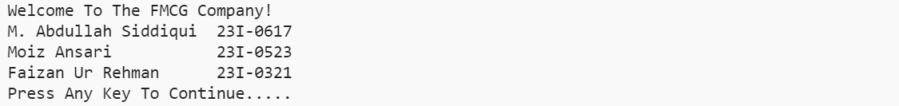
On the console, after the introduction of the group members, you’ll be prompted to “Press any key to continue…”, to which the user can press any key for the program to start running. After this, the program will run and ask the user to input price of BnB, and then use Automatic Differentiation to calculate how much the demand for BnB is affected by an increase in the price of the Product.
Then the program will prompt you with a choice to run another query. If you choose to do so, you may input ‘y’, and if you want to terminate the program, input ’n’.
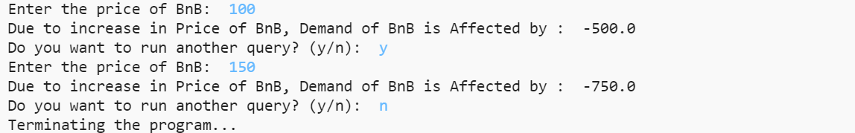
This is the due process for the Python script of Task 2.
The initial prerequisites remain the same for the Task 3 program, where the console output is the same except that the program outputs the effect on the demand of BnB due to an increase in the price of product A.
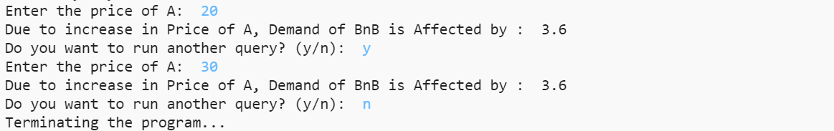

Conclusions and Analysis
In the end, the problem is multifaceted where the demand for one product, BnB, is not only affected by the increase or decrease of its price, but also the changes in the prices of its competitors, which are Product A and Product B. The final conclusion is that all these factors do affect the demand for BnB significantly, with an increase in the price of BnB lowering the demand by -600, whereas an increase in the price of Product A, increasing the demand for BnB by 3.6.
Thus, the final suggestion for the company is to take measures that increase the price of product A/B and decrease the price of BnB itself. This could be done through more effective marketing strategies, and outsourcing various parts of the process of BnB manufacturing to lower the costs of its production and thus, increase its demand exponentially.

Contributions
Abdullah Siddiqui: Task 2 and Task 3 which include writing the code and doing the by-hand solutions.
Moiz Ansari: Task 1 and Task 4 which includes forming the equation and giving suggestions to the company.
Faizan Ur Rehman Khan: Forming the entirety of the report, including methodology, detailing all solutions.

Difficulties faced
One of the major problems faced was the formation of the demand equation itself, which was followed by researching Automatic Differentiation and all the methods it could implement. This was resolved through extensive trial and error. Looking through different Python libraries in order to choose which one was the most ideal for our usage was also a difficult task but it was overcome with a joint research effort.

2D-Plot
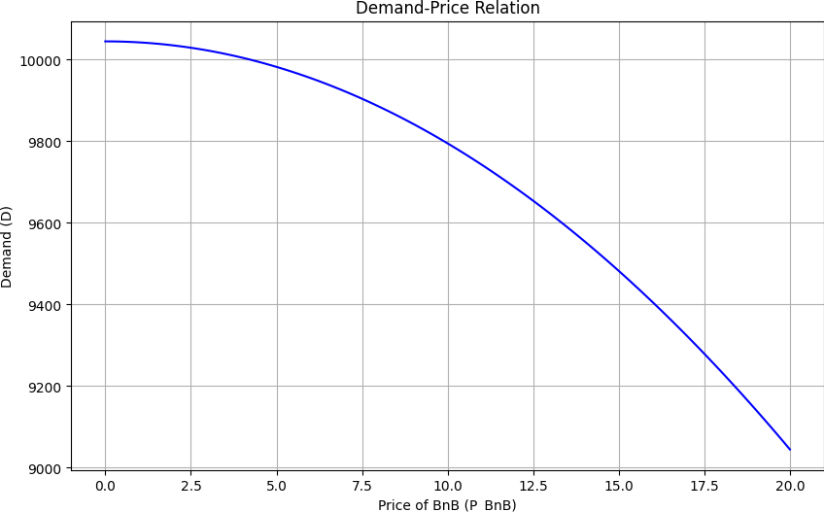
For prices, Pa = Pb = 10

Annexure A
Task 2:
import tensorflow as tf # Importing TensorFlow Library for Automatic Differentiation

print("Welcome To The FMCG Company!")
print("M. Abdullah Siddiqui 23I-0617")
print("Moiz Ansari 23I-0523")
print("Faizan Ur Rehman 23I-0321")
input("Press Any Key To Continue.....") # Generate response according to user Input

def Derivative(P_BnB, P_A, P_B): # User Defined Function For Calculating Derivative
with tf.GradientTape() as tape: # Used for Automatic Differentiation Based on inputs
tape.watch(P_BnB) # Track operations involving P_BnB
Function = 10000 - 2.5 * tf.pow(P_BnB, 2) + 3 * P_A + 1.5 * P_B # Making Function

Change = tape.gradient(Function, P_BnB) # Used for Automatic Differentiation Based on inputs

return Change # Returning The result of the defined function to the Called Place

def main():
while True:
# Assumed Values For Task 2
P_A = 10.0 # Same Price Of A & B Products
P_B = 10.0
P_BnB = float(input("Enter the price of BnB: ")) # Take input for Pbnb from the user

# Calculating The Effect
Effect = Derivative(tf.constant(P_BnB, dtype=tf.float32), tf.constant(P_A, dtype=tf.float32), tf.constant(P_B, dtype=tf.float32)) # Calling The Defined Function

print("Due to increase in Price of BnB, Demand of BnB is Affected by : ", Effect.numpy()) # Printing The Results

user_input = input("Do you want to run another query? (y/n): ").lower()
if user_input == "n":
print("Terminating the program...")
break

if __name__ == "__main__":
main()

Task 3:
import tensorflow as tf # Importing TensorFlow Library for Automatic Differentiation
print("Welcome To The FMCG Company!")
print("M. Abdullah Siddiqui 23I-0617")
print("Moiz Ansari 23I-0523")
print("Faizan Ur Rehman 23I-0321")
input("Press Any Key To Continue.....") # Generate response according to user Input

def Derivative(P_BnB, P_A, P_B): # User Defined Function For Calculating Derivative
with tf.GradientTape() as tape: # Used for Automatic Differentiation Based on inputs
tape.watch(P_A) # Track operations involving P_BnB
Function = 10000 - 3 * tf.pow(P_BnB, 2) + 3.6 * P_A + 1.8 * P_B # Making Function

Change = tape.gradient(Function, P_A) # Used for Automatic Differentiation Based on inputs

return Change # Returning The result of the defined function to the Called Place

def main():
while True:
# Assumed Values For Task 2
# Different Price Of A Product
P_A = float(input("Enter the price of A: ")) # Take input for Pbnb from the user
P_B = 10.0 # Same Price of BnB and B
P_BnB = 10.0

# Calculating The Effect
Effect = Derivative(tf.constant(P_BnB, dtype=tf.float32), tf.constant(P_A, dtype=tf.float32), tf.constant(P_B, dtype=tf.float32)) # Calling The Defined Function

print("Due to increase in Price of A, Demand of BnB is Affected by : ", Effect.numpy()) # Printing The Results

user_input = input("Do you want to run another query? (y/n): ").lower()
if user_input == "n":
print("Terminating the program...")
break

if __name__ == "__main__":
main()

