3/12/2023
COURSE INTSTRUCTOR: USMAN RASHID

Compiled by
Moiz Ansari (23i-0523) SEC-F
Minahil Kashif (23i-0554) SEC-F
Izza Urooj (23i-0669) SEC-F
CALCULUS AND ANALYTICAL GEOMETRY
Final Project Report


Contents
Introduction 2
Objectives of the problem 2
By-Hand Solution 2
MATLAB Code 4
Explanation of Commands: 7
Step by Step Example of MATLAB Solution 7
Instruction Manual 9
Results 9
Flowchart of the Methodology 10
Conclusion 11
Contributions 11

Introduction
Our business customizes wood beams for optimal strength, utilizing customer-supplied raw wood. Using MATLAB and optimization, we identify precise dimensions, marrying traditional craftsmanship with modern efficiency.

Objectives of the problem
- Optimal Design: Develop a program to find the strongest cross-sectional dimensions for wood beams from raw logs.
- Versatile Material Use: Allow customers to use any wood, optimizing for strength, grain density, and resistance.
- Structural Efficiency: Utilize MATLAB for an efficient interface that outputs the strongest beam dimensions from the input log diameter.

By-Hand Solution
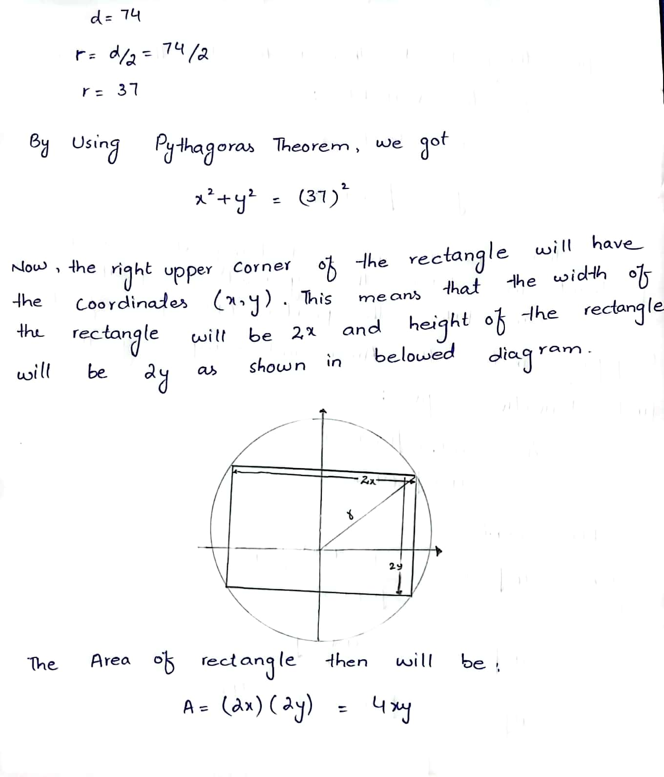
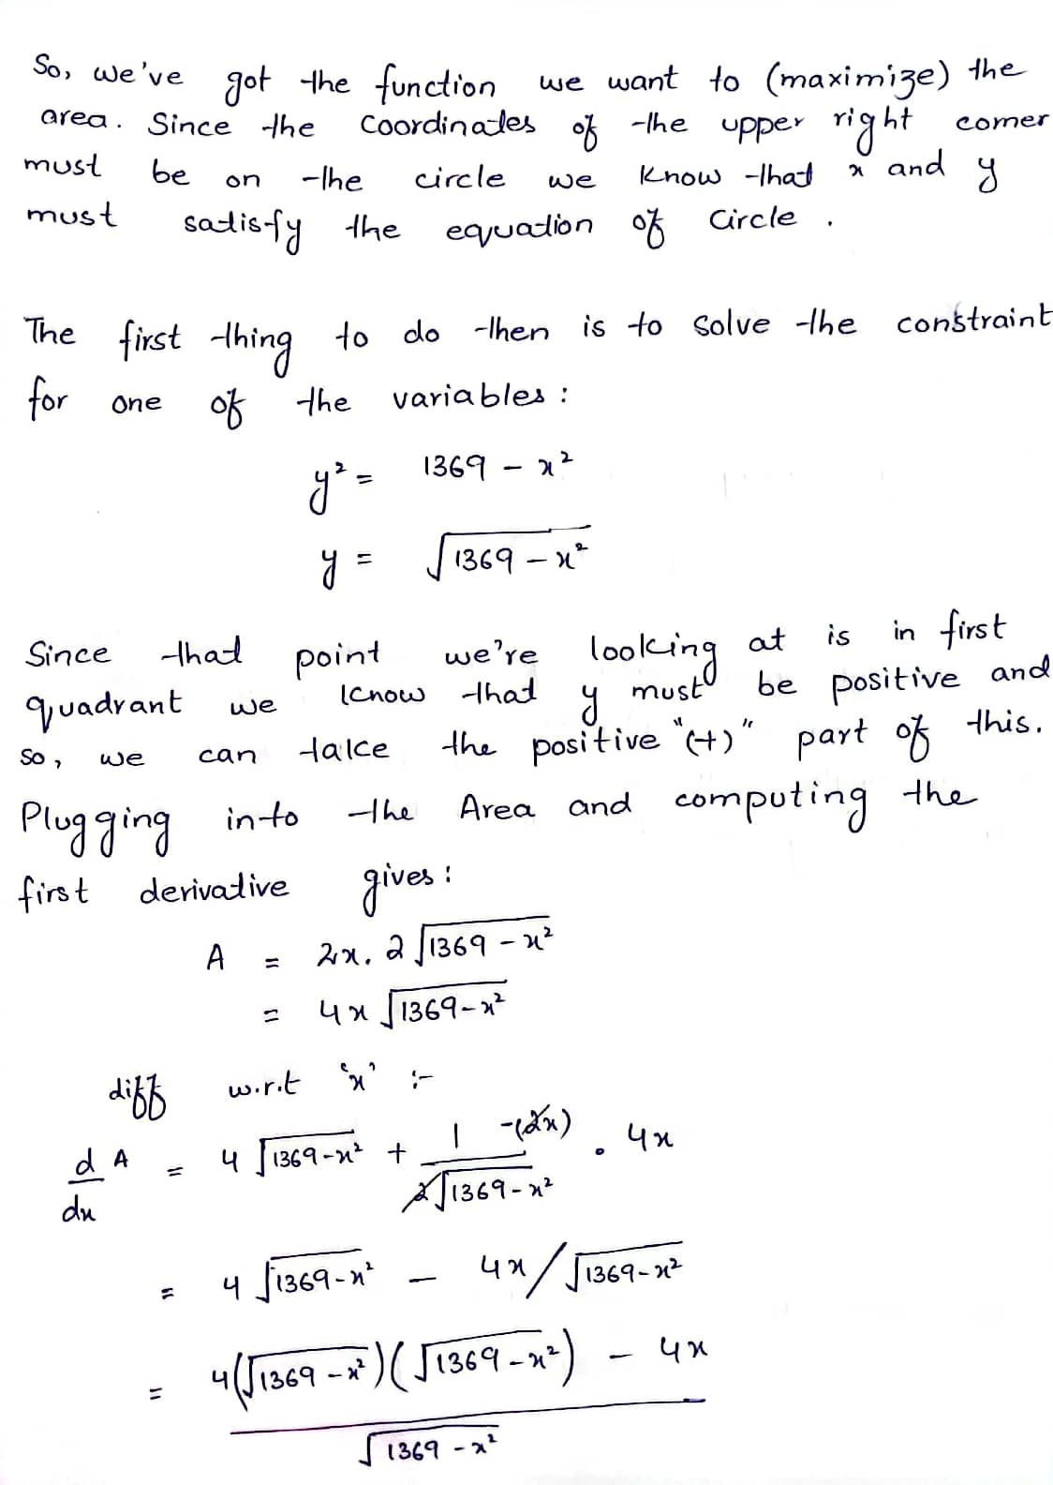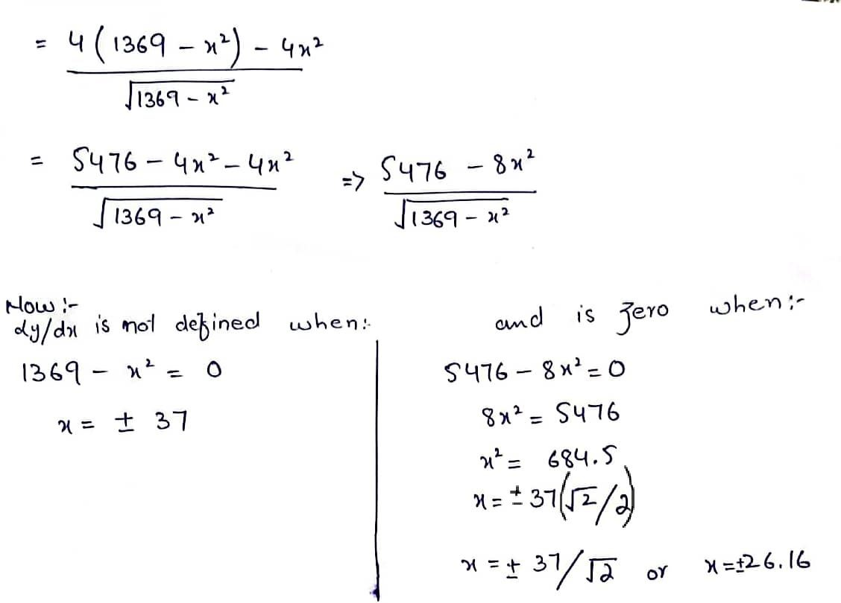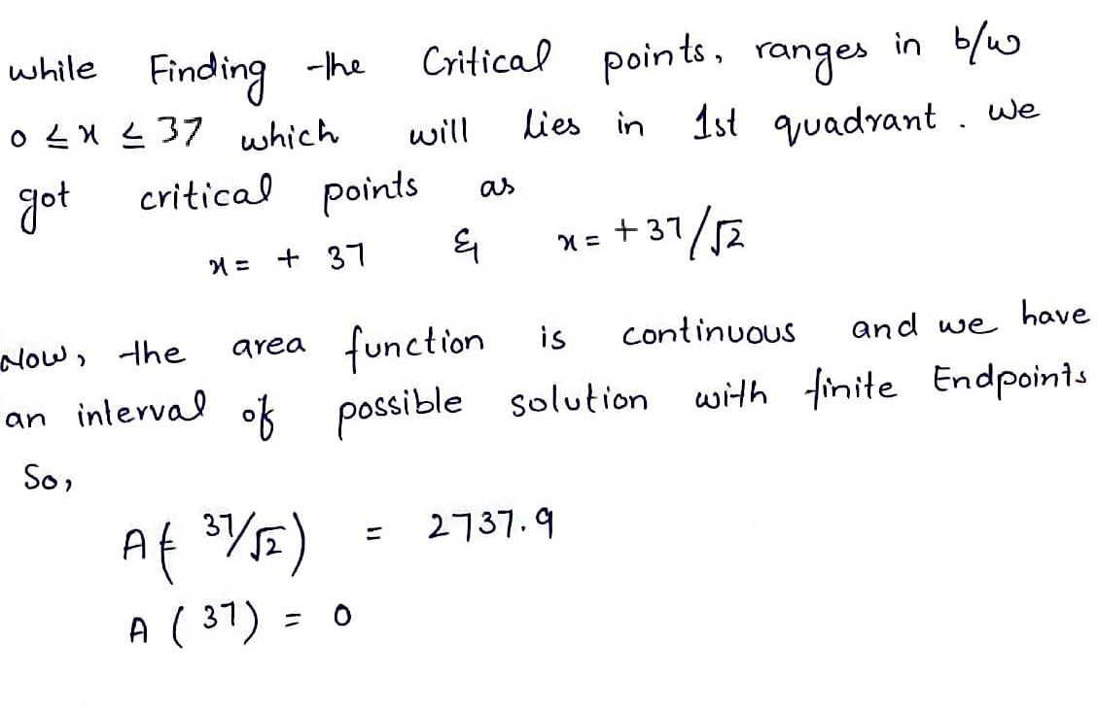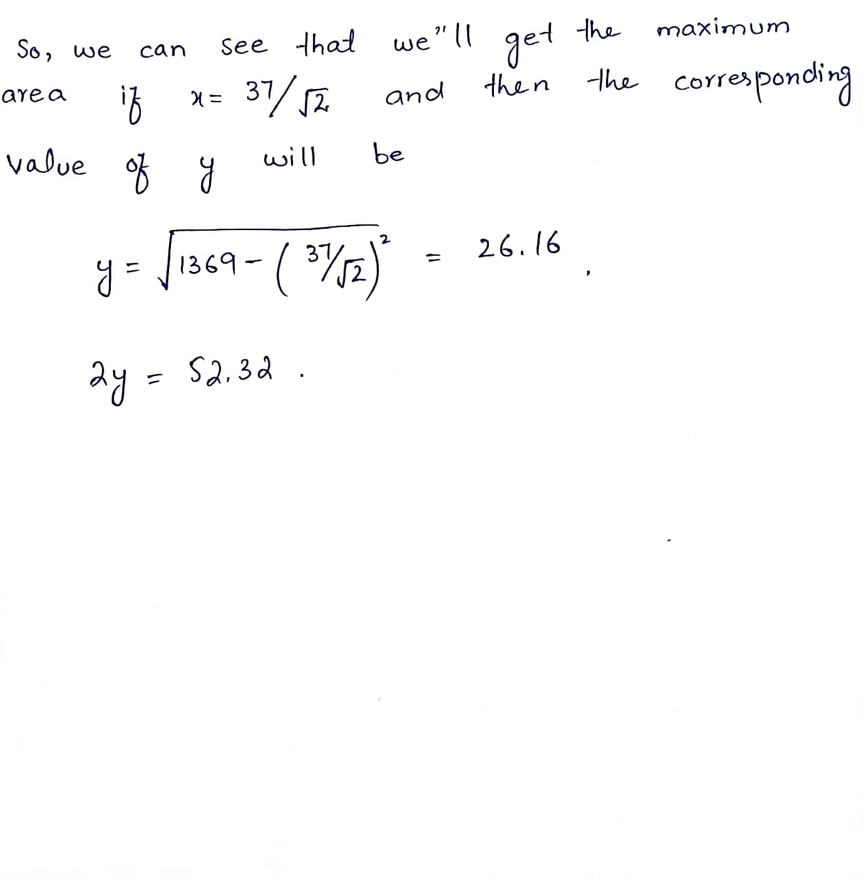

MATLAB Code
n=1; % Initializing variable to be used in loop
while n > 0 % Starting loop
disp('WELCOME TO MMI Software House'); %Displaying names of software house
disp("Programming Team: ");
disp("1. Moiz Ansari (23i-0523)");
disp("2. Minahil Kashif (23i-0554)");
disp("3. Izza Urooj (23i-0669)");
disp(" ");
%Waiting for presskey:
disp("Press any key to continue...");
disp(" ");
pause;
%Taking input:
diameter = input ("Enter the Diameter of the log (in inches): ");
disp(" ");
%Declaring variables:
syms x;
% Assuming x to be a real variable
assume (x, 'real');
%Radius of log:
r = diameter / 2;
%By using Pythagoras theorem:
%x^2 + y^2 = r^2-----Eq1
%Area of rectangle:
%A(x) = 4*x*y;
%Using eq 1:
y(x) = sqrt(power(r,2)-power(x,2));
%Area:
A(x) = 4*x*y(x);
%Differntating A w.r.t x:
y1(x) = diff(A,x);
%Solving (derivative of A(x)) = 0:
%When A'(x) = 0;
critical_point1 = solve(y1(x));
%Taking only poitive values:
result1 = abs(critical_point1);
%Checking range value for critical point 1:
critical_point1 = abs(critical_point1);
if critical_point1<=r
result1 = critical_point1;
else
result1 = 0;
end
%Printing critical point 1:
disp("Critical point 1: ");
disp(result1);
%When A'(x) is not defined:
critical_point2 = solve(y);
%Taking only poitive values:
critical_point2 = abs(critical_point2);
%Checking range value for critical point 2:
if critical_point2<=r
result2 = critical_point2;
else
result2 = 0;
end
%Printing critical point 2:
disp("Critical point 2: ");
disp(result2);
%Checking which critical point gives larger area:
%...
n1 = A(result1);
n2 = A(result2);
if n1>n2
X = result1;
else
X = result2;
end
%...
%Calculating y dimensions:
Y = sqrt(power(r,2)-power(X,2));
dim_y = 2*Y;
dim_x = 2*X;
%Printing Dimensions:
disp("Dimension x = ");
disp(dim_x);
disp("Dimension y = ");
disp(dim_y);
%Asks user if run program again or not:
reply = input ('Do you wish to run another query? Y/N [Y]:', 's');
if strcmpi(reply,'Y') %Ignores case sensitive
n=1;
else
n=0;
end
end

Explanation of Commands:
- while : loop used to run the program again and again
- disp : to display the text and results
- pause: for execution until a key is pressed.
- input : to take input from user
- if else : to check if a condition is true or not
- syms: to declare symbolic variables
- assume : to assume that the variable is a real number
- diff: to find the derivative of the equation
- solve: to solve the equation at a particular value
- strcmpi : to compare two strings, ignoring case sensitivity.

Step by Step Example of MATLAB Solution
- We initialize our variable n and initiate a while loop which will iterate throughout the code.
Displaying the names of the group members and asking the user to press a key that makes the code start running again.
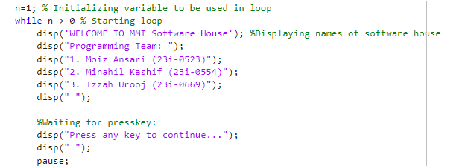
- OUTPUT
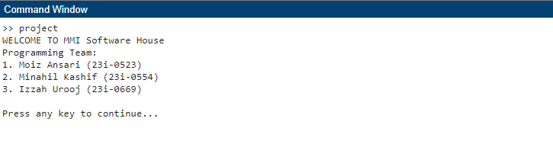
- Taking Input of the diameter of the log and calculating the radius.
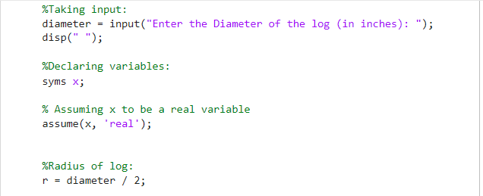
- OUTPUT
- - Declaring Pythagoras theorem as eq1 and Area of Rectangle as A(x)
-Taking the derivative of A(x) w.r.t x and equating it to 0 to find the critical point.
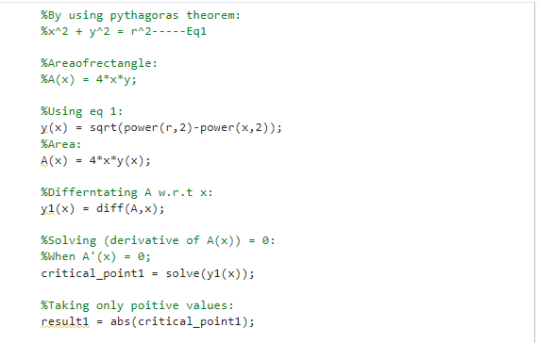
-Checking if it lies within the possible range if it does it is one side of the Rectangle and we print it, otherwise it is not.
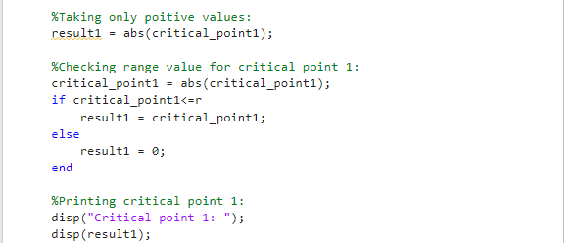
- Solve y(x) and find the 2nd critical point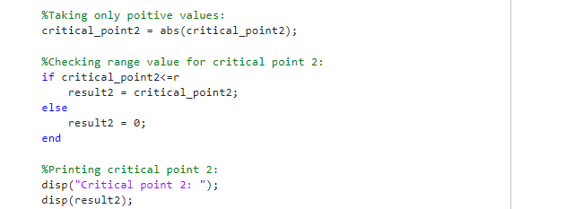
- OUTPUT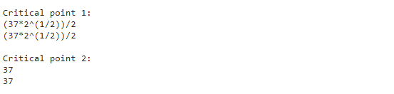
- Checking which point gives the larger area and using that to calculate the dimensions.
- Prompting the user to check if they want to run the program again.
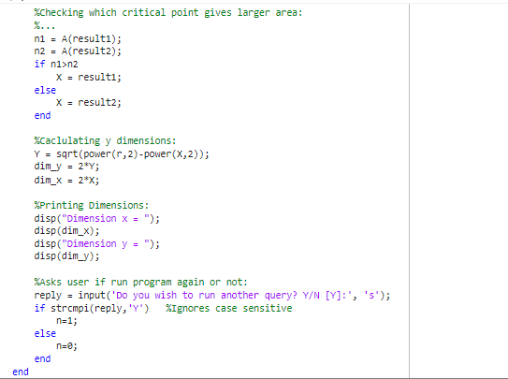
- OUTPUT

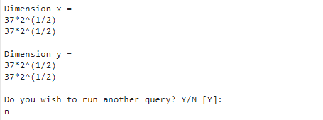

Instruction Manual
- First press any key to start the program.
- Then enter the diameter and press enter.
- The result will then appear on the command window.
- Now if you want to run the program again and don’t want to quit then press ‘y’.
- Otherwise press ‘n’ to exit the program.
- If you choose to start the program again, then the same procedure is repeated.

Results
The program result is the dimensions of cross-section of the strongest beam possible to be cut from the log.
Our results were the same as the by hand solution.

Flowchart of the Methodology
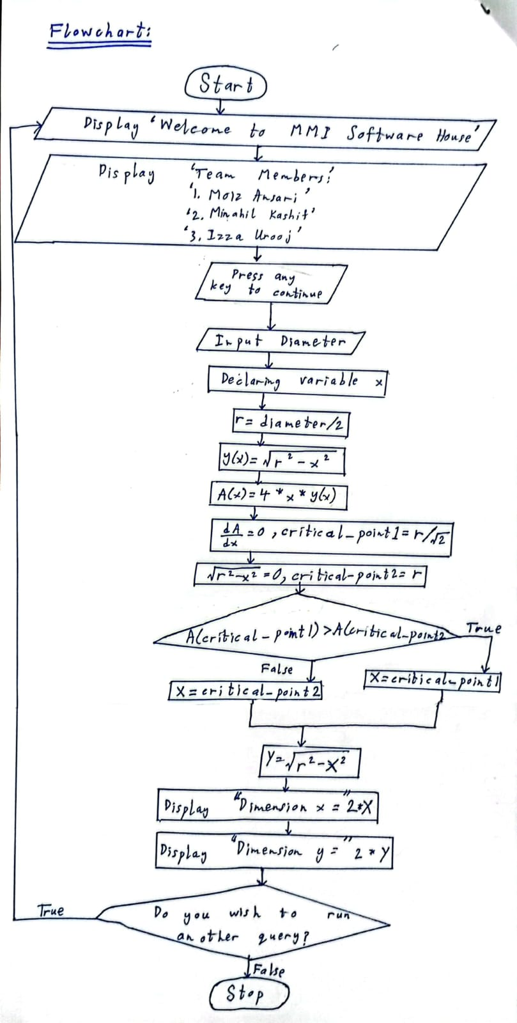

Conclusion
- Summary of the problem
The problem was about optimization. We had to use optimization techniques to find the best possible way to make a beam out of a wooden log.
- Results
We used 2 equations, derivated them, and evaluated them to find the cross-section of the strongest wooden beams.

- Difficulties faced
We faced diffuculties in finding the commands to make the equations and to find the critical points. We researched online to find the required commands.

Contributions
All 3 of us formulated the working of the problem together.
- Izzah Urooj wrote the final step-by-step solution of the problem.
- Moiz Ansari wrote the codes for the loops, the equations, and the derivations in the MATLAB program
- Minahil Kashif demonstrated the MATLAB solution step-by-step using an example.

