Lab #02 **Vingere Cipher (Encryption & Decryption)**

To encrypt, a table of alphabets can be used, termed a **[tabula recta](https://en.wikipedia.org/wiki/Tabula_recta" \o "Tabula recta)**, ***Vigenere square***or ***Vigenere table***. It has the alphabet written out 26 times in different rows, each alphabet shifted cyclically to the left compared to the previous alphabet, corresponding to the 26 possible Caesar ciphers. At different points in the encryption process, the cipher uses a different alphabet from one of the rows. The alphabet used at each point depends on a repeating keyword.

**Mathematically:**

*Vigenere encryption E using the key K can be written as,*

*Ci = (Mi + Ki) mod 26*

*Vigenere decryption E using the key K can be written as,*

*Ci = (Mi - Ki) mod 26*

**Deployed URL:**

https://muhammad-muneeb-ubit.github.io/encryption-decryption-vingere-ciepher/

**Source Code**

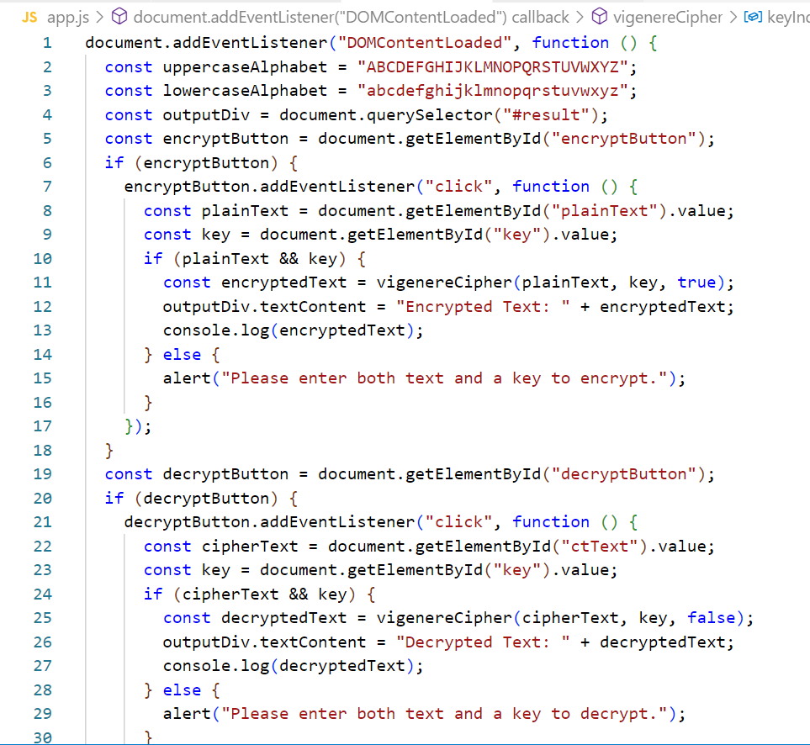

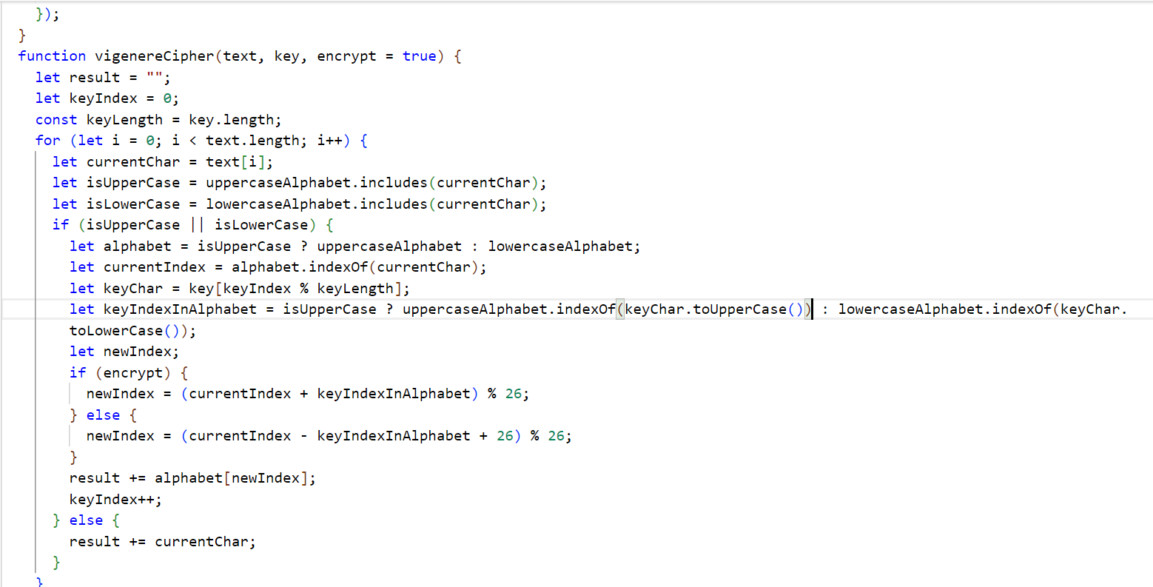

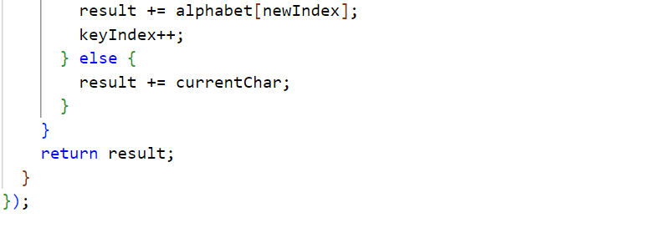

**Output:**

**Encryption**

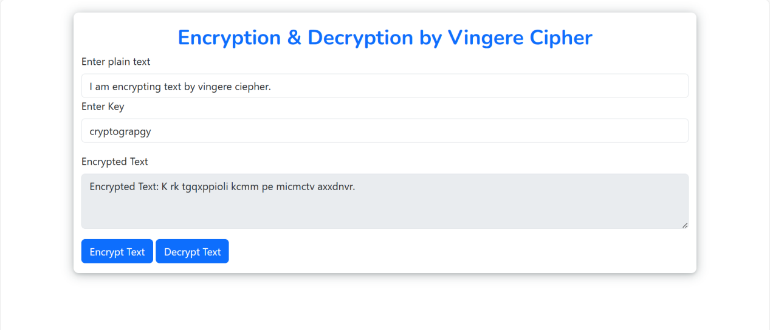

**Decryption:**

