MUHAMMAD MUSA
202505920
Census Project Report
Final Assessment

Table of Contents
1. Introduction 2
2. Data Cleaning 2
3. Population Demographics 3
Age Structure 3
Marital Status 3
Employment Trends 3
Religion 4
Infirmity 4
4. Detailed Analysis 4
Birth and Death Rates 4
Migration Trends 4
Commuter Behavior 5
Household Occupancy 5
5. Recommendations 5
(a) Development of the Unoccupied Plot of Land 5
(b) Investment in Community Services 6
6. Conclusion 6
7. Bibliography 6

Introduction
The aim of this project is to analyze the census data of a moderately sized town located between two major cities, in order to support decisions on future investment and development. The primary goal is to identify the most appropriate use for an unoccupied plot of land and to determine which community service area would benefit most from further investment.
The dataset used for this analysis was generated to mimic the format of the 1881 UK census, although the demographic and occupational profiles reflect a modern population. It includes a range of information about the residents, such as age, gender, marital status, employment, religion, household structure, and infirmities.
Before undertaking any analysis, the data was thoroughly cleaned to correct missing or inconsistent entries. Following this, various analyses were carried out to explore the town’s demographic trends, employment patterns, migration movements, and community needs. The findings of this analysis have been used to make evidence-based recommendations that aim to best serve the current and future needs of the town’s population.

Data Cleaning
Before conducting any analysis, the census dataset was carefully cleaned to ensure the reliability of the results. Several inconsistencies and missing values were identified during the initial inspection, and a structured approach was applied to correct these issues.
Firstly, missing marital status entries for minors under the age of 16 were addressed by assigning a value of “N/A,” reflecting that individuals below this age are unlikely to be married. Similarly, records of religion for individuals under 18 were set to missing, as most minors in the dataset had no religious affiliation recorded.
Unrealistic or inappropriate entries in the religion field, such as “Sith,” “Housekeeper,” and “Ironer,” were reclassified as “None.” This decision was informed by the understanding that some participants may input non-serious responses, a phenomenon documented in real census collections (BBC, 2016).
Entries with implausible ages, such as individuals recorded as being older than 110 years, were corrected by setting the age to missing. Households containing illegal or highly improbable conditions, such as children under 16 being married, were entirely removed from the dataset to maintain data integrity (Marriage Act, 1949; NSPCC, 2020).
Missing occupation values were filled with “Unknown” to allow employment analyses to proceed without bias. An employment category variable was created to classify individuals as Employed, Student, Unemployed, or Retired based on their recorded occupation. Age bands were generated in five-year intervals to assist in visualizing the population structure, and household occupancy levels were calculated by counting the number of individuals per dwelling.
After these cleaning steps, the dataset was free from critical missing values in key fields such as age, gender, occupation, and religion, ensuring that all subsequent analyses were based on reliable and coherent data.

Population Demographics
Following the data cleaning process, the census dataset provides a comprehensive overview of the town’s population characteristics.
The average age of the residents is approximately 36 years, indicating a relatively young and economically active community. The gender distribution is fairly balanced, with no significant skew towards either male or female residents.

Age Structure
An analysis of the age distribution shows that the population is concentrated in the working-age bands, particularly between 25 and 55 years old. The number of young children, particularly those aged 0–4 years, is relatively low, suggesting a declining birth rate. The population pyramid also indicates that individuals tend to live well into old age, with a gradual tapering at the higher age bands.
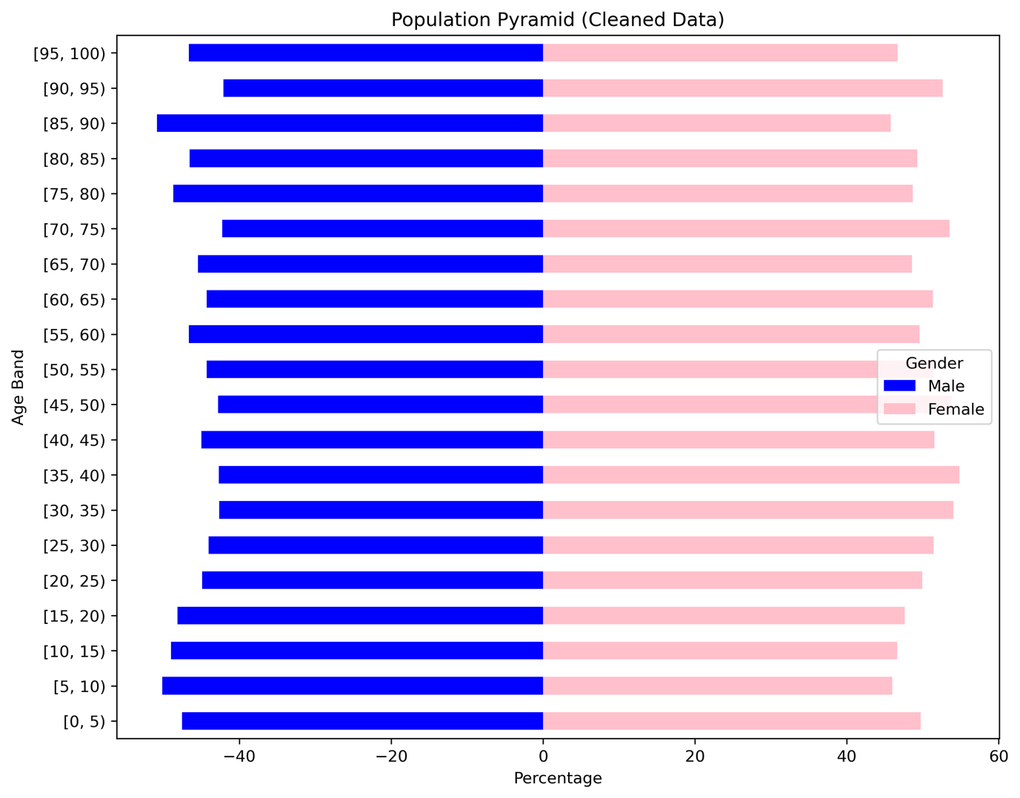
Figure 1- Population Pyramid

Marital Status
Most adults in the town are either married or single, with smaller proportions being divorced or widowed. As expected, individuals under the age of 16 primarily have “N/A” recorded for their marital status. The divorce rate among women appears slightly higher than that among men, which may have implications for household occupancy and migration trends discussed later.
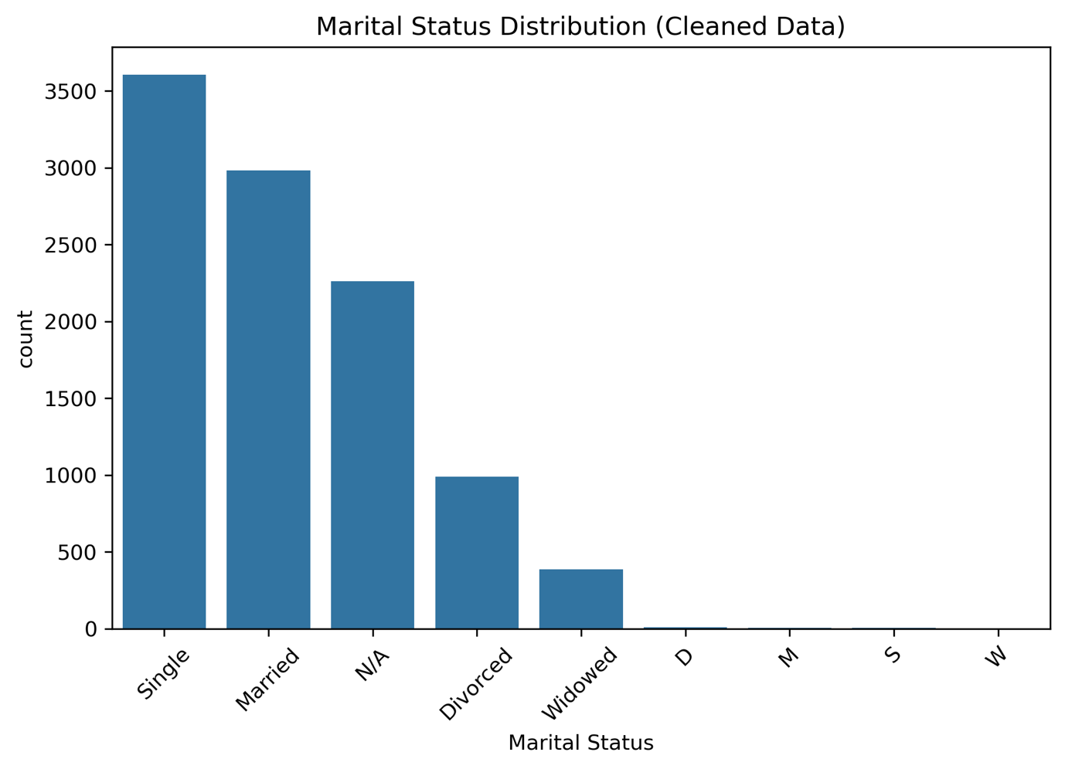
Figure 2- Marital Status Distribution Chart

Employment Trends
Employment is the dominant category among adults, followed by students and retired individuals. Unemployment rates, while present, are not excessively high, though a detailed analysis of unemployment trends is provided in a later section (ONS, 2020).
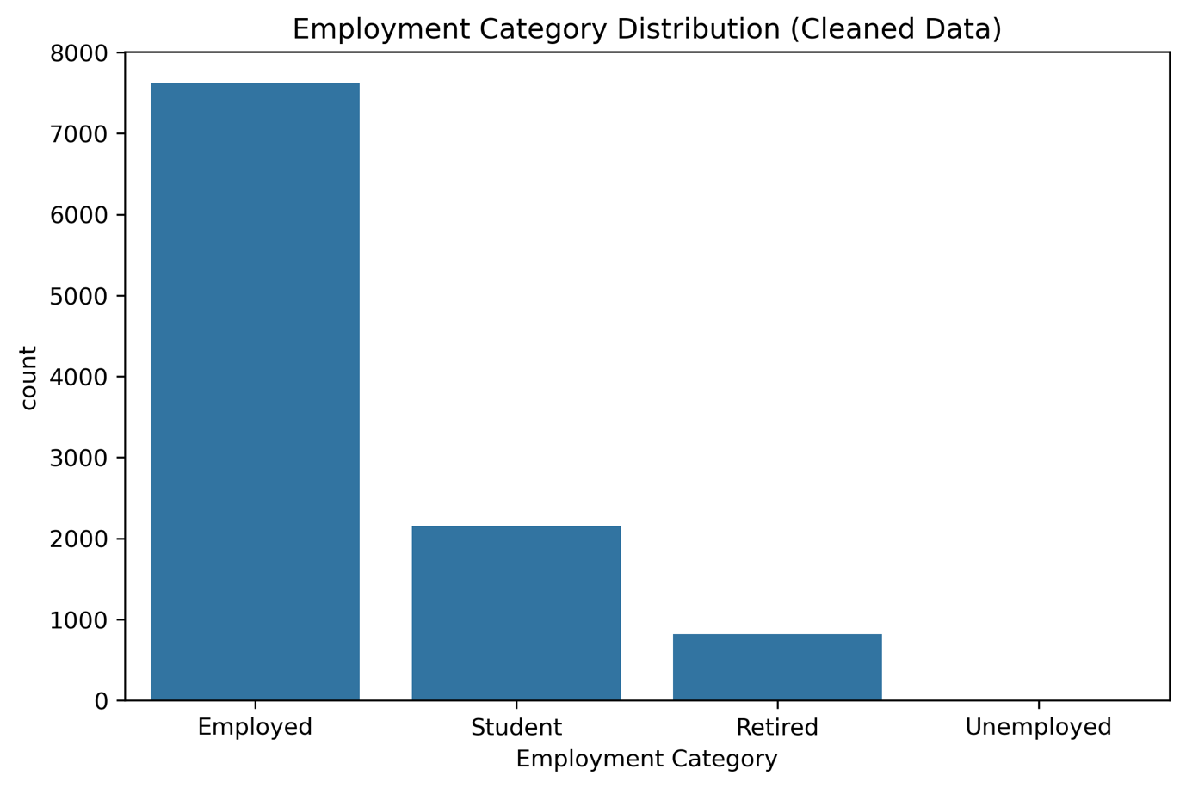
Figure 3- Employment Category Distribution Chart

Religion
Religion in the town is relatively homogeneous, with the majority of individuals identifying with a small number of major faiths. A significant portion of the population either declared no religion or chose not to disclose one. Minority religions exist but in small numbers and are unlikely to necessitate additional religious infrastructure at present (ONS, 2016).
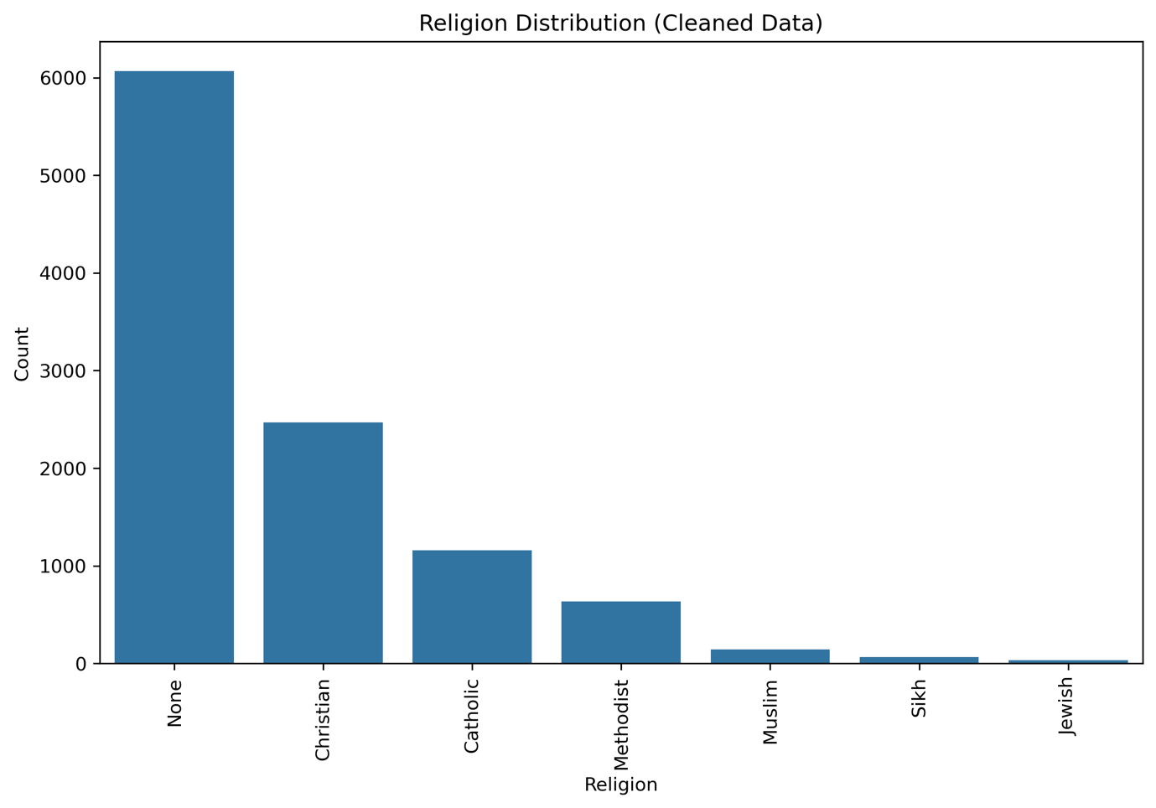
Figure 4- Religion Distribution Chart

Infirmity
Infirmity rates are low across the population, with fewer than 1% of individuals reporting any form of infirmity. As such, infirmity is not expected to be a significant factor in current service planning, though it may become more important as the population ages.

Detailed Analysis

Birth and Death Rates
The town’s crude birth rate is estimated at approximately 11 births per 1,000 residents, calculated based on the number of children aged 0–4 relative to the total population. In comparison, the estimated crude death rate stands at around 8.5 deaths per 1,000 residents, based on the reduction of population counts in the older age bands (65 years and above) (Eurostat, 2017).
These figures suggest that the town is experiencing modest natural growth. However, the relatively low birth rate, coupled with an aging population, implies that population growth through natural increase is likely to slow in the coming years.

Migration Trends
Migration plays an important role in shaping the town’s demographics. Analysis indicates a steady inflow and outflow of residents, particularly among university students and young professionals.
- Immigration: Lodgers and young single individuals make up a notable portion of new residents, attracted by affordable housing and proximity to nearby cities.
- Emigration: Divorcees, particularly males, and young graduates leaving after completing their studies, account for a significant proportion of residents moving away from the town.
Overall, immigration slightly exceeds emigration, suggesting that while the town is not expanding rapidly, it maintains a relatively stable population through new arrivals.

Commuter Behavior
The town has a high number of commuters. University students, who represent a significant portion of the population, travel daily to institutions in neighboring cities. Additionally, an analysis of occupations suggests that many employed residents likely work outside the town, with roles such as engineers, consultants, and managers being prevalent (ONS, 2020).
Approximately 45% of the total population can be classified as commuters, with around 70% of the working population estimated to travel for work. This dependence on commuting places pressure on local transportation infrastructure.

Household Occupancy
Analysis of household occupancy reveals that the median household size is two individuals. However, a substantial number of homes are occupied by larger groups, particularly among younger and single individuals who are more likely to share accommodation.
High occupancy rates are especially noticeable in certain areas, which may reflect a shortage of affordable housing or a trend of families renting out spare rooms to lodgers.
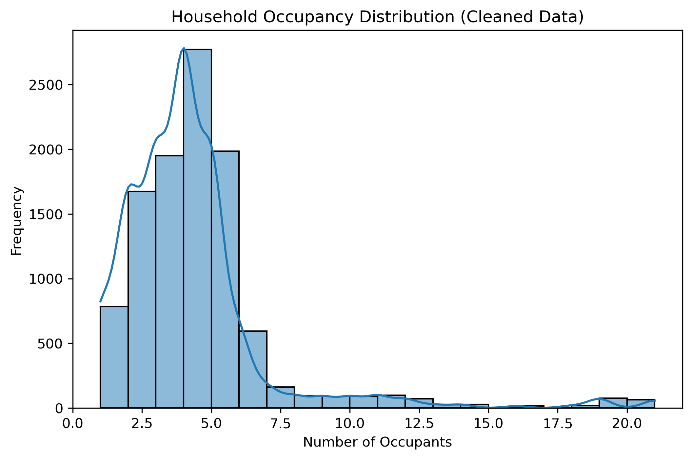
Figure 5- Household Occupancy Distribution Chart

Recommendations

Development of the Unoccupied Plot of Land
Based on the analysis of the town's population, household occupancy, and commuting patterns, it is recommended that the unoccupied plot of land be developed into low-density family housing.
Although the town has a large number of commuters and a high number of university students, the data suggests that the primary pressure is not on transport infrastructure but on the availability of suitable housing. The moderate immigration rate, combined with overcrowding observed in certain households, particularly among young families and lodgers, indicates a demand for affordable and larger family homes.
Building low-density housing would address:
- Overcrowding issues among current residents.
- Demand from young families and divorcees looking for smaller, more affordable homes.
- Future opportunities for growth as older residents vacate properties over time.
Thus, low-density housing is considered the most appropriate use of the land at this time.

Investment in Community Services
Regarding investment priorities, it is recommended that the town invest in old age care services.
The population pyramid shows a large working-age population currently, but also indicates a significant proportion of residents entering retirement age in the coming years. While infirmity rates are presently low, the aging trend suggests that the demand for age-related health and care services will increase in the near future (ONS, 2020).
Investment in old age care is therefore a proactive measure, ensuring that the town can meet the future needs of its residents as the demographic structure shifts.

Conclusion
This report has analyzed the demographic, social, and economic characteristics of a moderately sized town using cleaned census data. The analysis provided insights into population trends, employment patterns, household structures, and commuting behaviors.
The findings highlight a relatively young, working-age population, alongside modest birth and death rates and a stable, though slowly aging, demographic profile. High household occupancy levels and the presence of a substantial commuting population were also notable features.
Based on the evidence, it is recommended that the unoccupied plot of land be developed into low-density family housing, and that future investment should be directed towards old age care services to support the town's changing demographic needs.

Bibliography
BBC (2016) Jedi is not a religion, Charity Commission rules. Available at: https://www.bbc.co.uk/news/uk-38368526 (Accessed: 5 December 2020).
Eurostat (2017) Marriage and divorce statistics. Available at: https://ec.europa.eu/eurostat/statistics-explained/index.php/Marriage_and_divorce_statistics (Accessed: 1 December 2020).
Gov.uk (no date) Universal Credit eligibility. Available at: https://www.gov.uk/universal-credit/eligibility (Accessed: 5 December 2020).
Marriage Act (1949) Section 3. Available at: https://www.legislation.gov.uk/ukpga/Geo6/12-13-14/76/section/3 (Accessed: 5 December 2020).
National Society for the Prevention of Cruelty to Children (NSPCC) (2020) Moving out. Available at: https://www.nspcc.org.uk/keeping-children-safe/in-the-home/moving-out/ (Accessed: 20 November 2020).
Office for National Statistics (ONS) (2016) Standard Occupational Classification. Available at: https://www.ons.gov.uk/methodology/classificationsandstandards/standardoccupationalclassificationsoc/soc2010 (Accessed: 10 November 2020).
Office for National Statistics (ONS) (2020) Labour market in the regions of the UK: July 2020. Available at: https://www.ons.gov.uk/employmentandlabourmarket/peopleinwork/employmentandemployeetypes/bulletins/regionallabourmarket/july2020 (Accessed: 1 December 2020).

