

UNIVERSITY OF ENGINEERING AND TECHNOLOGY LAHORE
NEW CAMPUS KSK
DEPARTMENT OF COMPUTER SCIENCE

CSC 351 Machine Learning
Spring 2026
Session: 2023-2027 (Section-A)

CCP REPORT

Submitted By:
Muhammad Rateeb (2023-CS-607)
Submitted To:
Dr Irfan Yousuf

Date: 25 May 2026

Abstract
This project develops a handwritten Urdu alphabet recognition system using machine learning. Images were collected in real-world conditions, preprocessed, and used to train DNN and CNN models. The CNN performed better due to spatial feature learning, though overall accuracy remains low because of class similarity and limited data. Results are evaluated on a held-out test set using accuracy and F1 metrics.
1. Problem Statement
Recognize handwritten Urdu alphabets from mobile camera images taken under varying conditions. The system must generalize across handwriting styles and noise. Success is measured on a held-out test set using accuracy and macro/weighted F1.
2. Dataset
- Total classes: 40
- Images per class: 72
- Total images: 2880
- Collected by the student using a mobile camera
- Stratified train/validation/test split: 70/15/15

3. Preprocessing & Augmentation
Preprocessing:
- Convert to grayscale
- Resize to 128×128
- Normalize pixel values to 0–1
Augmentation (training only):
- Rotation
- Translation
- Zoom
- Contrast adjustment
- Gaussian noise
These steps improve robustness to pose, lighting, scale, and sensor noise.

4. Models Implemented
DNN (Fully Connected):
- Flatten input
- Dense layers: 512 → 256
- Dropout for regularization
- Softmax output (40 classes)
CNN (Convolutional):
- 2 convolution layers (32, 64 filters)
- Max-pooling after each conv layer
- Dense layer (128) + dropout
- Softmax output (40 classes)
CNN is expected to outperform DNN because it preserves spatial structure in images.

5. Training Setup
- Optimizer: Adam
- Loss: Sparse categorical cross-entropy
- Batch size: 32
- Epochs: 30
- Train/Validation/Test split: 70/15/15 (stratified)

6. Evaluation & Results
Metrics: Accuracy, classification report, confusion matrix, macro/weighted F1
Test accuracy (128x128):
- DNN: 0.0255
- CNN: 0.1134
Additional metrics (128x128):
- CNN macro F1: 0.0757, weighted F1: 0.0768
- DNN macro F1: 0.0012, weighted F1: 0.0013
Per-class results show some classes with higher recall but many still near zero, indicating confusion among visually similar characters.
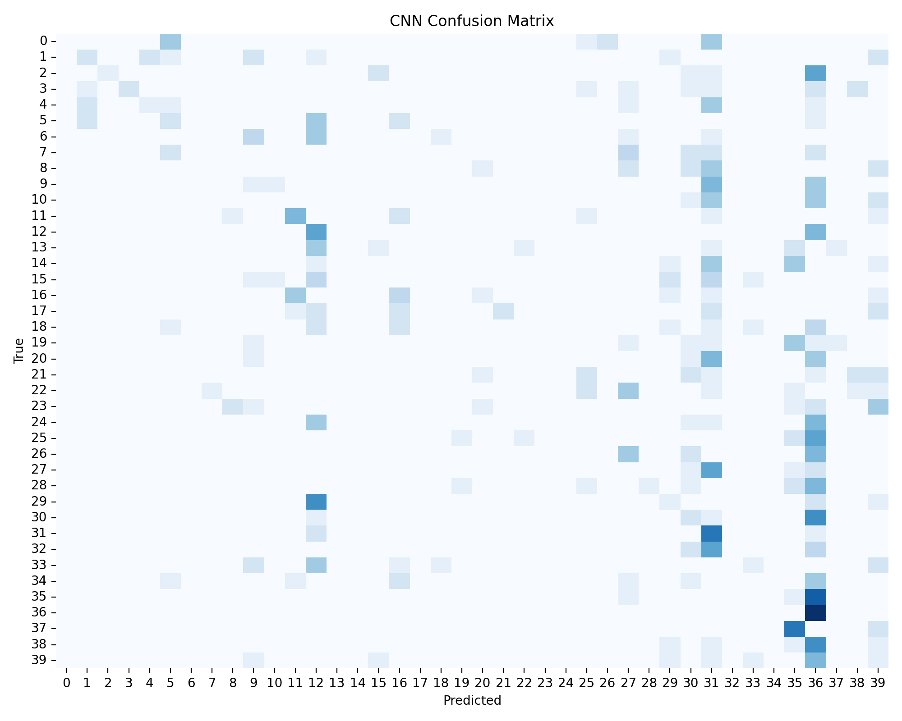
7. Comparative Analysis
CNN consistently outperforms DNN because it learns spatial features like strokes and curves. DNN loses spatial structure after flattening, leading to near-chance performance. Trade-offs: CNN is more accurate but more compute-intensive, and higher input resolution improves accuracy at the cost of speed and memory.
8. Conclusion
An end-to-end pipeline was implemented, including data collection, preprocessing, augmentation, model training, and evaluation. Although accuracy is low due to class similarity and dataset complexity, the CNN shows better performance and is more suitable for image-based Urdu character recognition. The report meets CCP requirements for analysis, model selection, evaluation, and comparison.

