**LAWYER**

**PROJECT GROUP MEMBERS**

|  |  |
| --- | --- |
| **Students Id** | **Students Name** |
| ***Student1431528*** | ***Muhammad Saad*** |
| ***Student1429988*** | ***Samiullah*** |
| ***Student1429139*** | ***Muhammad Zulqarnain*** |
| ***Student1358220*** | ***Muhammad Ali*** |

**CURRICULUM BATCH**

**7062 2211b1**

**FACULTY**

**SIR EBAD-UDDIN**

lawyer

**CO-ORDINATOR**

**MISS MUNAZZAH**

**Certificate**

This is to certify that the dissertation entitled **“lawyer”** is ***Muhammad Saad* *Student1431528*, *Sami Ansari* *Student1429988*, *Muhammad Zulqarnain* *Student1429139* and *Muhammad Ali* *Student1358220*** in their partial fulfilment of the requirement of the award of the Aptech Computer Certified.

lawyer

**Acknowledgement**

The success and final outcome of this project required a lot of guidance and assistance from many people and I am extremely privileged to have got this all along the completion of my project. All that I have done is only due to such supervision and assistance and I would not forget to thank them.

I respect and thank Aptech for providing me an opportunity to do the project work in ACE and giving us all support and guidance, which made me complete the project duly. I am extremely thankful to Aptech for providing such a nice support and guidance.

I owe my deep gratitude to our project guide **SIR EBAD-UDDIN**, who took keen interest on our project work and guided us all along, till the completion of our project work by providing all the necessary information for developing a good system.

***Muhammad Saad*  *Student1431528***

***Samiullah*  *Student1429988*,**

***Muhammad Zulqarnain* *Student1429139***

***Muhammad Ali* *Student1358220***

lawyer

**Abstract**

A good website is vital for your law firm, as it directly

reflects your brand and leaves a lasting impression

on potential clients. By creating visibility across search

engines, your website provides prospective clients

access to your firm and lets them to explore your

services.

Furthermore, potential clients should be able to contact

you quickly and access helpful information like FAQs

and legal education resources. You can also utilize

newsletter subscriptions and blogs on your website

to build relationships with current clients and

potential prospects.

lawyer

# INTRODUCTION

# Introduction : –

# Today everyone need legal services for some or the other reason. It is very difficult to

# find lawyers with respective specialization. Getting appointment is also very difficult.

# There is a need to have a website for doing all this.

# Proposed Solution : –

# We need to design and develop a website for lawyers and their service. Customers can

# register and search for lawyers basing their requirement. Info related to lawyers will be

# there in website which customers can browse through and view their profile before

# contacting them.

# Customers can book a schedule for meeting with lawyer. We also had a discussion in

# regard to few clarifications and inputs specifically to understand the project flow.

# Features-

# • Registration for customer as well as Lawyers.

# • Panel for Lawyers showcasing their details

# • Search by lawyer location, lawyer services like criminal, divorce, affidavit, civil,

# and then schedule a meeting with the same.

# • A customer search will show minimal info of a lawyer related to the service

# which customer searches, a click on lawyer profile should go to lawyer profile,

# where in customer can schedule a meeting and book a slot.

# • Login through normal registration form for customer is mandatory and for a

# lawyer registration form is required. Basically user/password required.

# • Showcase of the lawyer when they search one by one.

lawyer

# REQUIREMENTS

# User Registration:

# Customer Registration: Customers should be able to register with the

# website by providing necessary details such as name, email, contact

# information, and password.

# Lawyer Registration: Lawyers should have a separate registration

# process that collects information such as their name, contact details, area

# of specialization, experience, and other relevant professional information.

# Panel for Lawyers:

# A dedicated panel for lawyers where they can manage their profiles,

# update their information, add qualifications, experience, and other

# professional details.

# The panel should allow lawyers to manage their availability for meetings and appointments.

# Search Functionality:

# Customers should be able to search for lawyers based on location,

# specialization (criminal, divorce, affidavit, civil, etc.), availability, and other relevant criteria.

# The search results should display basic information about the lawyers,

# and customers should be able to click on a lawyer&#39;s profile to view more details.

# lawyer

# Scheduling Meetings and Appointments:

# Customers should be able to schedule meetings with lawyers based on

# the availability shown by the lawyers.

# The system should allow customers to book specific time slots for

# appointments and meetings with the chosen lawyer.

# Login System:

# Customers should be required to log in using their registered email and password to access the website and its features.

# Lawyers should also have a login system, allowing them to access their panel and manage their profiles and schedules.

# Lawyer Profile Showcasing:

# The website should provide a well-designed and informative layout for displaying lawyer profiles.

# Lawyer profiles should include details such as their qualifications,

# experience, contact information, specialization, availability, and any other relevant information to help customers make informed decisions.

# Admin Pages:

# An admin interface should be available to manage the information

# displayed on the website&#39;s homepage.

# Admins should be able to manage lawyer profiles, approve or reject

# registrations, manage scheduling and appointment booking slots, and

# perform other administrative tasks as needed.

# Security Measures:

# The system should ensure the security of user data and confidential

# information.

# Implement necessary security measures to protect user accounts,

# personal information, and any sensitive data stored within the system.

# lawyer

# Responsive Design:

# The website should have a responsive design to ensure it is accessible

# and user-friendly across various devices, including desktops, laptops,

# tablets, and smartphones.

# Communication Channels:

# Implement communication channels such as chat support or messaging features to allow customers and lawyers to communicate effectively with in the platform.

# These detailed requirements will form the foundation for the development of the

# Online Lawyers Application Website System, ensuring that it meets the needs of

# both customers and lawyers while providing a secure and user-friendly

# experience.

# lawyer

# REQUIREMENT SPECIFICATION

**Hardware**

* A minimum computer system that will help you access all the tools in the

courses is a Pentium 166 or better

* 128 Megabytes of RAM or better

**Operating System**

* LINUX / Windows 2000 Server (or higher if possible)

**Software**

* PHP
* MySQL
* PERL
* Apache

# 

# lawyer

**ADMIN PANEL:**

**ADMIN LOGIN**

Here You can Login in Your Admin Account.

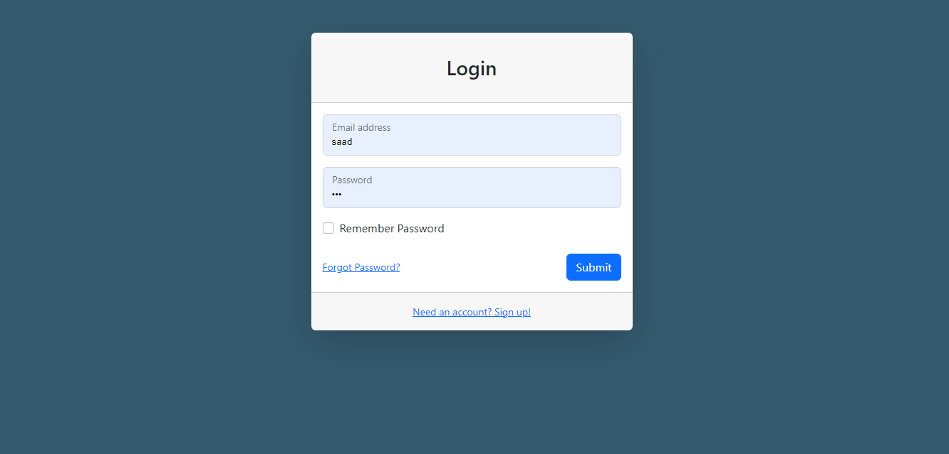

**ADMIN LAWYER REGISTER**

Here You can LAWYER REGISTER in Your Admin Account.

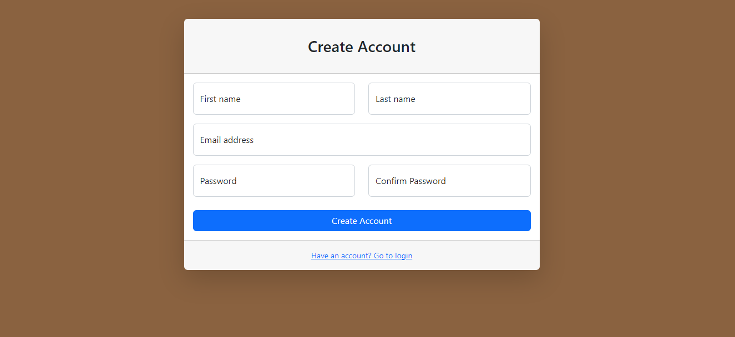

**HOME:**

Admin can read the details of login users.

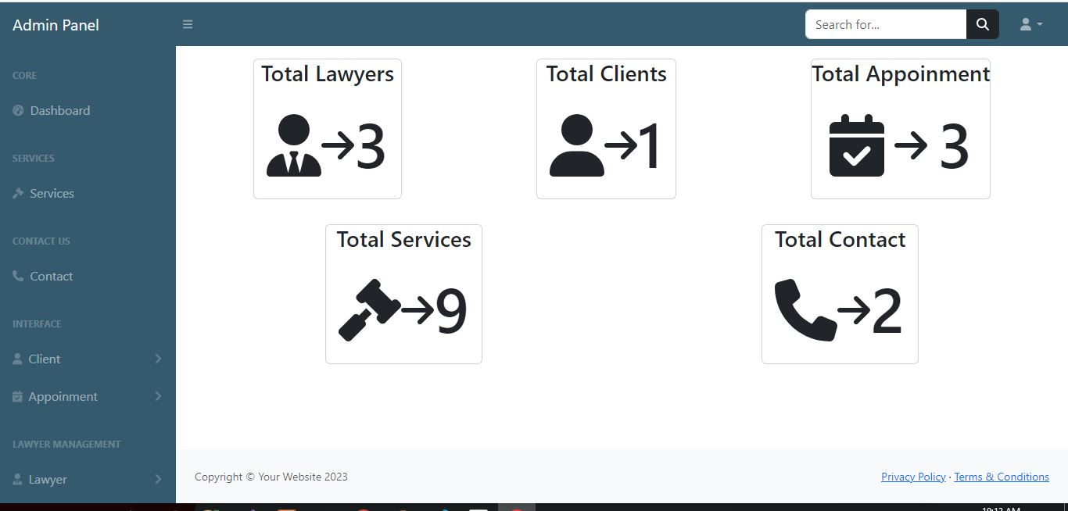

**ADD LAWYER:**

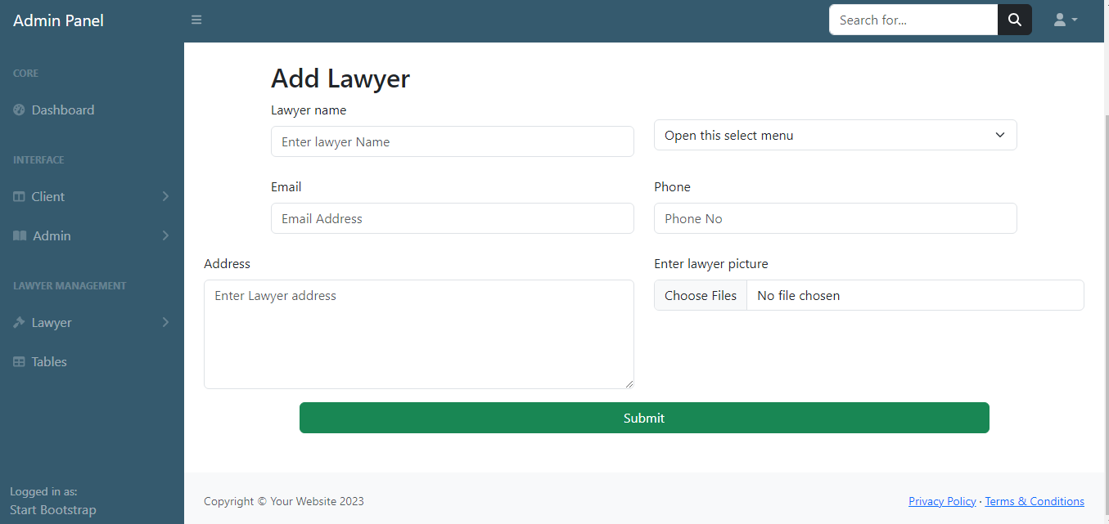

**VIEW LAWYER:**

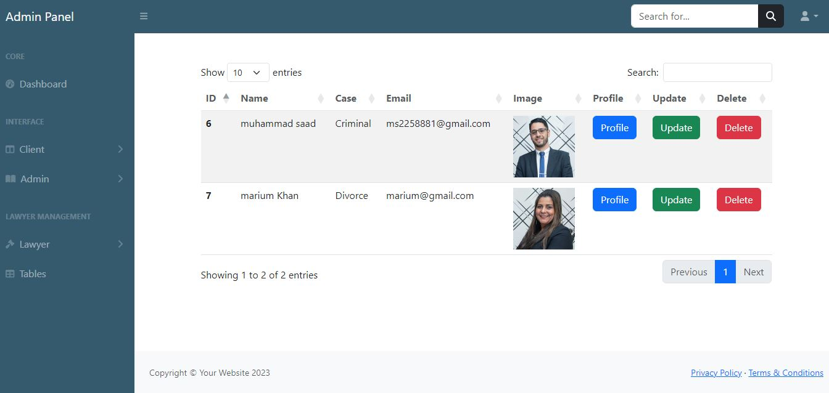

**ADD CLIENT:**

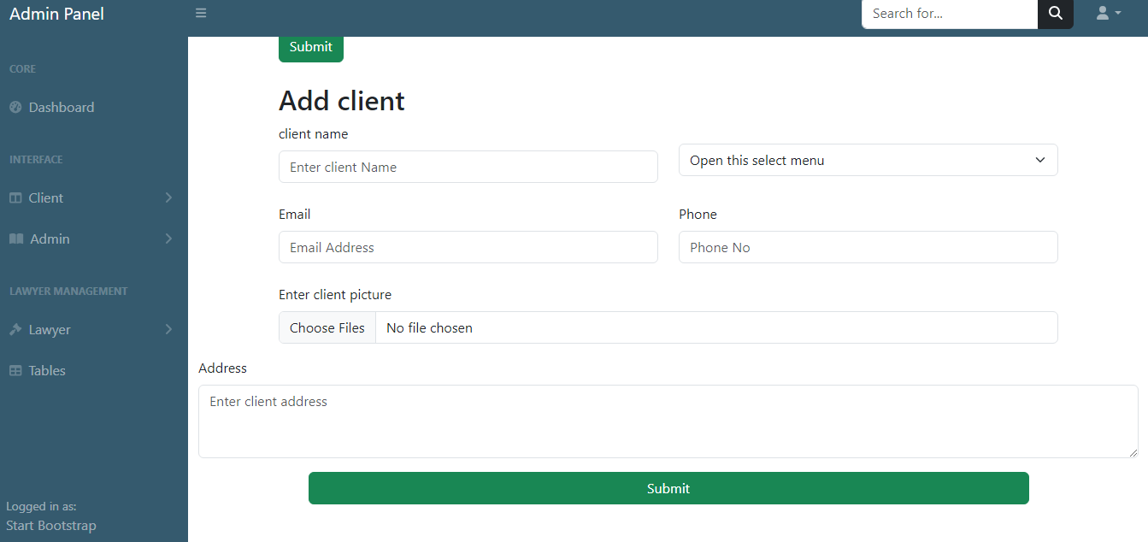

**VIEW CLIENT:**

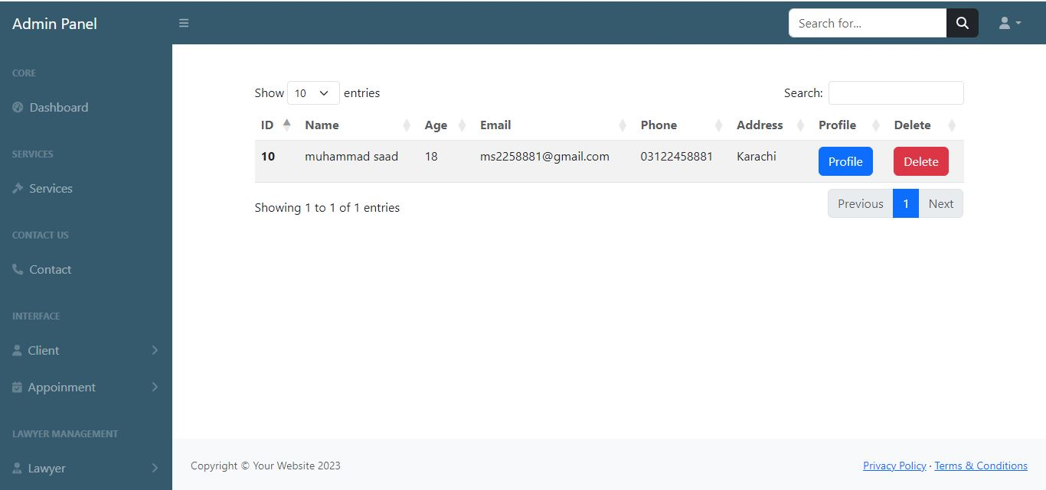

**CONTACT**

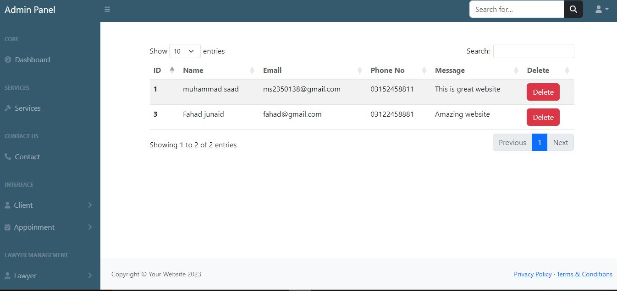

**VIEW APPOINMENT**

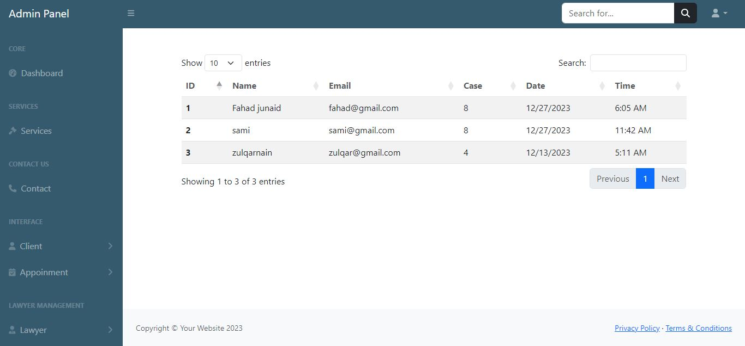

**SERVICES**

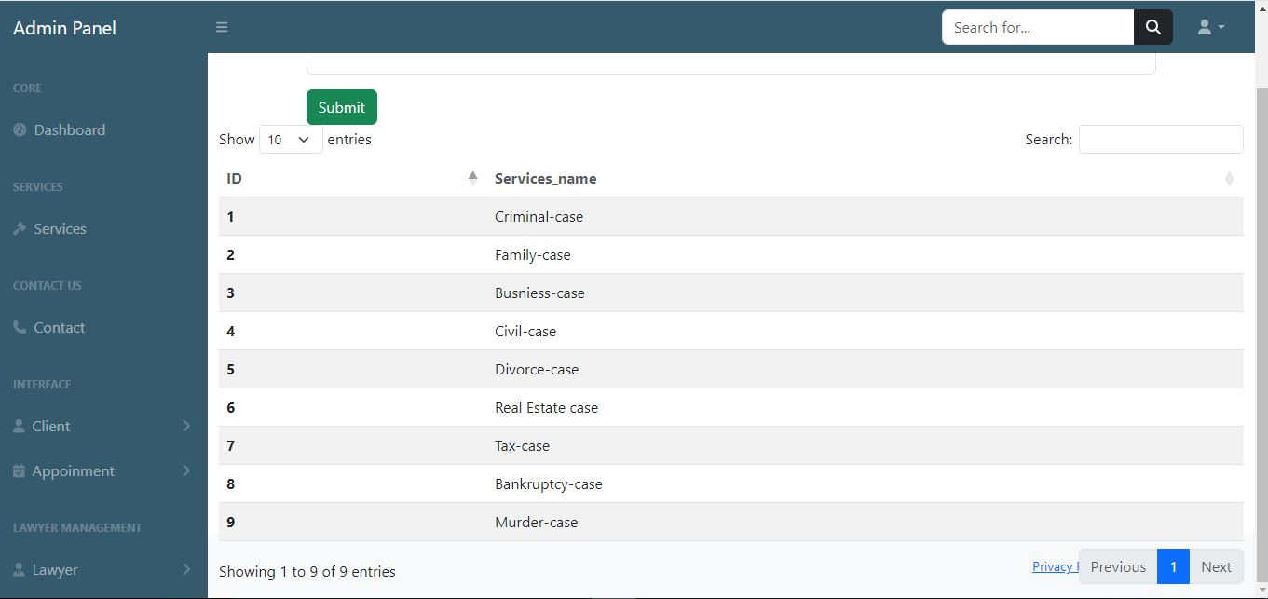

**LAWYER PANEL**

**LAWYER HOME**

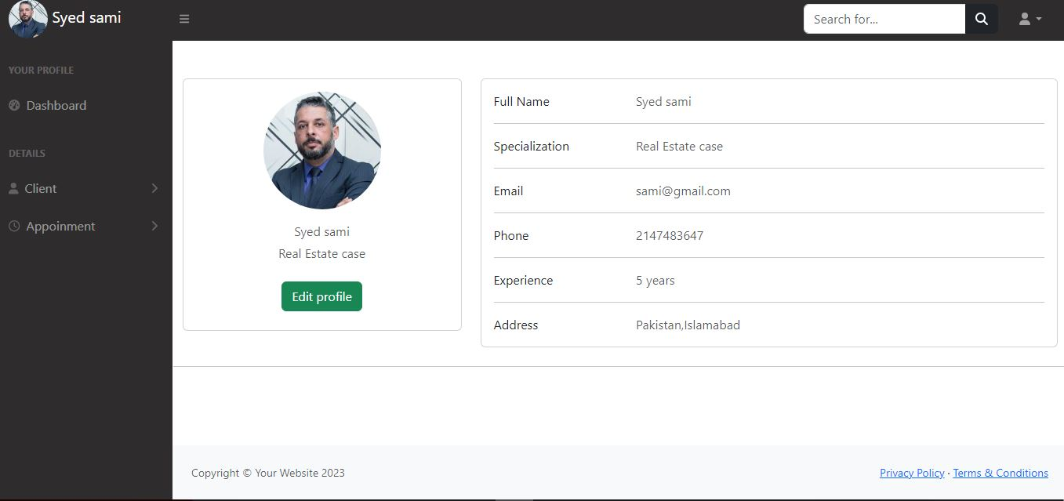

**VIEW APPOINMENT**

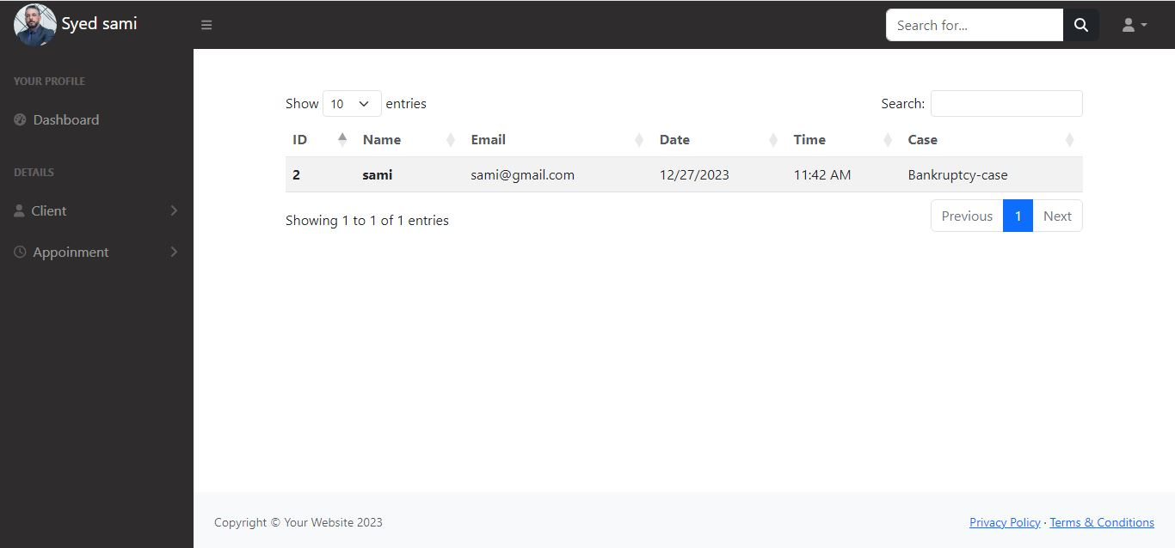

**VIEW CLIENT**

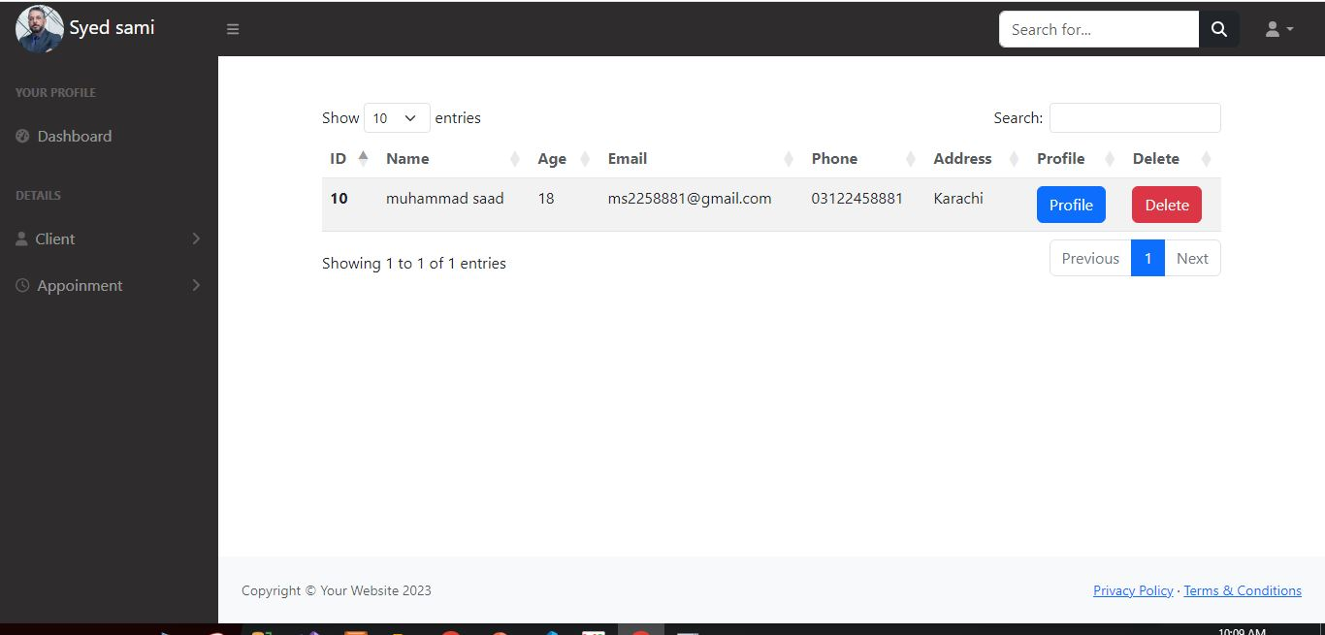

**SCREENSHOTS**

**LOGIN:**

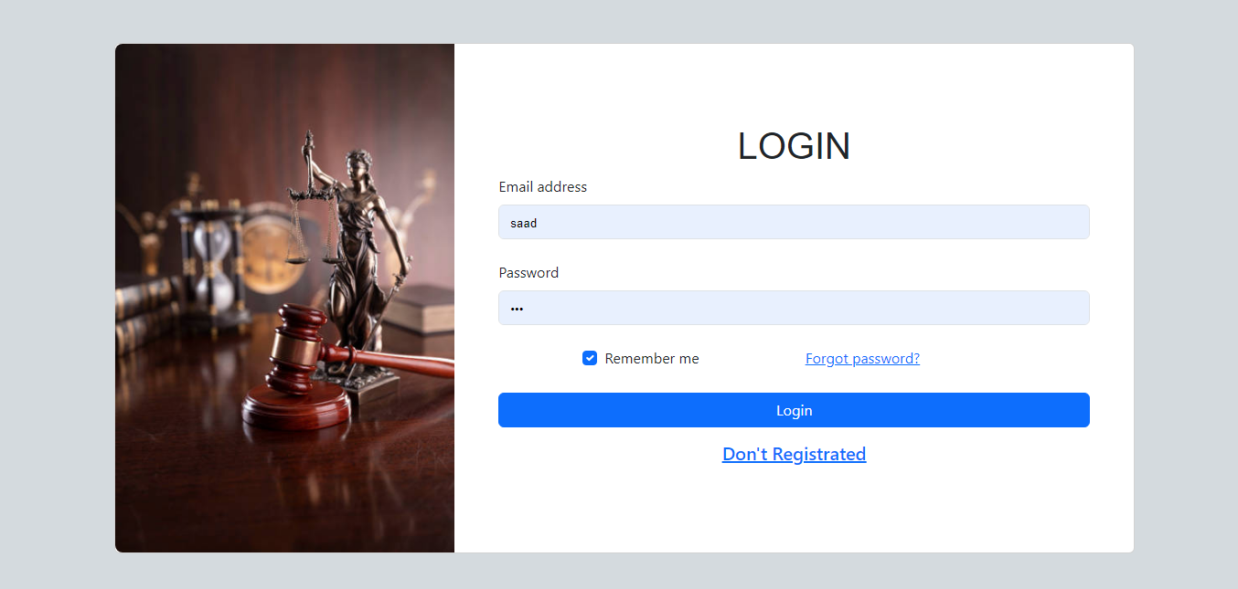

**LAWYER**

**REGISTER:**

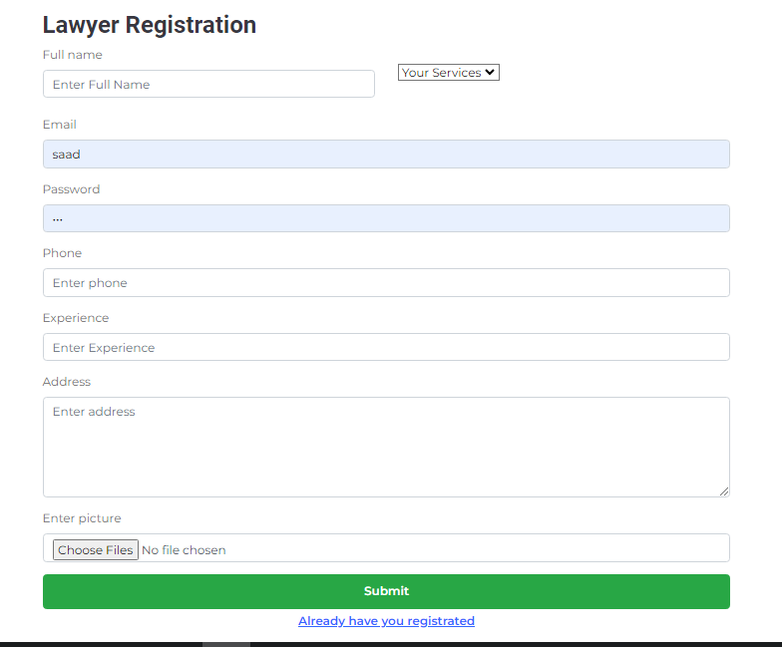

**CLIENT**

**REGISTER:**

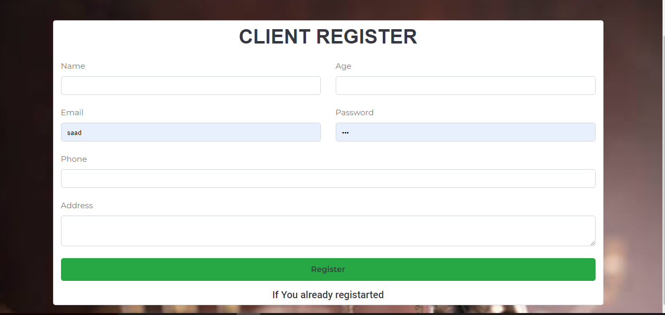

**HOME:**

Here a Home Page.

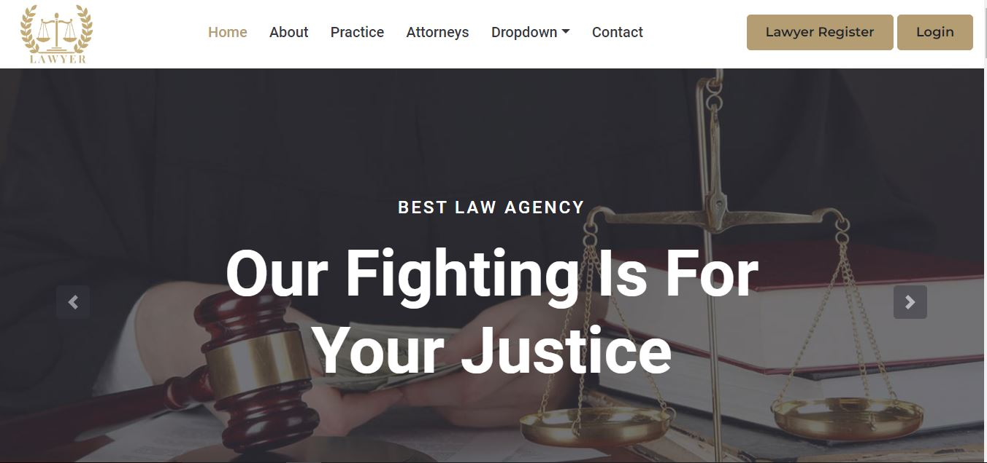

**ABOUT US:**

About information are as following:

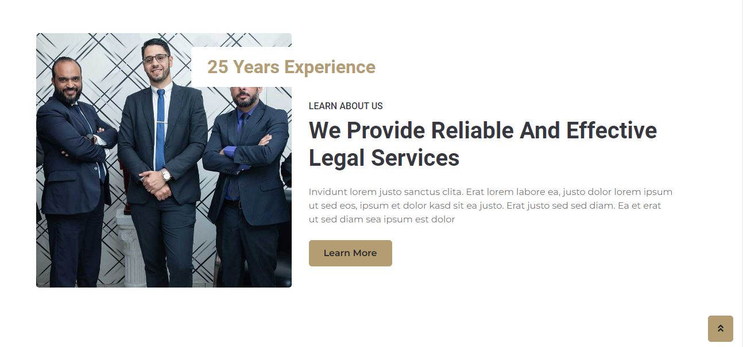

**HEADER:**

Here is header.



**FOOTER:**

Here is Footer.

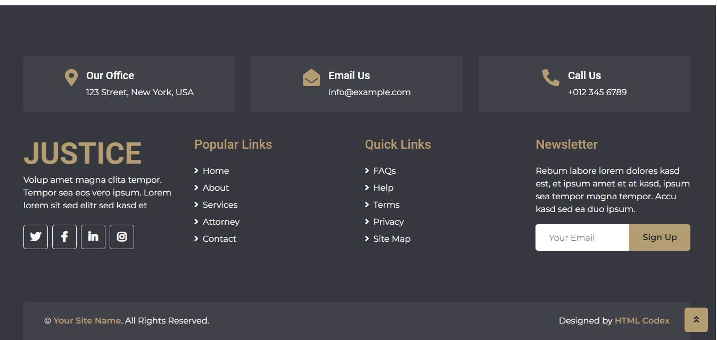

**PRACTICE:**

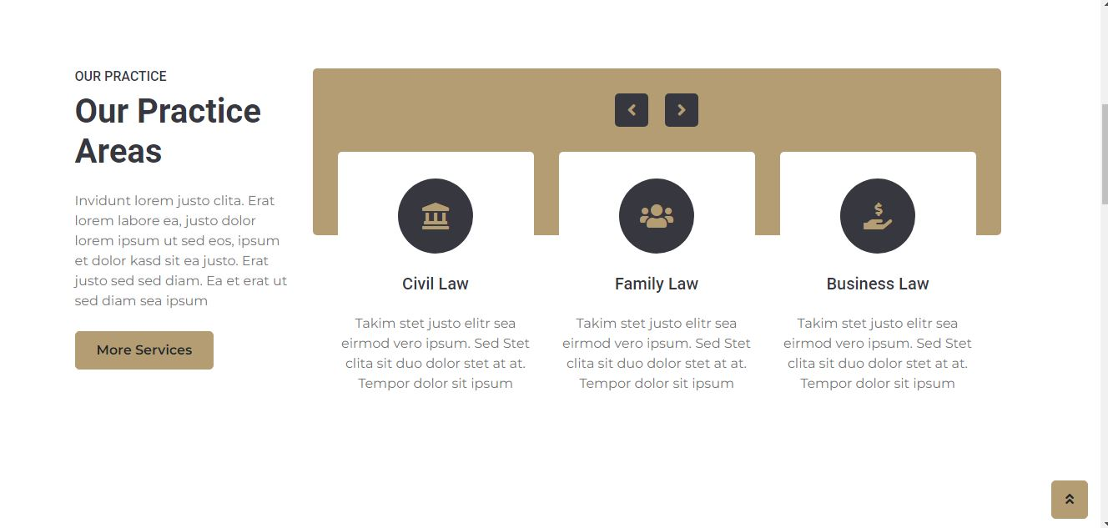

**ATTORNEYS:**

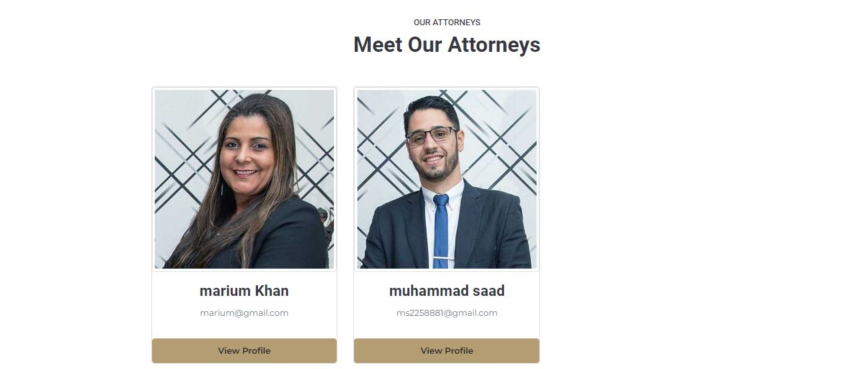

**CONTACT:**

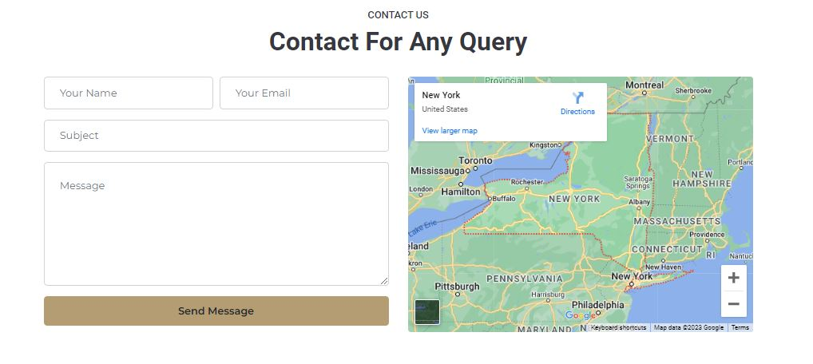

**CIVIL LAW**

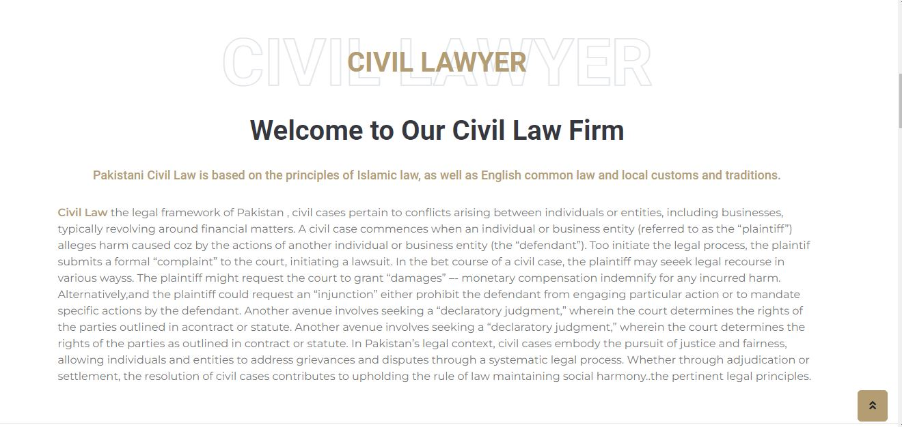

**CORPORATE LAW**



**DIVORCE LAW**

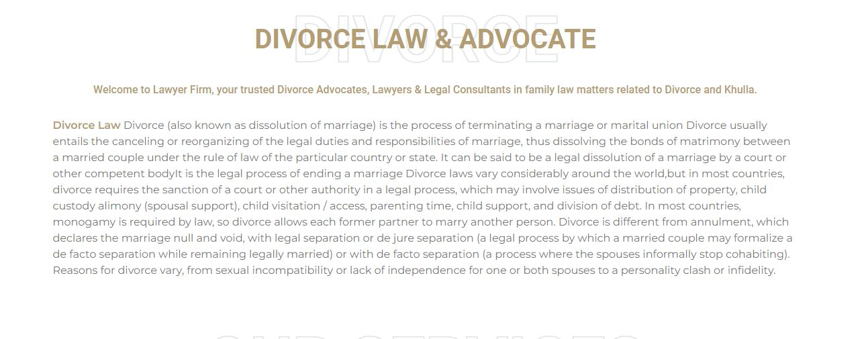

**CRIMINAL LAW**

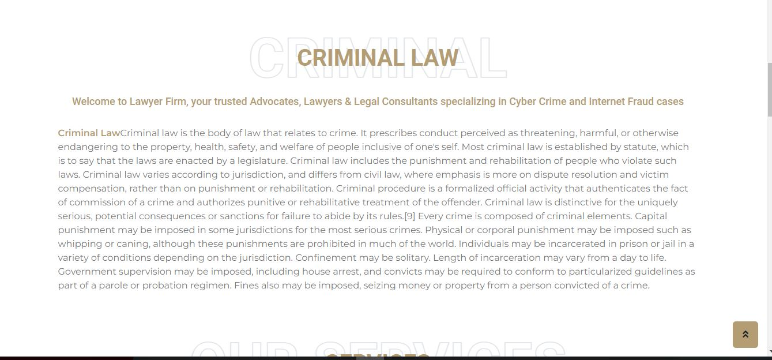

# lawyer

**TASKSHEET**

|  |  |  |  |
| --- | --- | --- | --- |
| S# | Task | Team Member Name | Status |
| 1. | Analysis | Muhammad zulqarnain,  muhammad saad,  sami ullah,  ali | ✓ |
| 2. | Design | Muhammad zulqarnain,  muhammad saad,  sami ullah,  ali | ✓ |
| 3. | Development | Muhammad zulqarnain,  muhammad saad,  sami ullah,  ali | ✓ |
| 4. | Documentation | Muhammad zulqarnain,  muhammad saad,  sami ullah,  ali | ✓ |

# lawyer

# SUBMISSION CHECKLIST

# lawyer

**SUBMISSION**

**CHECKLIST**

|  |  |  |  |
| --- | --- | --- | --- |
| S.no | List of items | Remarks | Comments |
| **1.** | Do All Pages Linked  together | **Yes** | ✓ |
| **2.** | Authorization | **Yes** | ✓ |
| **3.** | Crud Operations | **Yes** | ✓ |
| **4.** | Database Connection | **Yes** | ✓ |
| **5.** | Project Zip File | **Yes** | ✓ |

# lawyer

# lawyer

# lawyer

