Sara Mohammed Abbas Khairallah
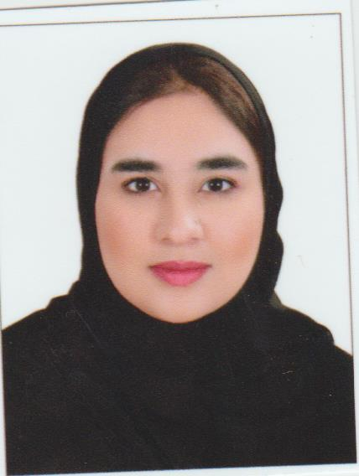
Date of birth: 16/06/2001
Nationality: Bahraini
CPR Number: 010607455
Address: Flat 4, Building 1684, Road 1124, Block 1211
Contact number: 35540705
E-mail: saraharmazi@gmail.com
Objective

I am an ambitious young graduate looking for a position in your esteemed company in where I can utilize my knowledge and develop my skills.

Academic Qualifications

Qualification Received Institute/School
High School Graduated Al-Ahd Alzahir Secondary School

Working Experience

Position Company From To
Non.

Skills

- Interpersonal Skills:

- Having the proper skills for participating in team work.

- Having proper skills on leadership and people management.

- Embracing lifelong learning (continuous professional development) and attempting to employ new ideas.

- Computer Skills: -Microsoft Office (Word, PPT, Outlook)
-Browsing online

- Languages: -Arabic (mother language)
-English (Excellent)
-Turkish (Good)
- Additional Skills: -Valid driving license

Interests

- Playing on the Piano.
- Reading books and listening to music.

