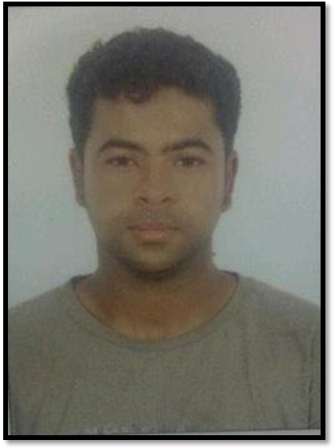
khalil Ebrahim Ali
Villa : 125 , Road: 7527
Janabiyah : 757

Tel: 39585535

PERSONAL INFORMATION:
Date of Birth: 4 / 8 / 1985

Gender: Male

Status:Single

Nationality: Bahrainai

EDUCATION:
Jiddhafs middle school for boy 1999-2000

EXPERIENCE:
HABIB ALI AWACHI & SONS  CONTRACTING COMPANY  The work of the company worker profession  2013- 2018  AL- Manama Cleaning &Maintenance | 2002- 2012

SKILLS:
Language | -Fluent in Arabic and little English
Computer knowledge | MsOffice

HOBBIES:
Riding hours , playing sport.

