CURRICULUM VITAE

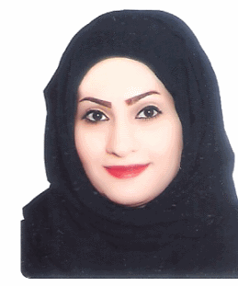
NAME: Marwa Moosa Abdulkarim
Salman abbas

NATIONALITY: Bahraini

DATE OF BIRTH: 15th June 1989

CPR: 890601178
ADDRESS: Villa # 1320 – Road # 3335 – Block # 233
Al-Dair, Kingdom of Bahrain

TELEPHONE: +973 32363878

EMAIL: mrawy89@gmail.com
MARITAL STATUS: married

LANGUAGES: Arabic (Understanding, Speaking & Writing)
English (Understanding, Speaking & Writing)

ACADEMIC QUALIFICATIONS:

Secondary Sitra School _ General Certificate (scientific) 2007.
Certificate for the art and science of value based decision making 8th January 2014.
Certificate for Bahrain retail fair and seminars 5th January 2014.
certificate for attending invest in Bahrain forum & exhibition 2013 on 30-31 October 2013
Training certificate from sabre programme August 2013.
English Language certificates _ British council, Dar-al-ma'rifa, Al-jazeera modern institute, The modern institute of sciences & computers.
Computer certificate from Al-jazeera modern institute.

SKILLS:

Excellent communication skills
Job supervise
Team working
Hard working
Ability to work under pressure
Ability to plan and manager
Prepare invoices, reports, memos, letters, financial statements.
Handle incoming calls, supply information to callers and relay messages.
Perform typing, word processing, filling, faxing and photocopying and distributed.
General office management and perform administrative tasks.
Driving

Experiences

Data entry in a national election in 2014.
One year Secretary in advertising office.
Two month in al-aman agency for travel and tourism.
One year sales in al-shaya group.

Hobbies:

Reading
Swimming
Traveling
Make friendships
Browse internet

References:
Moosa Abdulkarim Salman Abbas (39834981)

