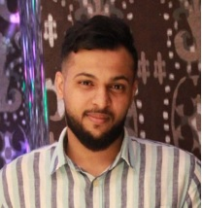
Kingdom of Bahrain
Malkiya 1033
Home 1385
Road 3336
Mobile: 66663343 - 36200870
Mohammed Saeed Abdulaziz Marhoon

Curriculum Vita

Personnel data:
Date of birth: 2/5/1987
Nationality: Bahraini
Marital status: married
CPR NO: 870500724
Passport NO: 2866847
Languages: Arabic – fluent
English – fluent

Educations & certificates:
2002 – 2005 certificate from Shaikh Abdulla secondary school
1999 – 2001 certificate from Al Farabi intermediate school
1993 – 1998 primary certificate from Shahrakan School

Skills:
Using Microsoft (word, Excel & power pint
Driving licenses
Typing: Arabic – English

Personnel skills:
- Capable of working as an effective part of team
- Used to hard working
- Ability to make a difference & decisions

Work Experience:
27/12/2015 Marks & Spencer (sales assistant & Trainer sales development)
09/10/2012 BFC (Sales consultant)
26/04/2009 NESTLE Bahrain (HR assistant Messenger)
25/10/2006 MXM international (Technical system operator)
Hobbies
- Reading , football , swimming

