**CURRICULUM VITAE**

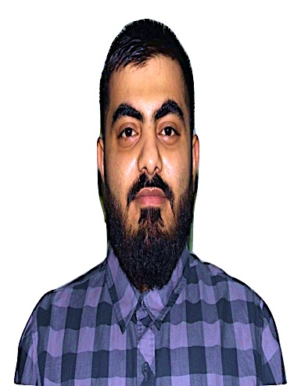

## PERSONAL INFORMATION:

Faisal Abdul Aziz Ali Haji Kamal Ali

Villa No: 1496, Road: 2835

Block: 328, Suqayya

Kingdom of Bahrain

Mob: +973 39015075

Email: faisalaziz454@gmail.com

Date of Birth: 23.06.1995

Sex: Male

Nationality: Bahraini

Marital Status: Single

CPR No: 950606375

Driving License: Valid in Bahrain

## EDUCATION:

Graduated from Al Jabriyah Industrial Secondary School

Location: Manama, Bahrain

Completion Date: June 2013

Grade: 80 out of 100

* Automotive high school diploma Al jaberiya technology secondary school
* Bahrain secondary and technical school certificate
* Improve my communication skill and I get the IELTS certificate

By studying in the Emirates Aviation University

## TRAINING AND CERTIFICATIONS:

* Automotive (Training)

Training Institute: SHEER GARAGE

Date Attended: December 2013 (168 hours)

* (Computer Repair)

Certificate from Al-Hayat institute (Computer Repair)

Date Attended: February 2014 (80 hours)

**SUMMARY:**

To be an ambassador of the company I work for to act professionally at all times as well as to conduct my work to the best of my knowledge*.*

## LANGUAGES:

* English
* Arabic

## HOBBIES AND INTERESTS:

* Playing basketball and Video Game