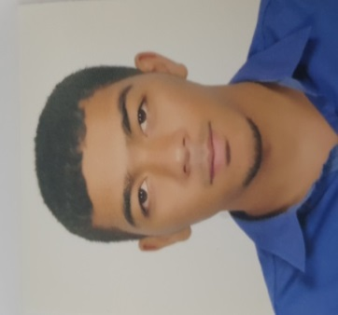 Husain a.ali faraj

**[husaincvwork@gmail.com](mailto:husaincvwork@gmail.com)**

**39115129**

**Muharraq-samaheej**

Bahrain university -3rd year

Accounting

**Education:**

* **Al Hidaya AlKhalifiya Secondary Boys School Certificate**
* **Currently studying at Bahrain university 2years left to get the degree of bc.s accounting**

**Experience:**

* **Practice as consultant for tamkeen program “intelaaq” for 3months**
* **Attending communication skills course is one of the workshop for “intelaaq”**
* **Volunteer for world largest lesson of sustainable development goals in 21oct 2018**

**Interest and SKILLS:**

* **Surf the Internet especially about business economies**
* **Passion and interests of learning others cultures and tradition**
* **Communication with others**
* **Attending events and workshop as volunteer or participator**