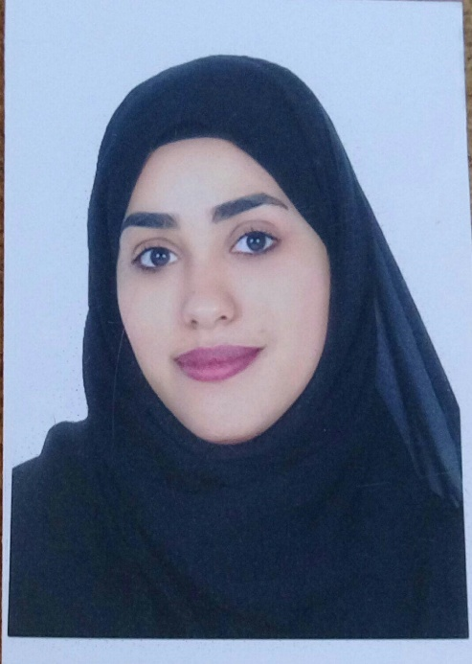Contact Information

**Curriculum Vitae**

**Name: Hanan A.wahed alfardan**

**Adress : Home: 2767 \ Road : 942 \ Hamad Town 1209**

**TEL.NO : 33664978 \ 34083179**

Personal Information

**Birth date: 26\1\1998**

**C.P.R.NO. :980109000**

**Nationality: Bahraini**

**Social status : Maried**

Opjective

**Looking forward to associate myself with an organization of quality environment where knowledge can be shared and dedicate my skills and talents for development of self and the organization served.**

LANGUAGES :

* **ENGLISH (Writing & Speaking)**
* **ARABIC (Writing & Speaking)**

EDUCATION:

**Hamad town secondary girls school .**

WORK EXPERIENCE :

**input data into a major shipping company with a general experience in this field two years.**

Other Skills

* **Wide knowledge in computer software using**
* **Ability to work within a team**
* **Ability to work under pressure**

HOBBIES:

* **Reading books .**