**CURRICULUM VITAE**

**HUSAIN ADEL YOSUF JABER YOUSUF**

Personal Details:

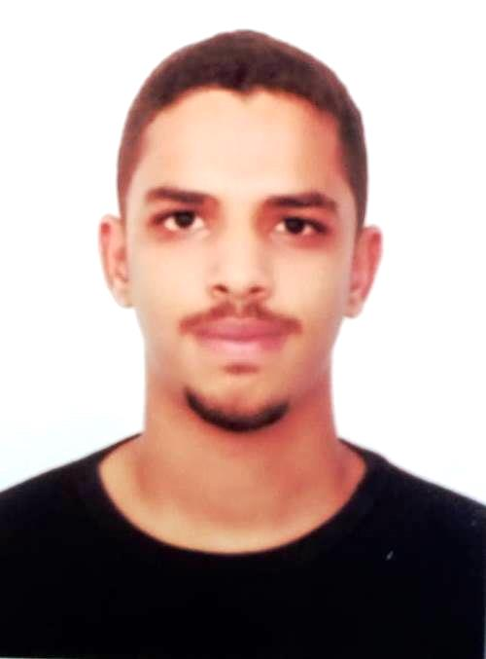

**Nationality : Bahraini**

**CPR No : 020109687**

**Civil Status: un married**

**Date of Birth: 30/01/2002**

**Phone Number:** 66378759

Objective: s

• My objective is to gain knowledge and develop my skills to raise my rank and position, also to gain the needed training for the career and help customers to feel satisfied

EDUCATIONAL QULIFICATION

* High school

Experience :

* Machine shop AIRMECH W.L.L Company completed

Languages Know:

* Good commando of spoken and writing & English&Arabic