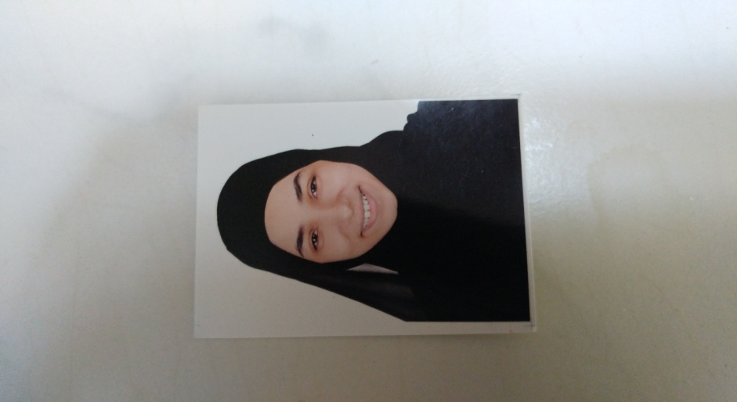

**Curriculum Vitae**

**Contact information**

**Kingdom of Bahrain (Address):Villa,**162 **Road,** 5106 **Block,** 551 **Al-Qurayia**

**E-Mail :**Umjoodabdulameer83 @gmali.com

**Mobile phone** **:** 33523343 , 35310266

**Personal Information**

**Name :** Zainab Abdulameer Hasan

**Gender :** Female

**Marital Status :** Married

**Passport** **:** 2436518

**CPR :** 970706235

**Birth date :** 21/7/1997

**Nationality** **:** Bahraini

**Career objective**

**Work in professional environment with good chances to growth and development .**

**Education**

**2014-2016** **:** Umaima Bint Al.Noaman Secondary School