Cover Latter

Dear Mr. / Ms.

I read about your respective organization, I would be so glad to work for an organization that has an excellent reputation like yours.

I hold High secondary certificate, kindly find my CV attached along with this latter.

If you have any questions, please don't hesitate to contact me.

Thank you for considering my application.

Regards,

Aqeel Hasan

1

I have a high school diploma from 2016_2019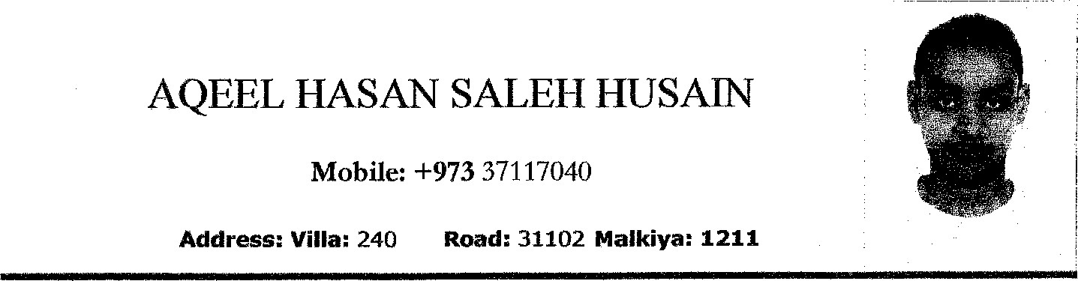

Date ofBirth: 27 Jul, 1999 Nationality: Bahraini

CPR Number: 990710327

Gender: Male Social Status: Single

OBJECTIVE

To have a permanent career in any field, where I can make use of my knowledge and experience skills.

EDUCATION & EXPERAINCE

* Ahmed Al Omran secondary School 12th standards.
* Worked in Batelco – worked one month
* Riffa Views - Worked as cashier

SKILLS AND COMPETENCES

 Fluent in English & Arabic language.

 Ability to work independently.

Willingness to put in effort in job whether small or big.

 Sincere in any work situation, adapt at people management.

 Willing to accept responsibility and fulfill it.  Leadership.

PERSONAL INTERESTS & ACTIVITIES

 Riding motor cycle.

 Electronics.

 Internet, car racing.

References

Upon request

2