Curriculum Vitae

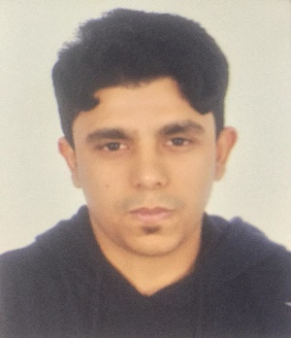

Personal Details:

Name: Naser Fardan Abdulkarim Abdulla

C.P.R NO.: 940500825

Address: Building no. 2337, Road no. 3468, Block no. 1034 Malkiya

Passport NO.: 2251703

Contact NO.: 66360294

Nationality: BAHRAINI

Gender: Male

Marital Status: Single

Education:

Qualification: High School

Language: Arabic / English

Experience: Security Quard