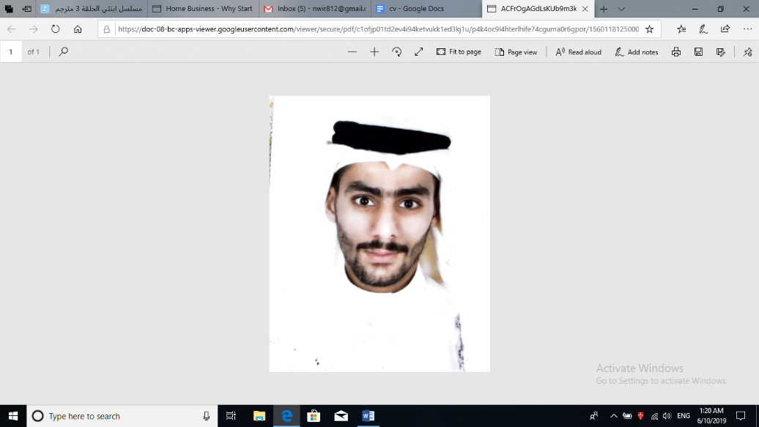

**ALI  AHMED FARDAN**

**Contact Number: 36683913**

**Personal Information:**

* **Date of birth:** August 15 1998
* **Gender:** male
* **Nationality**: Bahraini
* **CPR Number:** 980804833
* **Passport No:** 2802101
* **Educational Qualification:**
* **(2018)-(2019)Bahrain Airport services (Bas)**
* **(2018) lpod water park (Marketer)**
* **(2016) Real Estate Office (Marketer)**

**Objectives:**

* + **To develop the skills needed for effective management using technical, interpersonal and conceptual skills. I am looking for a challenging career in a dynamic work environment that also offering an opportunity for professional and personal growth.**

**Experience:**

**At Marvell Technology Summer duration as sales man.**

**Responsibilities:**

* **Responsible of Customers and help them.**
* **Typing Letters English & Arabic.**

**Skills and knowledge:**

* **Microsoft office applications (Excel, Word & Access)**
* **Languages (Arabic & English)**
* **Very independent & responsible**
* **Ability to work under pressure & as part of team**
* **Self motivated and confident**

**Hobbies:**

* + **Playing football**
  + **Traveling**
  + **Web browsing**
  + **Learning and acquiring new skills in computer and all business fields.**

**References:**

**Available upon request.**