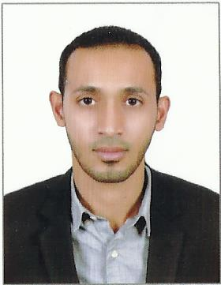**Curriculum Vitae**

**Personal Details**

•     Name:  Ali Abbas Ebrahim AL-Mulla

•     CPR:  950208094

•     Nationality: Bahraini

•     Date of Birth: 26 february1995

•     Address:  Villa.1396, Road.3627 A'ALI.736

•     Telephone No.: 33376646 - 38996165

•     Marital Status: Single

•     E-mail:  Alo00oy1995@HOTMAIL.COM

**Occupational goals**

**•**     A job I can optimize my skills and my experience.

**Work experience**

2013  commissionaire in Bahrain Court

2013  Secretary in Almobain Office

**Educational Qualification**

|  |  |  |
| --- | --- | --- |
| 2014 –2018 | BSc in Commerce. | Bharati Vidyapeeth Deemed University, Pune |
| 2018-2018 | Diploma in Marketing | Bharati vidyapeeth Deemed university , Pune |
| 2010-2013 | Secondary Certificate in Commercial | Altaawn Secondary School |

**•**     Extra Courses - Microsoft Power point XP, Microsoft Word XP, Web Page Design, Computer Laboratory Management.

**Skills**

**•**     Familiar with two languages ( Arabic, English and Indian )

•     Good skills in social activities and relationships.

•     Likes working in groups.

•     Flexible to work in hard situation and under work pressure.

•     Good Driver

•     Excellent in Microsoft Office (Word, PowerPoint, Excel )

•     Install operating system (Windows98,2000, XP)

**Hobbies**

Exercising, Swimming and Football.