**CURRICULUM VITAE**

**Ali Abdulrazaq Abdulla Yusuf Jasim**

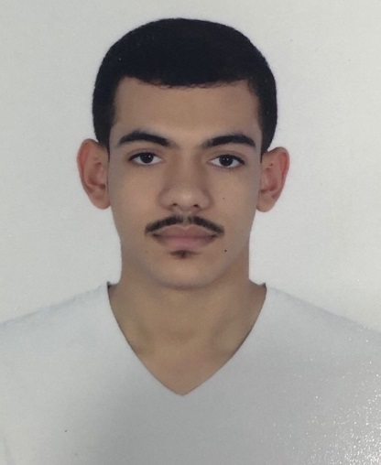 **PERSONAL DETAILS:**

Date of birth 15/11/1999

CPR 991105010

Nationality Bahraini

Address **Villa 228, Road 2209,**

**Dumistan 1022**

Telephone 66300646

E-mail aaajy07@gmail.com

Marital Status single

**PROFILE:**

Dedicated and organized person with good interpersonal skills.

Excellent team worker willing to learn and develop new skills. Reliable and dependable person seeking new responsibilities within a wide range of employment areas. Determined and decisive with active and dynamic approach to work and getting things done.

**EDUCATION:**

**September 2018- 2019 Study at University of Bahrain in Accounting**

**September 2017- june 2018 Study English in two semesters**

**[University of Bahrain]**

**September 2014 – june 2017 Sheikh Isa Bin Ali Secondary boys school**

**(commercial Section) [Isa Town, Bahrain]**

**SKILLS:**

* Numeracy skills.
* Time managing
* Business owning.
* Problem solving skills.
* Manage work smoothly.
* Strong customer service skills.
* Teamwork skills.

**LANGUAGES:**

Arabic -fluent-.

English –very good-.

**EXPERIENCES:**

2017-2018 Work at I-print for lending design and printing

**QUALIFICATIONS:**

* Good listener and learner, capable to communicate well with people.
* Hardworking individual or as a part of team from the experience I have of doing business in cars.
* Can work under stress and keep within set budgets and targets.
* Organized and willing to participate in developing the efficiency.
* Punctual with an excellent attendance record.
* Aims to achieve a high standard in whatever work I undertake.
* Confident person with sales experience, team leadership skills and the ability to create new sales and build on existing accounts.