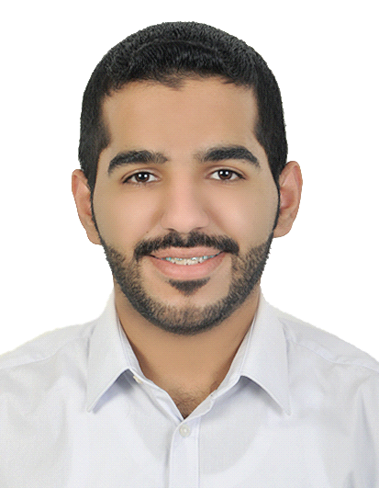 Mahdi Mohsen Mahdi

Personal information:

Nationality: Bahraini Martial state: Single

CPR.: 971203393

Contact:

Cell phone: 00973-34456806 Email: [mahdi19097@gmail.com](mailto:mahdi19097@gmail.com)

Education:

2013-2016 Commercial science sector, Shaikh Isa bin Ali school

Experience:

2012-Present ONE LINE PLUS MOBILE

Salesman, customer service

*Perform monthly sales audit and inventory. Clearing of governmental transactions. Technical service (updating/programming) and repair of the mobiles .*

Skills:

* Basic awareness of: AutoCAD
* Highly skilled of windows and Ms office (Excel, Words, PowerPoint)
* Communication and customer service skills
* Hard working

Languages:

Fluent in Arabic, middle in English (reading, writing, speaking)

References are available upon request