**Curriculum Vitae**

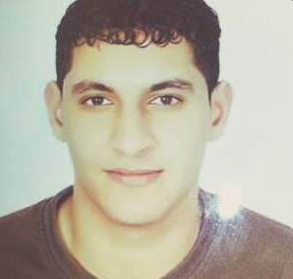

**PERSONAL PROFILE:**

**Name:** Mohammed Majeed Isa Mohammed

**Nationality:** Bahraini

**CPR Number:** 930501292

**Date of Birth:** 23\5\1993

**Marital Status:** single

**Address:** 68 Road 24 west AL-Eker 624

**Telephone:** +97333863541 +97339319909 + 36684819

**EDUCTIONAL QUALIFICATION:**

**2011 – 2010:** High School degree from al-taawon secondary boy's school

**LANGUAGE & TECHNICAL SKILLS:**

**Languages:** Arabic & English.

**Computer Skills:** Mastering the use of computer as well as print

And internet explorer.

**SKILLS & CAPABILITIES:**

Proficiency in computer use, printing and writing continue.  
Proficiency using Excel and PowerPoint and roses and many other programs.

**HOBBIES:**

* Drawing
* Read the stories and novels
* Read scientific books in general
* Solving difficult math, as well as solution gas

**OBJECTIVE:**

* Serve the nation and society