***PlERSONAL DETAILS:***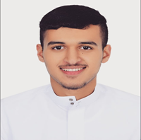

**- Name:** Hassan Ebrahim Abbas Ali Marhoon

**- Date of Birth** : 22/7/2001

**- Age :** 17

**- Sex :** Male

**- Religion** : Muslim

**- Nationality :** Bahraini

**- CPR No. :** 010707093

**- Marital statue :** single

**- Adress :** H:4151 R:957 B:609

**- Contact No :** 33058661

**-E-mail** : marhoonh931@gmail.com

***Objectives :***

To obtain a full time position that will allow me to contribute to an organization’s strategic objectives. To use my professional and academic qualifications in a challenging environment that will increase my skills and provide benefit to the business.

***Acadimic qualifications:***

* General certificate of secondary.

***Qualities:***

* Creative.
* Pereverance.
* Good team worker.
* Ability to work under pressure.

***Language known:***

_ Mother- tongue Arabic.

_ English

***OTHER SKILLS:***

* Conversant with all secretarial skills.
* Type Word , Power Point and Excel.
* Fully capable of using internet.

**HASSAN EBRAHIM ABBAS ALI MARHOON**