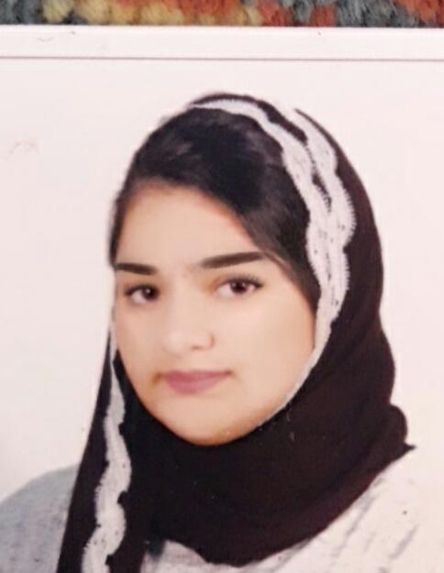**Curriculum vitae**

* **My objective:**

is utilizing any opportunity of new experiences and merging them together in order to obtain optimum results, To work for an organization that will give me the opportunity to learn, develop and contribute to the organization.

* **Personal details:**

Name: Fatima Sayed Ameer Mohamed Jawad Ahmed

Date of Birth: 09/01/1999

Address: Flat21, Building26, Block740, Road4001, A'Ali

Nationality: Bahraini

Phone Number: +973 35051754 , +973 34008540

Email: Fatimas.alhashimi@gmail.com

Marital status: Single

* **Academic details:**

2014_2017 Al-Hoora Secondary High School Major: Technical and vocational education

* **Training Experience:**

05th Feb 2017 Work ethics/ Insurance principles &time management

06th Feb 2017 Self-motivation to build future path abilities/ Discover your inner treasure

08th Feb 2017 Negotiation skills/The role of supreme council of woman

09th Feb 2017 The role of social centres in the kingdom of Bahrain/Customer services and banking

* **Languages:**

Arabic: Reading, Writing& Speaking.

English: Reading, Writing& Speaking.

Persian/Farsi: Reading, Writing& Speaking.

* **Hobbies:**

reading novels, photography& listen to music.

* **Other details:**

Driving licence/ Full time availability.