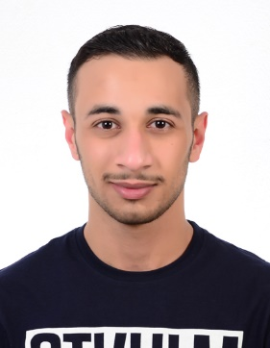

**Hamza Ebrahim Husain Mohammed**

House No. 1400 Road No. 1119

Block No. 1211, Hamad Town

**Contact Information:** +: +973-66376869

**E-mail:** Hamza.Ebrahim7@hotmail.com

CURRICULUM VITAE

|  |
| --- |
| **CAREER AMBITIONS** |

I am an energetic, ambitious person who has developed a mature and responsible approach to any task that I undertake, or situation that I presented with. I am excellent in working with others to achieve a certain objective on time and with excellence. As a hardworking University student, job opportunity will help me to achieve and develop my skills.

|  |
| --- |
| **I. PERSONAL DETAILS** |

|  |  |  |  |
| --- | --- | --- | --- |
|  |  |  |  |
| **Identity Number** | : | 971004510 |
| **Nationality** | : | Bahraini |
| **Date of Birth** | : | 16th October 1997 |
| **Marital Status** | : | single |

|  |
| --- |
| **II. EDUCATIONAL HISTORY** |

|  |
| --- |
| 1. **ACADEMIC QUALIFICATIONS** |

1. **Present** Mechatronics engineering

**AMA International University**

1. **2015-2018** IT – Computer engineering

**University of Bahrain**

1. **2012-2015** Secondary School General Certificate-Technical

**Aljabreya Secondary Boys School**

|  |
| --- |
| **III. WORK EXPERIENCE** |

* None

|  |
| --- |
| **IIII. SKILLS** |

* **Computer Skills:**
* Very familiar with Windows and most of Microsoft Office applications
* Professional in using and researching through the Internet.
* **Communication Skills:**
* Excellent in presentation and communication.
* Excellent customer services.
* Excellent team working and team leading.
* Good experience in dealing and solving problems and issues.
* **Languages:**
* Arabic: Native
* English: good
* **Marketing Skills:**
* E-Commerce
* Search Engine Optimizing (SEO)
* Social Media Marketing
* Managing Social Media Platforms

|  |
| --- |
| **VI. INTERESTS AND HOBBIES** |

# Travelling.

* Watching movies.
* Social activities .
* Mechanic

|  |
| --- |
| VII. REFERENCES |

* Available Upon Request.