

**Curriculum Vitae**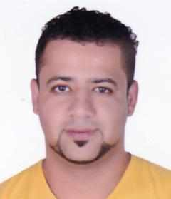

**Contact Information**

Name : Hassan.a.nabi

Address : Bld 795,Road 3322,block 1033,Flat 12 Malkiya

Mobail : 35583947

**Personal Information**

Date of Birth : 02-04-2002

CPR Number : 020400233

Nationality : Bahrain

Gender : Male

Marital : Single

**Objective**

Looking forward to associate myself with an organization of quality environment where knowledge can be shared and dedicate my skills and talents for development of self and the organization served.

**Education**

* Bahrain Vocational Boys Secondary school

**Language**

* Arabic: Speaking Writing and Reading
* English: Speaking Writing and Reading

**Professional Skills**

* Driving Car, Good People skills, Good Communication,

Team working, Hard Working, Work Under Pressure, creativity active listening , leader ship , problem-solving , management