**Curriculum Vitae**

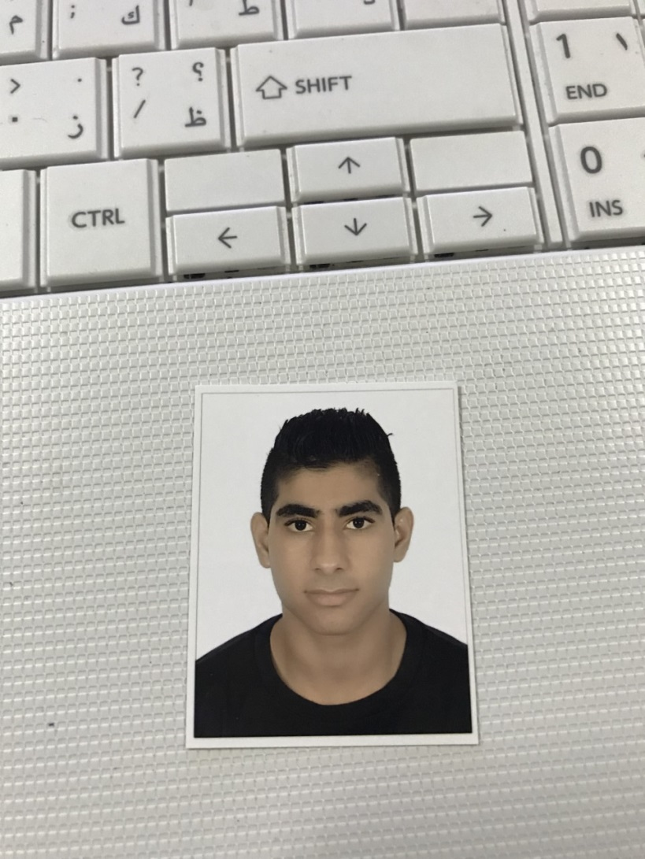

**PERSONAL PROFILE:**

**Name:** Isa Majeed Isa Mohammed

**Nationality:** Bahraini

**CPR Number:** 990201635

**Date of Birth:** 07/02/1999

**Marital Status:** Single

**Address:** 68 Road 24 West AL-Eker 624

**Telephone:** 36006910 _ 39319909 _ 36950531

**EDUCTIONAL QUALIFICATION:**

**2014 – 2015:** High School Degree From Al_mameer Boy's School

**LANGUAGE & TECHNICAL SKILLS:**

**Languages:** Arabic & English.

**Computer Skills:** Mastering the use of computer as well as print

And internet explorer.

**SKILLS & CAPABILITIES:**

Proficiency in computer use, printing and writing continue.  
Proficiency using Excel and PowerPoint and roses and many other programs.

**HOBBIES:**

* Drawing
* Read the stories and novels
* Read scientific books in general
* Solving difficult math, as well as solution gas

**OBJECTIVE:**

* Serve the nation and society