**Isa AbdulNabi Isa Sahlan**

**00973-38126326** 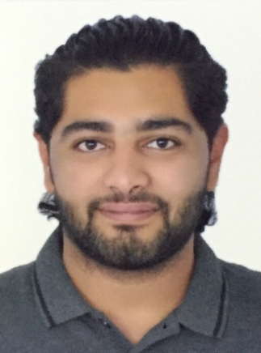

[Isasahlan80@gmail.com](mailto:Isasahlan80@gmail.com)

___________________________________________________________________

**DOB**: 26-April-1998

**Gender**: Male

**Nationality**: Bahrain

**Languages:** Arabic, English.

**Profile**: looking forward to seek a bright future where I can apply my educational knowledge. Ready to work under any situation and give my best service to organization.

**Career objectives**: To pursue and give my best effort by working hardly and dedicated to my work.

**Area of interest**: Reading , Bike riding , Social service , cooking

**Educational qualification:**

|  |  |  |  |
| --- | --- | --- | --- |
| **No.** | **Degree** | **Board/University** | **Year of passing** |
| 1. | High school | Al-Tawon | 2016 |