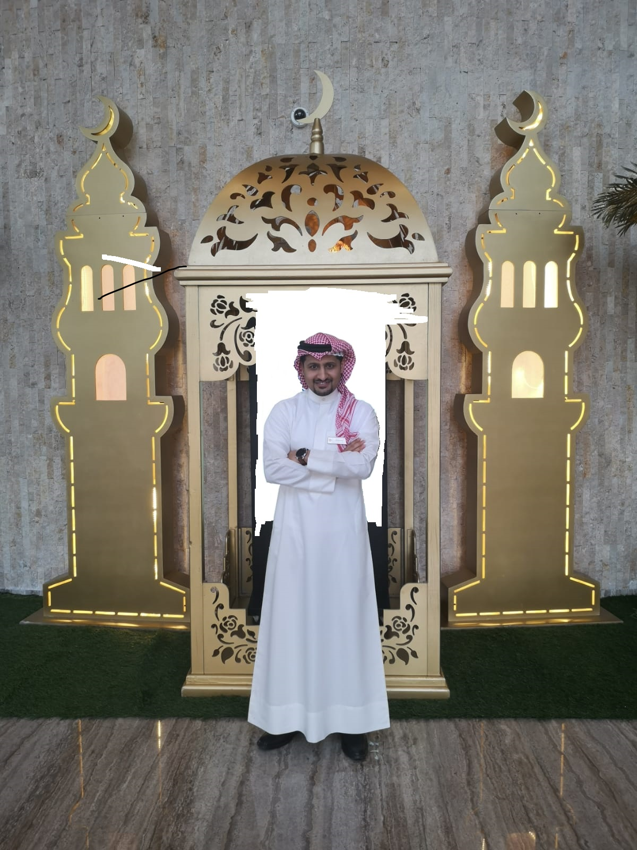Ljdcnlkdnckjdc **MOHAMMED TAQI**

**Contact Information**

__________________________

**Email**

Bo.taqi92@gmail.com

**Address**

House 1134, Road 2623, Al Eker 626, Kingdom of Bahrain

**Phone**

+973 32200623

**Skills**

__________________________

* Computer skills: well versed with usage of MS Office, Emails, and internet browsers.
* Interpersonal : Good communication skills, Friendly, Flexible, Cooperative, Honest and fast learner
* Basic knowledge in programing: java and java script.
* Basic knowledge in designing web pages
* Fix computer problems
* Ability to speak and write two languages : English: Well spoken, Arabic: Native speaker

**Languages**

__________________________

**Arabic**

Native language

**English**

Well Spoken

**Arabic**

Native speaker

* Date of Birth: 25 Jan 1992
* Gender: Male
* Nationality: Bahraini
* Marital Sates: Single
* Religion: Muslim
* To explore my career by working in well-developed organization where careers growth and developed is optimum. My goals can be achieved by supporting my competencies to be utilized for the benefit of the organization.

__________________________________________________________

**Experience**

**Wyndham Grand Wyndham Grand Front Office Supervisor**

**Man Manama Hotel**

* General duties of the receptionist
* Writing reports and Emails
* Handling guests complains
* Checking all the bookings and transactions off my colleagues

Bahrain Bay, Bahrain January – 2019

Until now.

___________________________________________________________

**Wyndham Grand Receptionist**

**Man Manama Hotel**

* Warmly and graciously greet all guests upon arrival
* Answering calls and making bookings.
* General duties of a receptionist
* Dealing with customers on one to one basis and groups
* Taking inquiries and bookings and inputting on the correct system

Bahrain Bay, Bahrain December – 2017

December – 2019.

___________________________________________________________

**Wyndham Grand Operator**

___________________________________________________________

* Part of the opening team which makes me have an excellent knowledge about all the department in the hotel and how the work and a good opportunity to get well trained.
* Answering calls and making bookings.
* Answering calls and Transfer it to the correct department.
* Dealing with customers on a one to one basis and group.
* Taking enquirers and bookings and inputting on the correct system.
* Writing reports.
* Doing the GNS in and out in daily biases.

**Manama Hotel**

Bahrain Bay, Bahrain

October – 2017

December – 2017

___________________________________________________________

**GulfCX Operator**

* Answering calls and assisting the customers of deferent companies.
* Working as part of a team and alone on occasions.
* Solving customers problems
* Writing reports.

Seef Area, Bahrain

July – 2016

September – 2017

yyyy

___________________________________________________________

**Education**

**High School High school or equivalent**

* Secondary School Certificate ( Scientific )
* GPA: 82.1

Sheikh Abdul-Aziz School,

Adlya, Bahrain

July - 2009

___________________________________________________________

___________________________________________________________

**Arab Open University Studying to get a Bachelor’s degree degree**

* Studying IT and it’s my last year to graduate

Aali, Bahrain Until now

July - 2016

**High**

___________________________________________________________