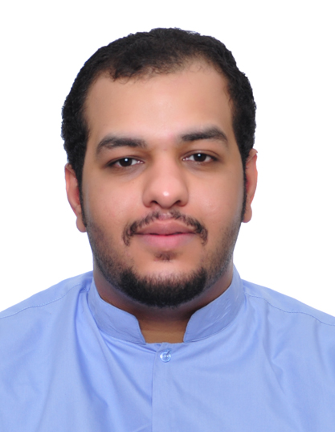 **Alawi sayed abdulla majed**

|  |
| --- |
| **Sitra • bahrain** |
| **Mobile:(+973) 34155185 •** **TEL:(+973) 17730335**  •**e-mail:ALSAYED.BH7@GMAIL.COM** |

|  |  |
| --- | --- |
| **Personal Information**  **Gender : Male**  **Date of Birth : 09 – 02 - 1993**  **Nationality : Bahraini**  **C.P.R No. : 930203968**  **Martial status : Single** | |
| **Education** | |
|  | **September 2013 – 2014 Bahrain Training Institute (BTI)**   1. **Diploma In Travel and Tourism**   **September 2009 – June 2012 AL-Ta’won Secondary School**   1. **High School – Commerce** |
| **Skills** | |
|  | * **Computer skills** * **Microsoft office (professionally adept at using Word, Power point, Excel , Access )** * **Researching the Internet** * **Typing (English & Arabic)** * **Graphic Design ( Adobe Photoshop )** * **Interpersonal skills** * **Enjoy working with teams or as individual.** * **Willing to learn and work hard with strong work ethics .** * **Ability to manage and complete multiple tasks.** * **Languages** * **Arabic** * **English** |
| **Interests** | |
|  | **Playing Football and Basketball**  **Photography and Design**  **Readers** |
| **Refrences** | |
|  | **Are Readily Available upon request** |