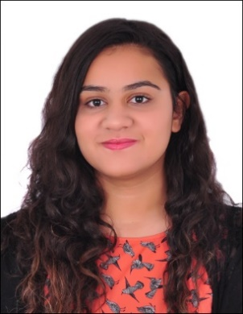

Manar Abdul Jalil Saleh Ali Abdulla

Date of Birth: 6th of January 2001, Nationality: Bahrain

Flat, Bldg:2234, Road: 1553, Isa Town 815, Mobile: 35414898,36893888

Email: [manarabdulla16@gmail.com](mailto:manarabdulla16@gmail.com).

Profile:

* Trained Volunteer with a proven certificate.
* Hardworking and can handle long hours.
* Driven by challenge and has excellent English language and communication skills that provide the ability to communicate with different nationalities.

Qualifications, Education and training courses:

* First year student at Bahrain Polytechnic.
* Secondary school (Al Noor secondary school).
* Course in volunteer and dealing with different types of people.
* Involvement with Bahrain authority for culture and antiquities.

Skills:

* Fluent in English
* Fluent translation skills
* Average knowledge of Computer skills
* Maintaining and developing relationships with new and existing visitors via meetings, telephone calls and Email.
* Establish strong relations with clients
* Managing and attending public relations events
* Strong communication skills.

**Career summary**: **18th June till 18th August 2018**: Bahrain authority for culture and antiquities.

Duties and responsibilities:

* Able to take control of a conversation and accurately determine the visitor’s specific needs and desires.
* Handling all correspondence and organizing contact with the visitors.
* Maintaining visitors records.
* Keeping records of visitors
* Forecasts goals and objectives expenses on a daily basis
* Coordinate with management to ensure delivering the desired goals according to the plan and management policies
* Gaining a clear understanding of visitors and their requirements
* Dealing with different types of visitors directly.

Other Interest:

Participate in English events.

Referee:

Name: Mr. Ahmed Emam

Job Title: Activity Manager

Mobile: +973 33327710