**CURRICULUM VITAE**

**PERSONAL DETAILS:**

Full Name : Mohammad Jawad Ali Masool

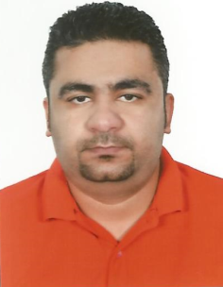Date of Birth : 2nd March, 1984

Place of Birth : Manama

Marital Status : Married

Nationality : Bahraini

CPR No. : 840307268

Passport No. : 2119847

Address : House 3100, Road 1150, Block 1211

City & State : Madinat Hamad, Kingdom of Bahrain

Contact No. : 39522171/39073722

E-Mail : [abojassoom177@gmail.com](mailto:abojassoom177@gmail.com)

**QUALIFICATIONS:**

* Tulatila Primary Boys School
* Al-Farabi Intermediate Boys School

**EXPERIENCES:**

* Al-Aujan Est. Driver
* Manama Textile Machines Operator
* Group 4 Security

**PERSONAL SKILLS:**

* MS Office (Word & PowerPoint)
* Computer literate
* Auto/Domestic electrician
* Have a valid driving license
* Languages:

Arabic - Read/Write/Speak.

English - Read/Write/Speak.

**INTERESTS:**

* Computing Programs
* Serving the Net
* Fishing